Press Release
2022-148

Schmitz Cargobull AG
“Innovations for Transport Efficiency”

Schmitz Cargobull presents its latest product and service highlights for the IAA Transportation 2022

September 2022 – Inspired by the motto of “Innovations for Transport Efficiency”, Schmitz Cargobull is showcasing a comprehensive portfolio of innovative new products and services, aimed particularly at improving economic efficiency for users. When it comes to the new products, the focus is on aerodynamics for cutting emissions and costs, cooling efficiency for temperature-managed freight, lower vehicle weights but with the same level of durability, and the use of telematics data for added process efficiency.

Here is an overview of the new features:

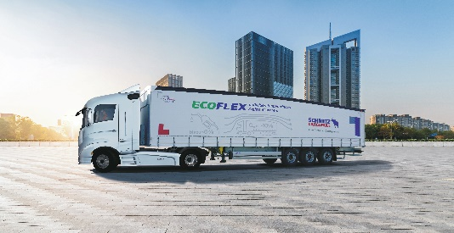
Aerodynamic freight transport: Schmitz Cargobull EcoGeneration vehicles
- EcoFLEX with lath-free POWER CURTAIN for rapid loading and unloading
- NEW: Sensors detect height adjustments and transfer this data to the telematics system
- NEW: Aerodynamic storage box improves efficiency even further
- NEW: Interior lighting for added occupational safety
Find out more in Press Release 2022-306

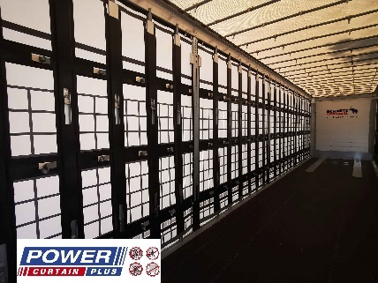
Strong, secure, flexible and speedy

Schmitz Cargobull S.CS MEGA DB curtainsider with POWER CURTAIN PLUS
- The POWER CURTAIN PLUS body with tyre certificate is specially designed for transporting dimensionally unstable goods.
- NEW: Ferry underride guard for multimodal transport by rail or ferry.
Find out more in Press Release 2022-307

2022-148

Smart features for cool transport solutions
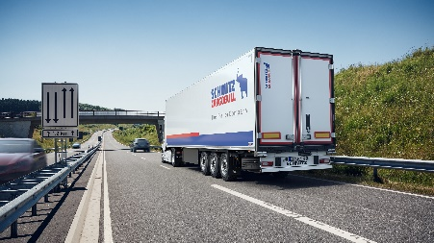
The S.KO COOL refrigerated semi-trailer
- NEW: Extension of the theft prevention package with TAPA TSR1 ex works for S.KO COOL
- NEW: New air distribution system for uniform cooling for the entire cargo area, efficient, durable and with pharmaceuticals certification ex works
- Further equipment available to ensure vehicle and cargo security, for example door locking system, immobilizer, etc.
- 100% SMART thanks to TrailerConnect® telematics system fitted as standard Find out more in Press Releases 2022-511 and 2022-512

Safe and efficient – Transport cooling units from Schmitz Cargobull
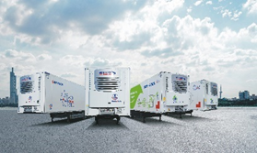
- NEW: S.CUd80 – Quietest diesel-based cooling unit in MonoTemp design with new cooling circuit, optimised for consumption
- NEW: With a new Performance mode: S.CU 2.0 – with efficient common rail diesel engine – in MonoTemp and MultiTemp (mt) design
- NEW: S.CUep85 – electric, battery-operated cooling unit with power electronics module; low maintenance and quiet
- S.CUe85 – electrically powered cooling unit does not generate any emissions and is designed especially for use in urban transport
Find out more in Press Release 2022-513

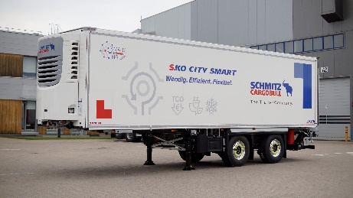
City campaign – The S.KO CITY box body semi-trailer for food distribution
- Manoeuvrable twin-axle, force-steered semi-trailer
- With electric cooling unit S.CUe85
- 100% SMART thanks to TrailerConnect® telematics system fitted as standard
Find out more in Press Release 2022-515

2022-148
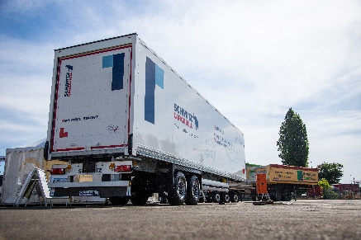
New S.BO PACE trailer from Schmitz Cargobull for dry freight
- New dry freight box body S.BO PACE for safe CEP transport now available across Europe
- Stable, lightweight body made from STRUKTOPLAST
- S.BO is Schmitz Cargobull's new product name for dry freighters
Other trailer in the dry freight segment: S.BO EXPRESS
Find out more in Press Release 2022-508

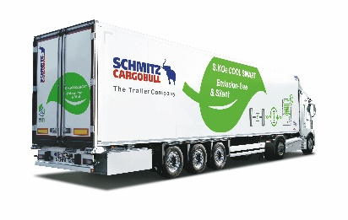
Zero emissions for temperature-controlled transport: The S.KOe COOL all-electric box body semi-trailer
- Refrigerated box body with battery-powered cooling unit and trailer axle with energy recuperation for environmentally friendly freight transport
Find out more in Press Release 2022-514

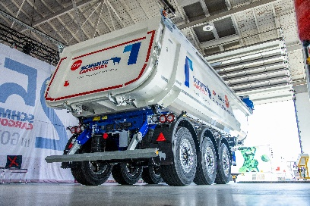
New Schmitz Cargobull tipper trailer for even greater payload
- Weight reduction: Thanks to a new generation of bodies and frames, the new S.KI tipper semi-trailer is up to 280 kg lighter
- NEW: Digital on-board weighing system
- NEW: Rear area and cargo area camera
- New bodies also available for the M.KI truck tipper body
- Redesigned underride guard: Simple handling and high clearance
- Production start for new S.KI tipper semi-trailer planned for end of 1st quarter 2023.
Find out more in Press Release 2022-707

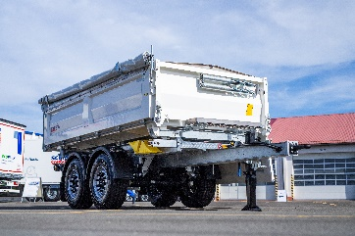
Increased flexibility for daily transport operations

New and back in the portfolio: The Z.KI three-sided tipper
- Lighter and easier to handle
- Unladen weight reduced by 50 kg
Find out more in Press Release 2022-704

2022-148

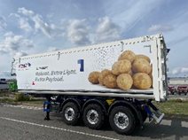
Light and low – trailers for high-volume transport
- S.KI LIGHT tipper semi-trailer with aluminium box body designed especially for transporting agricultural products.
- Tapered frame design allows for low loading height, ground clearance and total height while maintaining the same trailer coupling height.
Find out more in Press Release 2022-708

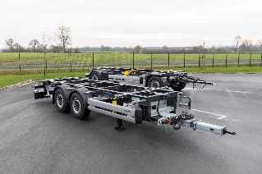
Efficient solutions for multimodal transport
- A.WF trailer swap chassis
- Z.WF central axle swap body chassis
- W.BO swap box from Schmitz Cargobull
Find out more in Press Release 2022-808

Digital services from Schmitz Cargobull
- Data management centre offers automated, controlled data transparency
- Proprietary tyre pressure monitoring system (TPMS) for smart trailers
- “Proactive Monitoring” for Schmitz Cargobull S.CU cooling unit via the TrailerConnect®* telematics system
- The new TL4 door locking system offers safety for cargo and drivers
- TrailerConnect® TourTrack for professional monitoring and analysis of routes and transport jobs
Find out more in Press Releases 2022-133, 2022-134, 2022-135, 2022-136 and 2022-149

About Schmitz Cargobull
With an annual production of around 61,000 trailers and with approximately 6,900 employees, Schmitz Cargobull AG is Europe’s leading manufacturer of semi-trailers, trailers and truck bodies for temperature-controlled freight, general cargo and bulk goods. The company achieved sales of around €2.3 billion in the 2021/22 financial year. As a pioneer in the industry, the North German company developed a comprehensive brand strategy early on and consistently established quality standards spanning every level: from research and development, through production and service contracts, to trailer telematics, financing, spare parts, and used vehicles.

The Schmitz Cargobull press team:
Anna Stuhlmeier +49 2558 81-1340 I anna.stuhlmeier@cargobull.com
Andrea Beckonert +49 2558 81-1321 I andrea.beckonert@cargobull.com
Silke Hesener: +49 2558 81-1501 I silke.hesener@cargobull.com

