Press Information
2019-109

Schmitz Cargobull AG
Michael Grund named Member of the Board for Schmitz Cargobull’s Operations division

April 2019 – The Supervisory Board of Schmitz Cargobull AG has appointed Michael Grund as the new Member of the Board for Operations. He took up his position at Schmitz Cargobull on 18 March 2019. Grund has international experience in numerous management positions in fields such as operations, portfolio management/strategy and business development, along with programme management and engineering, as well as digitalisation.

“His profound knowledge of the sector, his impressive management expertise and his affinity for the automotive sector make Michael Grund the perfect choice for the Board Member for Operations. We are thrilled that he has decided to take on this exciting new challenge,” declares Professor Jürgen Kluge, Chairman of the Supervisory Board at Schmitz Cargobull AG.

After studying industrial engineering, Grund successfully founded a company specialising in meteorological services in 1998. He continued his career with positions at Hewlett Packard, and in 2014 joined technology company ZF Group TRW Automotive GmbH in Düsseldorf. Here as Global Director he was responsible for product portfolio strategy for the Electric Power Steering Column Drive business unit. From 2016 onward, in his position as Vice President Operations European Steering, Grund was responsible for the production, quality, logistics, AME & CI/Lean for power steering, electric motors, power packs and pumps and was also responsible for the digitalisation initiatives in these areas.

“I am grateful for the trust placed in me and I am looking forward to my new role at Schmitz Cargobull. Europe's largest trailer manufacturer has a successful business model. I can build on this solid foundation and, above all, contribute with my experience in portfolio strategy and digitalisation”, says Grund.

2019-109

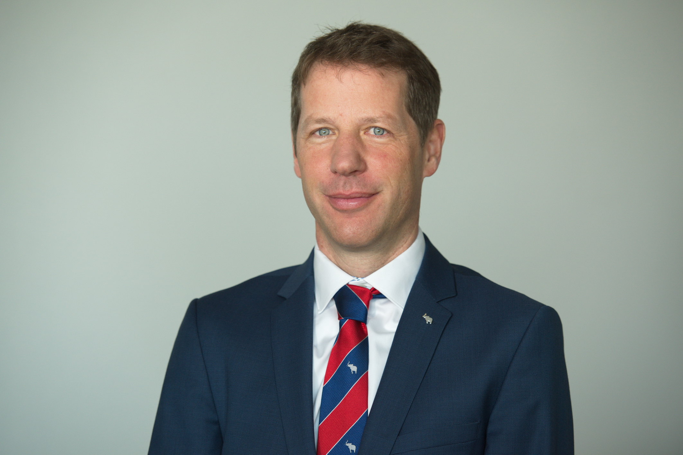

About Schmitz Cargobull

With an annual production of more than 61,000 vehicles and approximately 6400 employees, Schmitz Cargobull AG is Europe’s leading manufacturer of semi-trailers, trailers and vehicle bodies for temperature control freight, general cargo and bulk goods. The company achieved sales of almost € 2.2 billion in the 2017/2018 financial year. As a pioneer in the industry, the North German company developed a comprehensive brand strategy early on and consistently established quality standards at all levels: from research and development to production and service contracts, trailer telematics, financing, spare parts supply and used vehicle trade.
The Schmitz Cargobull press team:
Anna Stuhlmeier: +49 2558 81-1340 I anna.stuhlmeier@cargobull.com
Andrea Beckonert: +49 2558 81-1321 I andrea.beckonert@cargobull.com
Silke Hesener: +49 2558 81-1501 I silke.hesener@cargobull.com

