
Press Release
2024-119

Schmitz Cargobull AG
Schmitz Cargobull supports Ukraine aid organisation "Brücke" with donation campaign
Over 37,000 euros raised for urgently needed medical supplies

April 2024 - In view of the ongoing war and the suffering faced by the population in Ukraine, Schmitz Cargobull recently launched another appeal for donations for urgently needed medical supplies and means of transport within the company.

The response and willingness to help within the workforce was great, with employees donating the impressive sum of 18,565 euros. This sum was doubled by the company, so that a total of 37,137 euros was transferred to the Ukrainian aid organisation, the "Brücke" association.

The donations will go directly towards the purchase of an ambulance and life-saving medical equipment, such as medication, bandages, syringes, bandages, catheters, defibrillators, stretchers and much more.

The "Brücke" association was founded in 2022 by eleven committed German and Ukrainian members who have established a direct link to the clinics in the crisis areas. They receive requests on a daily basis and deliver the urgently needed aid directly to the Ukrainian clinics. The donated funds are spent 1:1 on purchasing the materials needed to help the people in Ukraine directly and quickly.

2024-119

For further support, please find below the contact details:
https://www.bruecke-ukrainehilfe.com/
Brücke Ukrainehilfe Halle (Saale) e.V.
Robert-Blum-Strasse 37
06114 Halle (Saale)
Halle (Saale) Germany
Donations to:
IBAN: DE83 8005 3762 1894 1206 51
BIC: NOLADE21HAL

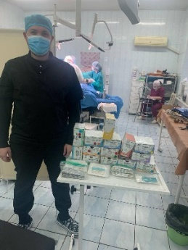
Caption: Grateful recipients of the urgently needed medical aid

About Schmitz Cargobull
Schmitz Cargobull is the leading manufacturer of semi-trailers for temperature-controlled freight, general cargo and bulk goods in Europe and a pioneer in digital solutions for trailer services and improved connectivity. The company also manufactures transport refrigeration machines for refrigerated semi-trailers for temperature-controlled freight transport. With a comprehensive range of services from financing, spare parts supply, service contracts and telematics solutions to used vehicle trading, Schmitz Cargobull supports its customers in optimising their total cost of ownership (TCO) and digital transformation. Schmitz Cargobull was founded in 1892 in Münsterland, Germany. The family-run company produces around 60,000 vehicles per year with over 6,000 employees and generated a turnover of around 2.6 billion euros in the 2022/23 financial year. The international production network currently comprises ten plants in Germany, Lithuania, Spain, England, Turkey, Slovakia and Australia.

The Schmitz Cargobull press team:
Anna Stuhlmeier +49 2558 81-1340 I anna.stuhlmeier@cargobull.com
Andrea Beckonert +49 2558 81-1321 I andrea.beckonert@cargobull.com
Silke Hesener +49 2558 81-1501 I silke.hesener@cargobull.com

