Press Release
2024-102

Schmitz Cargobull AG

Schmitz Cargobull and Berger Fahrzeugtechnik GmbH join forces

January 2024 – Since the beginning of 2024, BERGERecotrail trailers have been available to purchase via the Schmitz Cargobull sales network. The relevant authorities have approved Schmitz Cargobull AG’s 49-percent investment in Berger Fahrzeugtechnik GmbH as agreed between the companies in September 2023.
With immediate effect, the two firms will consolidate their strengths and launch their relationship with the marketing of the lightweight BERGERecotrail trailer across Schmitz Cargobull’s Europe-wide sales network.

Discussing the next steps, Schmitz Cargobull AG’s Chief Sales Officer Boris Billich says: “We are delighted that we will now be able to offer our customers an even more extensive product portfolio as a result of our collaboration with Berger. Customers can now purchase the specialist lightweight BERGERecotrail vehicles through their Schmitz Cargobull contact partners. Transport firms will benefit from a greater range of vehicles and an extensive package of services for both product lines. This is hugely advantageous for our customers.”

Roland Schneider, Managing Director Sales at Berger Fahrzeugtechnik GmbH, based in Tyrol, Austria, adds: “Our lightweight BERGERecotrail semi-trailers are in particularly high demand among customers looking for high payloads. However, two of the main reasons why lightweight trailers are becoming increasingly relevant for transport firms is their ability to optimise payload and increase sustainability. Customers can now use Schmitz Cargobull’s Europe-wide sales and service network, which offers huge added value.”

With its BERGERecotrail vehicles, Berger Fahrzeugtechnik is a renowned specialist in premium lightweight vehicles with extensive expertise in lightweight construction. Now that the two companies have consolidated their strengths, BERGERecotrail lightweight trailers from the Radfeld factory in Tyrol are now also available through Schmitz Cargobull’s sales channels.

2024-102

Customers will also be able to access comprehensive European spare parts supply through the Schmitz Cargobull Service Partner network. The next step will see Schmitz Cargobull’s entire service portfolio being extended to cover Berger lightweight vehicles.

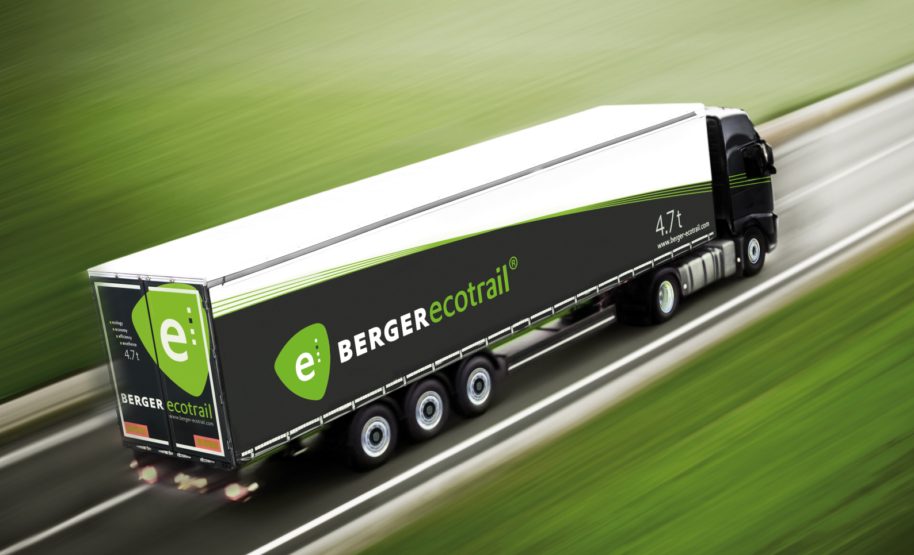

Boris Billich, Chief Sales Officer at Schmitz Cargobull AG
Roland Schneider, Managing Director Sales at Berger Fahrzeugtechnik GmbH

2024-102

About Schmitz Cargobull
Schmitz Cargobull is the leading manufacturer of semi-trailers for temperature-controlled freight, general cargo and bulk goods in Europe and a pioneer in digital solutions for trailer services and improved connectivity. The company also manufactures transport refrigeration machines for refrigerated semi-trailers for temperature-controlled freight transport. With a comprehensive range of services from financing, spare parts supply, service contracts and telematics solutions to used vehicle trading, Schmitz Cargobull supports its customers in optimising their total cost of ownership (TCO) and digital transformation.
Schmitz Cargobull was founded in 1892 in Münsterland, Germany. The family-run company produces around 60,000 vehicles per year with over 6,000 employees and generated a turnover of around 2.6 billion euros in the 2022/23 financial year. The international production network currently comprises ten plants in Germany, Lithuania, Spain, England, Turkey, Slovakia and Australia.

The Schmitz Cargobull press team:
Anna Stuhlmeier +49 2558 81-1340 I anna.stuhlmeier@cargobull.com
Andrea Beckonert +49 2558 81-1321 I andrea.beckonert@cargobull.com
Silke Hesener +49 2558 81-1501 I silke.hesener@cargobull.com

