Press Release
2025-161

Schmitz Cargobull AG
TTW Award 2025: Schmitz Cargobull voted pioneer in temperature-controlled transport by readers

First place in the eCHAMp category for hybrid transport cooling unit S.CU d80 ePTO ready

September 2025 – Schmitz Cargobull was honoured with the TTW Award from the trade journal Truck & Trailer Welt at this year's NUFAM trade fair, in Karlsruhe on 25 september.
In the ‘eCHAMp’ category, the company impressed with its innovative S.CU d80 ePTO ready transport cooling unit, which can be operated emission-free via the electric power take-off (ePTO) of an electric semi-trailer tractor unit. The readers' choice underscores the practical orientation of the solution and its high relevance for everyday use.

“We are particularly pleased about this award because it comes directly from the users of our products on a daily basis. It confirms that the S.CU d80 ePTO ready is not only technologically and economically impressive, but also offers real added value in practical operation,” said Ralph Kleideiter, CSO of Schmitz Cargobull, at the award ceremony.
“My thanks go to our customers and readers who have placed their trust in us. I would also like to thank the entire Schmitz Cargobull team, whose innovative spirit and great commitment have made this success possible.”

With the S.CU d80 ePTO ready, Schmitz Cargobull is underlining its role as a pioneer in temperature-controlled transport. The company is the first trailer manufacturer to offer a series-produced diesel-powered transport cooling unit that can be operated completely emission-free when used with an electric truck – providing an effective and practical solution for decarbonising temperature-controlled transport.

The transport cooling unit is prepared for electric operation directly ex works. At the same time, an integrated diesel generator ensures maximum operational reliability – automatic switching between energy sources guarantees uninterrupted cooling performance while driving. With this technology, Schmitz Cargobull enables its customers to make an

2025-161

economically viable transition to alternative drive systems without compromising on performance and reliability.

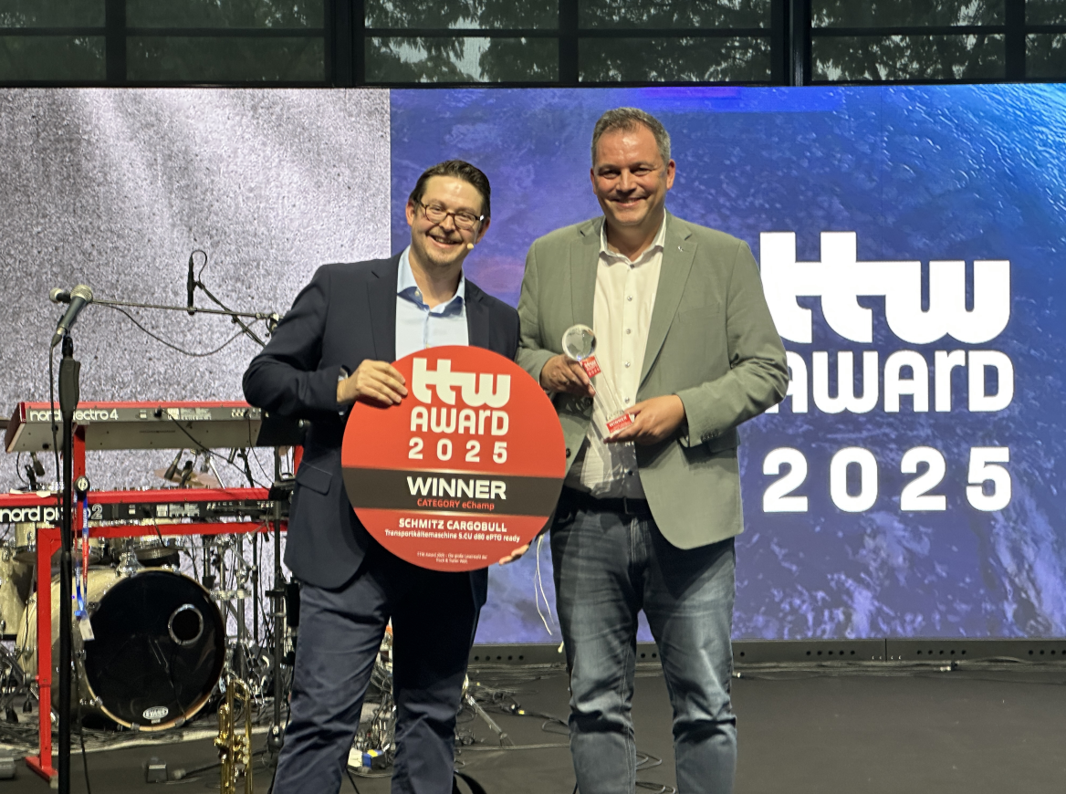
Caption:
f.l.: Phillip Bönders (editor-in-chief of Truck & Trailer Welt) and Ralph Kleideiter (CSO of Schmitz Cargobull) at the award ceremony in Karlsruhe

About Schmitz Cargobull
Schmitz Cargobull is the leading manufacturer of semi-trailers for temperature-controlled freight, general cargo and bulk goods in Europe, and a pioneer in digital solutions for trailer services and improved connectivity. The company also manufactures transport cooling units for refrigerated box body semi-trailers for temperature-controlled freight transport. With a comprehensive range of services from financing, spare parts supply, service contracts and telematics solutions to used vehicle trading, Schmitz Cargobull supports its customers in optimising their total cost of ownership (TCO) and digital transformation.
Schmitz Cargobull was founded in 1892 in Münsterland, Germany. The family-run company produces around 50,000 vehicles per year with over 6,000 employees, and generated a turnover of around €2.16 billion in the financial year 2024/25. Its international production network is made up of factories in Germany, Lithuania, Spain, Turkey and the UK.

The Schmitz Cargobull press team:
Anna Stuhlmeier +49 2558 81-1340 I anna.stuhlmeier@cargobull.com
Andrea Beckonert +49 2558 81-1321 I andrea.beckonert@cargobull.com
Silke Hesener +49 2558 81-1501 I silke.hesener@cargobull.com

