Press Release
2026-132

Schmitz Cargobull AG
Schmitz Cargobull wins big in ETM Awards readers' poll

The trailer manufacturer received the ETM Award 2026 "Best of New Transportation" in eight different product categories.

June 2026 – Schmitz Cargobull was one of the big winners of this year's readers' poll by ETM Verlag, receiving the prestigious ETM Award "Best of New Transportation" in eight categories. In this way, readers not only confirm the performance of individual products but the strength of the Schmitz Cargobull brand as a reliable partner in everyday transport. Solutions were awarded in the categories of container chassis, curtainsiders, refrigerated box trailers, lightweight trailers, swap body trailers, refrigeration units, telematics and in the category "Future of Logistics".

3,384 readers of the trade magazines FERNFAHRER and trans aktuell, as well as the online portal eurotransport.de, took part in the vote and selected the best commercial vehicle solutions of the year. The decisive factor here is that the choice is not only based on products, but also deliberately on the brand behind them. Users chose Schmitz Cargobull in eight categories, underlining the high level of confidence in the company's brand, quality and systems expertise.

"Our customers have voted Schmitz Cargobull in the top spot in eight categories – this shows us that our solutions are convincing in practice and meet the requirements of our customers. We are really very pleased about this, such a vote is anything but a matter of course," said Andreas Schmitz, CEO of Schmitz Cargobull AG, at the award ceremony on 11 June 2026 in Stuttgart. "The decision in favour of our brand stands for reliability, innovation and partnership-based cooperation. This is exactly what our teams work on every day – with the clear aim of creating added value for our customers. We would like to thank our customers for their trust."

2026-132
The award-winning solutions reflect Schmitz Cargobull's broad positioning along the entire transport chain. In the container chassis segment, the vehicles impressed with their high flexibility and cost-effectiveness in intermodal use. The S.CS curtainsider semi-trailers stand for efficient transport processes in general cargo transport, combined with high body stability and practical loading and unloading concepts. In temperature-controlled transport, the S.KO refrigerated box trailers set standards with their reliable insulation performance, energy efficiency and intelligent control. Thanks to its optimised dead weight, the lightweight trailer BERGERecotrail enables a higher payload with reduced fuel consumption at the same time, thus contributing to increasing efficiency in the fleet. Schmitz Cargobull also offers cost-effective and flexible solutions for combined transport in the field of swap body trailers and systems.

In addition, the readers' choice confirms the company's system competence. With the TrailerConnect® telematics solution, Schmitz Cargobull enables complete transparency along the supply chain and supports customers in the digitalisation of their transport processes. The in-house transport refrigeration units - S.CU - stand for efficient, low-emission cooling, and are optimally matched to the refrigerated vehicles. The interplay of vehicle, refrigeration unit and digital networking underlines the holistic approach of Schmitz Cargobull as an integrated system provider.

In the "Future of Logistics" category, Schmitz Cargobull's EcoDuo concept was also recognised. With this innovative approach, the company is committed to the Europe-wide introduction of a particularly efficient transport concept. The combination of two standard semi-trailers, connected by a dolly and towed by just one tractor unit, enables a reduction in CO₂ emissions. The concept has already proven its practicality: In the German pilot project, the EcoDuo has been successfully used in the pre-and-on-carriage of combined transport. It is also in regular service internationally, for example in Spain.

The ETM Award is considered an important indicator and benchmark in the commercial vehicle industry. ETM Verlag has been conducting the readers' poll since 1997. Since 2024, the award has been presented under the guiding principle of "Best of New Transportation" in the categories "Vehicles and Trailers", "Suppliers and Service Providers" and "Concepts". This year, selected participants in 42 categories were up for

2026-132

election. Readers were able to choose several companies in the commercial vehicle industry – from trucks and vans to innovative products, solutions and concepts.

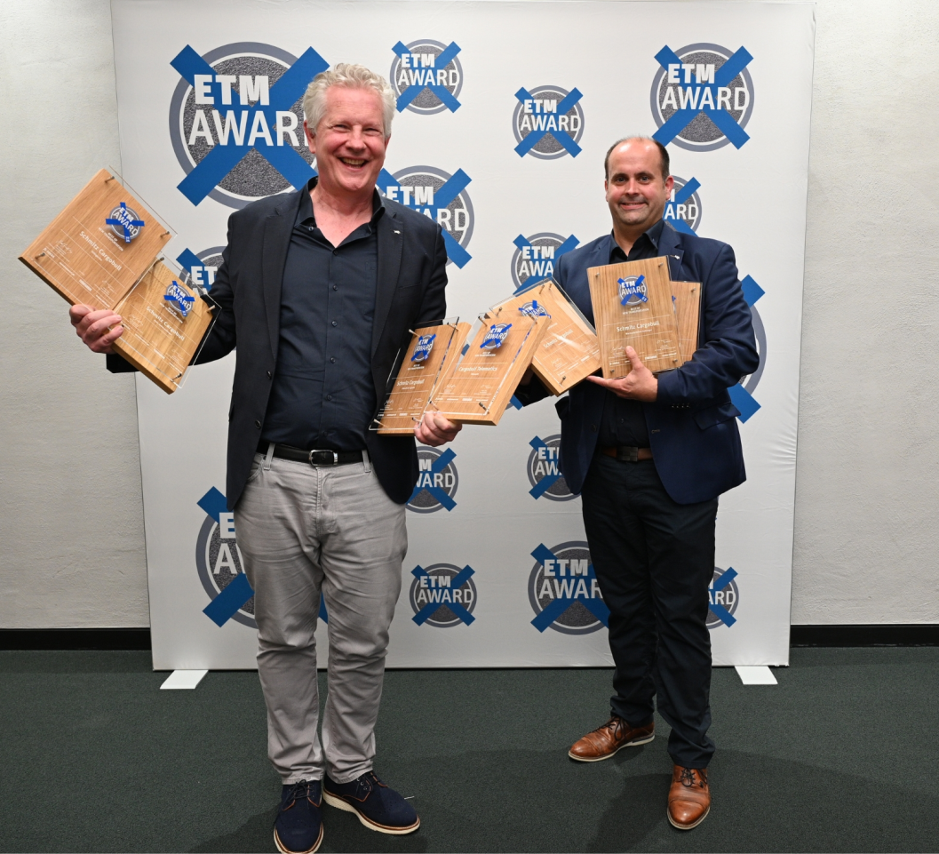
Caption: from left to right: Andreas Schmitz (CEO of Schmitz Cargobull) and Tim Warmeling (Head of Product Line General Cargo of Schmitz Cargobull)

About Schmitz Cargobull
Schmitz Cargobull is the leading manufacturer of semi-trailers for temperature-controlled freight, general cargo and bulk goods in Europe, and a pioneer in digital solutions for trailer services and improved connectivity. The company also manufactures transport cooling units for refrigerated box body semi-trailers for temperature-controlled freight transport. With a comprehensive range of services from financing, spare parts supply, service contracts and telematics solutions to used vehicle trading, Schmitz Cargobull supports its customers in optimising their total cost of ownership (TCO) and digital transformation.
Schmitz Cargobull was founded in 1892 in Münsterland, Germany. The family-run company produces around 50,000 vehicles per year with over 6,000 employees and generated a turnover of around €2.16 billion in the financial year 2024/25. Its international production network is made up of factories in Germany, Lithuania, Spain, Turkey, Romania and the UK.

The Schmitz Cargobull press team:
Anna Stuhlmeier +49 2558 81-1340 I anna.stuhlmeier@cargobull.com
Andrea Beckonert +49 2558 81-1321 I andrea.beckonert@cargobull.com
Silke Hesener +49 2558 81-1501 I silke.hesener@cargobull.com

