Press Release
2023-170

Schmitz Cargobull AG
Schmitz Cargobull opens subsidiaries in Georgia and Kazakhstan

Market and brand presence further expanded in Europe and Central Asia to meet the needs of growing customer base

October 2023 – Schmitz Cargobull has again delivered on its "We are where our customers are" brand promise, after unveiling two subsidiaries in Georgia and Kazakhstan.

Schmitz Cargobull relies not only on a well-developed production network but also on direct sales through subsidiaries in almost all European countries and strategically important sales markets worldwide. With the two newly founded subsidiaries, the European market leader is expanding its presence and further increasing its proximity to customers.

At the ceremonial opening of the two new locations in Tbilisi and Almaty, representatives of the Schmitz Cargobull Board of Management and the respective country representatives met with customers and local media at the end of September.

"We are very pleased to expand our business activities in Georgia and Kazakhstan with our local expert teams,” said Boris Billich, Chief Sales Officer of Schmitz Cargobull.
“Our goal is to provide our customers in these important markets with better service and quality by offering them innovative products and solutions that are optimally tailored to their needs. With the step to becoming fully-fledged national companies, we reaffirm our promise to be close to our customers, to solve their requirements in the best way with our products and services and to be an active partner in their success. Vehicles, spare parts, repair solutions, telematics and financing services are offered Europe-wide."

With Schmitz Cargobull Georgia LLC in Georgia, the European market leader is creating a solid basis for its business activities throughout the Caucasus. The subsidiary, based in Gardabani in the Tbilisi region, offers local customers direct and individual support for the entire Caucasian catchment area.

2023-170

This includes new and used trailers for freight transport, the construction industry, refrigerated transport and agriculture. The range of services is also being further expanded. With a turnover of 6.8 million euros and over 130 vehicle units sold, the 6-strong team was able to further expand its position as market leader last year and can now respond even better to the needs of transport companies, especially in Georgia, Armenia and Azerbaijan, thanks to the local branch.
Address: Schmitz Cargobull Georgia LLC, Village Martkhopi, Gardabani, Georgia 1320
(Coordinates 41.67177969019, 45.02279045061203)
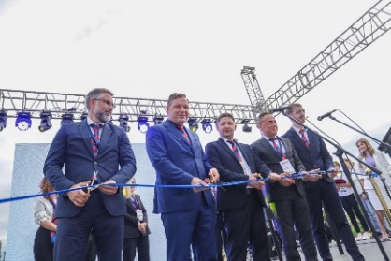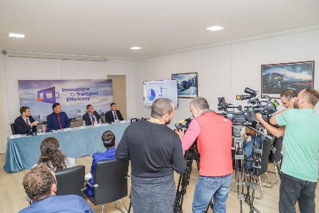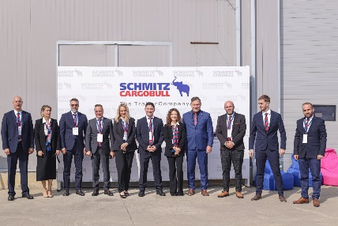
Caption: Ceremonial opening of the subsidiary in Georgia (from left): Evgenij Sajaz (Regional CFO East Europe), Boris Billich (CSO), Artem Svintsov (Country Manager Georgia), Mile Mishevski (Sales Director East Europe), Dimitri Kajaia (Sales Manager Caucasus Region)
Caption: Press conference at the opening of the new subsidiary in Georgia
Caption: The dedicated team of Schmitz Cargobull Georgia LLC

The new subsidiary TOO Schmitz Cargobull KAZ, based in Otegen-Batyr in the Almaty/Kazakhstan region, provides comprehensive support in the STAN states. The Central Asian market had already been supplied for several years by sales representatives of Schmitz Cargobull AG. Last year, the 18-strong team achieved sales of 49 million euros with over 800 vehicle units sold.

With the new subsidiary, Schmitz Cargobull can provide targeted support to transport companies in Kazakhstan and the neighbouring countries of Uzbekistan, Kyrgyzstan and Turkmenistan. This is because it is not only the sale of new and used trailers that is being further expanded by the dedicated team under the leadership of Country Manager Yuriy Tsoy. A workshop with trained personnel is available for repair or retrofit orders, and a new spare parts warehouse has been set up on site for the comprehensive and rapid supply of spare parts. Appropriate sales and presentation areas are also available for used vehicles. In addition, the service partner network, currently consisting of 12 service partners in Kazakhstan, is being continuously expanded.
Address: TOO Schmitz Cargobull KAZ, Almaty region, Ili district, Industrial zone 207 - KZ-040700 Otegen-Batyr

2023-170

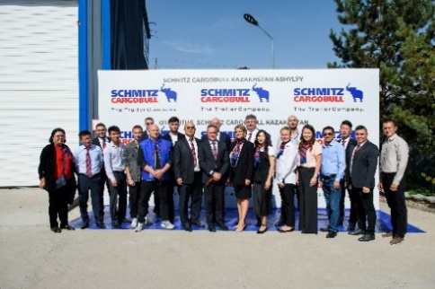 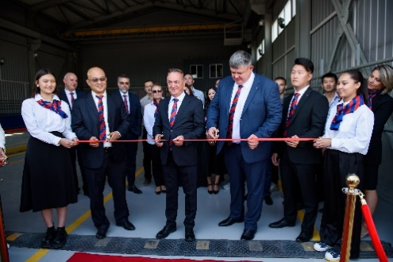
Caption: Yuriy Tsoy (9th from left) with his dedicated team
Caption: Ceremonial opening of the new subsidiary in Kazakhstan (with Country Manager Yuriy Tsoy (3rd from left) and Mile Mishevski, Sales Director East Europe, (7th from left)

About Schmitz Cargobull
With an annual production of around 57,100 trailers and with approximately 6,800 employees, Schmitz Cargobull AG is Europe’s leading manufacturer of semi-trailers, trailers and truck bodies for temperature-controlled freight, general cargo and bulk goods. The company achieved sales of around €2.6 billion in the 2022/23 financial year. As a pioneer in the industry, the North German company developed a comprehensive brand strategy early on and consistently established quality standards spanning every level: from research and development, through production and service contracts, to trailer telematics, financing, spare parts, and used vehicles.

The Schmitz Cargobull press team:
Anna Stuhlmeier +49 2558 81-1340 I anna.stuhlmeier@cargobull.com
Andrea Beckonert +49 2558 81-1321 I andrea.beckonert@cargobull.com
Silke Hesener: +49 2558 81-1501 I silke.hesener@cargobull.com

