Press Release
2023-138

Schmitz Cargobull AG

Schmitz Cargobull celebrates opening of new production facility in Zaragoza
June 2023 - More than 700 customers and partners from the transport sector gathered to celebrate the official inauguration of Schmitz Cargobull’s new plant in Figueruelas, Zaragoza (Spain) on June 1. They were able to get an on-site impression of the new, state-of-the-art assembly line.

The new plant for curtainsiders, reefer semi-trailers and dry freight semi-trailers covers a total area of around 104,000m². About 20,000m² will be used for production and logistics, office space and for the delivery of new and used vehicles. In the new assembly facility, Schmitz Cargobull produces curtainsiders S.CS, reefer semi-trailers and dry freight semi-trailers S.KO with a capacity of 60 units/day (20 units per shift) on just one production line.

Schmitz Cargobull invested around €16.6 million in the new production facility. A hi-tech photovoltaic system supplies the energy for the new production site.

"More than 20 years ago, we laid the foundation stone for our success story here in Spain with our own production facility. Now we are setting another milestone with our new assembly production line. We are planning further steps, such as the assembly of tipper trailers, a project we started only a few months ago," says Andreas Schmitz, CEO of Schmitz Cargobull.

"In our new assembly line, we need only 150 minutes from the start of production of a semi-trailer to its completion. We can decide at any time which vehicle we want to produce. If we only wanted to produce refrigerated vehicles, we were limited to six semi-trailers per day in the previous plants. Today we can produce sixty semi-trailers per day," says Plant Manager and Managing Director of Schmitz Cargobull Ibérica, Jordi Romero. "This makes us more flexible and versatile and allows us to better adapt to changes in the market and demand.”

2023-138

Miguel Iglesias, Commercial Director of Schmitz Cargobull Ibérica, says:
“We want to support our customers in the best possible way with our comprehensive range of reliable and innovative transport solutions. We can offer them a range of customised vehicles that contribute to a low total cost of ownership thanks to the high quality standard. We also provide the shortest delivery times, an extensive 24/7 spare parts supply and our proven range of services from financing to telematics and used vehicle sales. Ongoing development based on innovation and technology enables us to optimise fleet management and drive forward digitalisation.”

Schmitz Cargobull stands for reliability and innovation and guarantees consistently high quality standards worldwide, from vehicle configuration to delivery to the customer. The units manufactured in the new plant will be distributed in Spain, France, Portugal and North Africa, and in smaller numbers also in Italy, Belgium, Germany, Ukraine and Bulgaria.

When planning and building the new production facility, Schmitz Cargobull did not just focus on the production aspects. The European market leader in the semi-trailer sector placed special emphasis on environmental aspects, so that despite the increase in capacity and metres built, a 33% reduction in energy consumption was achieved. In addition, the photovoltaic system installed on the roof of the plant generates more than 33% of the total electricity consumption.

"With our commitment to the reduction of CO2 emissions, we are a benchmark in the industry. Schmitz Cargobull's position in the Spanish market has been consolidated for years, but the new installations will undoubtedly mark a turning point in terms of efficiency, safety and profitability, which will be passed on to customers. We have also recently expanded the customer service facility in Zaragoza by around 12,000m²," Iglesias added.

The Schmitz Cargobull workforce in Spain totals almost 330 employees. After reporting turnover of €160 million and annual production of 3,878 units last year, Schmitz Cargobull expects production in Spain to increase to 5,000 units in the 2023/24 financial year.

2023-138

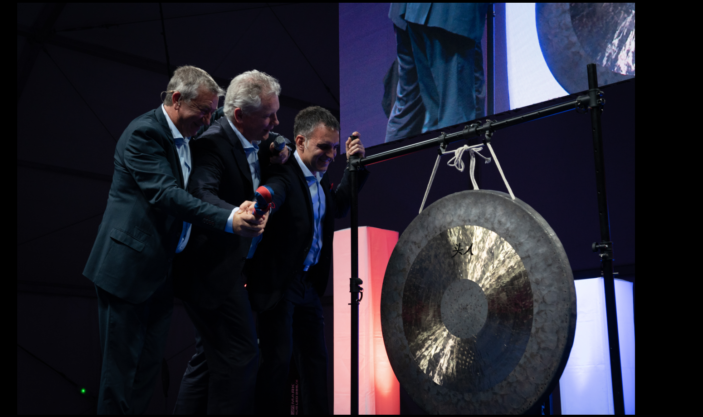
f.l.: Miguel Iglesias (Commercial Director of Schmitz Cargobull Ibérica), Andreas Schmitz (CEO Schmitz Cargobull), Jordi Romero (Managing Director Schmitz Cargobull Ibérica)

About Schmitz Cargobull
With an annual production of around 61,000 trailers and with approximately 6,900 employees, Schmitz Cargobull AG is Europe’s leading manufacturer of semi-trailers, trailers and truck bodies for temperature-controlled freight, general cargo and bulk goods. The company achieved sales of around €2.3 billion in the 2021/22 financial year. As a pioneer in the industry, the North German company developed a comprehensive brand strategy early on and consistently established quality standards spanning every level: from research and development, through production and service contracts, to trailer telematics, financing, spare parts, and used vehicles.

The Schmitz Cargobull press team:
Anna Stuhlmeier +49 2558 81-1340 I anna.stuhlmeier@cargobull.com
Andrea Beckonert +49 2558 81-1321 I andrea.beckonert@cargobull.com
Silke Hesener: +49 2558 81-1501 I silke.hesener@cargobull.com

