Press Release
2026-113

Schmitz Cargobull AG
Schmitz Cargobull honours "Service Partner of the Year 2025"
Coveted award is presented to 35 service partners in 34 countries

March 2026 – Schmitz Cargobull has awarded the "Service Partner of the Year 2025" award to 35 Service Partner companies from across Europe. This award goes to the best workshops and service centres within the Schmitz Cargobull Service Partner network.

In line with the service promise of maximum vehicle availability, Schmitz Cargobull works with authorised service partners throughout Europe. The workshops awarded "Service Partner of the Year" have impressed with their reliable and successful breakdown assistance, high workshop quality and dedicated customer service. Another key success factor is the smooth processing of service contracts and warranty cases. High availability of spare parts also ensures short downtimes, so that the trailers are quickly ready for use again.

"Our service partners make a decisive contribution to ensuring that we can deliver on our central service promise to customers – maximum trailer uptime – every day. The award-winning partners stand for high quality, fast support and lived customer proximity, both in mobile and stationary service. Together, we have further strengthened our service network and are growing together step by step, both regionally and internationally. This award impressively shows how successful cooperative partnership is for all parties involved – for us, for our service partners and, above all, for our customers," explains Britta Sprey, Managing Director of Schmitz Cargobull subsidiary Cargobull Parts & Services GmbH.

Currently, around 1,400 authorised Schmitz Cargobull Service Partners throughout Europe are available to provide services for trailers, tyres, transport refrigeration units and
telematics. Through ongoing training and instruction units, both in person and online, service partners are regularly qualified and specialised in Schmitz Cargobull products and services. For this purpose, there is the Cargobull Campus learning platform, which is
2026-113

easily accessible to service partners with one click via the Cargobull PartnerConnect platform.

Schmitz Cargobull congratulates the winners and thanks them for their excellent performance!

This year's award-winning companies are:
Austria: LENHARDT GmbH and Mossier GmbH Karosserie- und Fahrzeugbau
Bosnia/Herzegovina: SCANIA BH d.o.o Sarajevo
Belgium: Van Dyck Repair & Projects NV
Bulgaria: TT-Service OOD
Switzerland: ZIZ Reparaturwerkstatt GmbH
Czech Republic: TURBOSOL Servis, spol. s. r. o.
Germany: Auto-Scholz-AVS GmbH & Co. KG
Denmark: B&K Service Padborg A/S
Estonia: Cargoservice OÜ
Spain: REFRIP (Reparaciones Frigorificas del Poniente)
Finland: Asennustyö M Ahlqvist Oy
France: VOLVO TRUCKS CENTER
Greece: Cargocool Hellas
Croatia: FRIGO-LO
Hungary: BEST CAMION Kft.
Ireland: Mulvey Technology Ltd t/a Mulvey Refrigeration Technology
Italy: Officine Martini s.r.l.
Kazakhstan: TRUCK SERVICE KAZAKHSTAN LLP
Lithuania: Hanse Trailer UAB
Latvia: Tehpark-D SIA
Macedonia: MANI DOOEL STRUMICA
Netherlands: Arledo B.V.
Norway: TIP Trailer Service Norway
Poland: HT Trucks & Parts Poland Sp. z o.o.
Portugal: José Araújo Rebelo, Unip. Lda
Romania: RomTrailer Service SRL Sibiu
Serbia: MATIC AUTO CENTAR D.O.O.
2026-113

Sweden: STS Sydhamnens Trailer Service
Slovenia: SIGR DOO
Slovakia: STSZ Trnava
Turkey: ARTIFE SERVİSONE TİCARİ ARAÇLAR SAN. VE TİC. A.Ş.
UK: Cold Air Solutions
Ukraine: Autokomplekt LLC

More information about the winners at: https://schmitz.cargobull.com/spoty2025-en

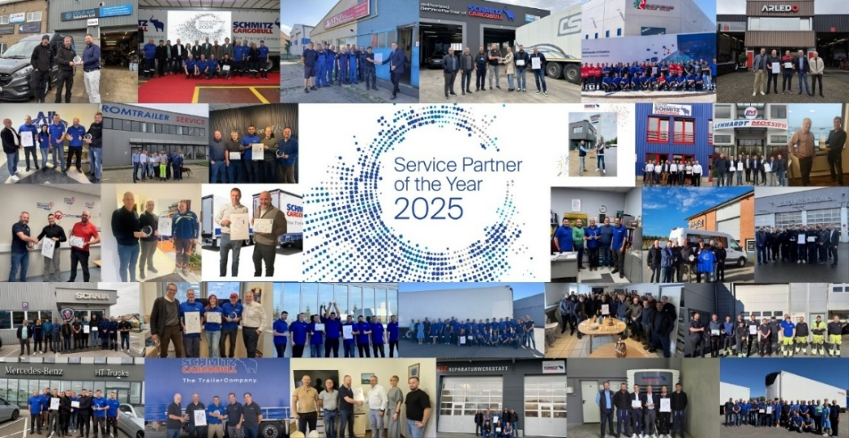
Caption: Congratulations go to Schmitz Cargobull "Service Partner of the Year 2025".

About Schmitz Cargobull
Schmitz Cargobull is the leading manufacturer of semi-trailers for temperature-controlled freight, general cargo and bulk goods in Europe, and a pioneer in digital solutions for trailer services and improved connectivity. The company also manufactures transport cooling units for refrigerated box body semi-trailers for temperature-controlled freight transport. With a comprehensive range of services from financing, spare parts supply, service contracts and telematics solutions to used vehicle trading, Schmitz Cargobull supports its customers in optimising their total cost of ownership (TCO) and digital transformation.
Schmitz Cargobull was founded in 1892 in Münsterland, Germany. The family-run company produces around 50,000 vehicles per year with over 6,000 employees and generated a turnover of around €2.16 billion in the financial year 2024/25. Its international production network is made up of factories in Germany, Lithuania, Spain, Turkey, Romania and the UK.

The Schmitz Cargobull press team:
Anna Stuhlmeier +49 2558 81-1340 I anna.stuhlmeier@cargobull.com
Andrea Beckonert +49 2558 81-1321 I andrea.beckonert@cargobull.com
Silke Hesener +49 2558 81-1501 I silke.hesener@cargobull.com

