Press Release
2026-115

Schmitz Cargobull AG
Schmitz Cargobull expands TrailerConnect® with integrated washing and parking service via partner TRAVIS

August 2026 – Schmitz Cargobull is expanding its TrailerConnect® telematics ecosystem with an integrated wash and parking service. Through a connection to the pan-European service partner TRAVIS, fleet operators now have access to digital services for trailer cleaning and scheduling centrally within the TrailerConnect® portal.

An interface to the TRAVIS app, one of the leading digital tools for truck drivers in Europe, allows users to find and book wash bays and parking spaces across Europe. Dispatchers receive a central map view in the TrailerConnect portal, showing the current location of their trailers as well as available washing and parking locations in the area – comparable to familiar map applications. All connected service points are stored in the system, including detailed information, as well as the available services such as interior and exterior washing, additional cleaning options and detailed information, such as the search for a parking space and its monitoring options. This is particularly relevant for security-sensitive cargo.

Through this integration, necessary cleaning stops can be factored into route planning. Cleaning – for example, when changing goods in accordance with GDP or HACCP specifications – can be planned, booked and documented. Time-consuming manual research and separate booking processes are no longer necessary. External services such as WashOperations are centrally orchestrated via TrailerConnect® and displayed on a common interface.

Especially in food transport, complete and verifiable cleaning of the trailers is essential. A typical example from refrigerated and fresh food logistics: when changing from meat to fruit transport, documented interior cleaning is required according to applicable

2026-115

regulations. The integrated TRAVIS connection can be used to identify and book suitable cleaning stations along the route and provide the corresponding evidence in an audit-proof manner. There is no need for manual research and separate posting steps.

Currently, bookings are made via the TrailerConnect® system, while payment processing is carried out via the TRAVIS platform, to which users are redirected to directly from TrailerConnect®. The management of cleaning certificates is also already handled via the TrailerConnect® portal. The available services and locations are already fully visible on the TrailerConnect® portal.

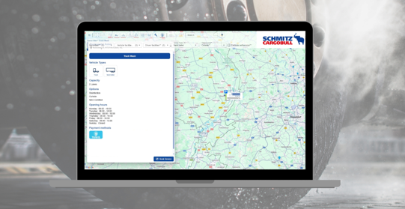

Caption: Schmitz Cargobull expands TrailerConnect® with integrated washing and parking service via partner TRAVIS

About Schmitz Cargobull
Schmitz Cargobull is the leading manufacturer of semi-trailers for temperature-controlled freight, general cargo and bulk goods in Europe, and a pioneer in digital solutions for trailer services and improved connectivity. The company also manufactures transport cooling units for refrigerated box body semi-trailers for temperature-controlled freight transport. With a comprehensive range of services from financing, spare parts supply, service contracts and telematics solutions to used vehicle trading, Schmitz Cargobull supports its customers in optimising their total cost of ownership (TCO) and digital transformation.
Schmitz Cargobull was founded in 1892 in Münsterland, Germany. The family-run company produces around 50,000 vehicles per year with over 6,000 employees and generated a turnover of around €2.16 billion in the financial year 2024/25. Its international production network is made up of factories in Germany, Lithuania, Spain, Turkey, Romania and the UK.

The Schmitz Cargobull press team:
Anna Stuhlmeier +49 2558 81-1340 I anna.stuhlmeier@cargobull.com
Andrea Beckonert +49 2558 81-1321 I andrea.beckonert@cargobull.com
Silke Hesener +49 2558 81-1501 I silke.hesener@cargobull.com

