Press Release
2026-120

Schmitz Cargobull AG
Schmitz Cargobull acquires 100% of Berger Fahrzeugtechnik

Horstmar/Radfeld, April 2026 – The shareholders of Berger Fahrzeugtechnik GmbH have decided to transfer their remaining shares to Schmitz Cargobull AG. As a result, Schmitz Cargobull, which has held a 49 per cent stake in Berger since 2024, will become the 100 per cent owner of the company. The transaction is subject to approval by the relevant competition authorities.

The decision is based on the collaboration since 2024, which has demonstrated that Berger’s expertise in lightweight construction and Schmitz Cargobull’s industrial know-how, together with its Europe-wide sales and service network, form a powerful combination. Against this backdrop, full integration was prepared as the next logical step.

In 2025, both companies jointly invested in production technology at the Radfeld site and in the development of the new Evolution Generation of BERGERecotrail. The new product line combines Berger’s weight-optimised lightweight chassis with Schmitz Cargobull’s modular and versatile body system.

Andreas Schmitz, CEO of Schmitz Cargobull AG, says: “The collaboration has demonstrated the depth of technical expertise and commitment behind Berger Fahrzeugtechnik’s products. With this acquisition, we gain Berger’s distinctive expertise in lightweight construction, which ideally complements our portfolio. For our customers, this creates an even broader range of efficient transport solutions from a single source.”

Gerhard Berger, main shareholder of BERGER Fahrzeugtechnik, explains: “The handover and integration into the Schmitz Cargobull Group provides the ideal conditions for further developing our technologies more quickly and reaching more customers in Europe. Combining our lightweight construction expertise with Schmitz Cargobull’s industrial strength and network provides a solid foundation for further growth.”

2026-120

Long-term development with a strong industrial partner
The aim of the integration is to secure and further expand Berger Fahrzeugtechnik’s specialisation in lightweight construction. Schmitz Cargobull offers the appropriate structures and framework conditions for this.

Added value for customers
For customers, this will result in an expanded range of trailers from a single source – including Berger’s lightweight construction solutions – complemented by Schmitz Cargobull’s Europe-wide sales, service, and spare parts network. Existing products, contacts and services will remain unchanged.

Subject to regulatory approval
The completion of the transaction is subject to antitrust approval by the relevant authorities.

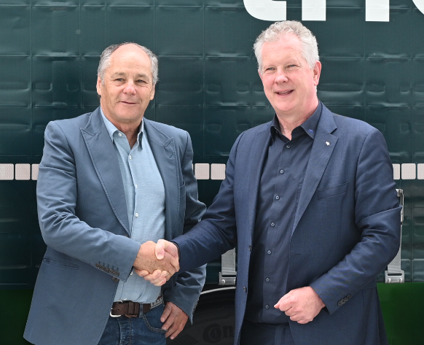
(Left): Gerhard Berger (main shareholder of Berger Fahrzeugtechnik) and Andreas Schmitz (CEO of Schmitz Cargobull AG)

About Schmitz Cargobull
Schmitz Cargobull is the leading manufacturer of semi-trailers for temperature-controlled freight, general cargo and bulk goods in Europe, and a pioneer in digital solutions for trailer services and improved connectivity. The company also manufactures transport cooling units for refrigerated box body semi-trailers for temperature-controlled freight transport. With a comprehensive range of services from financing, spare parts supply, service contracts and telematics solutions to used vehicle trading, Schmitz Cargobull supports its customers in optimising their total cost of ownership (TCO) and digital transformation.
Schmitz Cargobull was founded in 1892 in Münsterland, Germany. The family-run company produces around 50,000 vehicles per year with over 6,000 employees and generated a turnover of around €2.16 billion in the financial year 2024/25. Its international production network is made up of factories in Germany, Lithuania, Spain, Turkey, Romania and the UK.

The Schmitz Cargobull press team:
Anna Stuhlmeier +49 2558 81-1340 I anna.stuhlmeier@cargobull.com
Andrea Beckonert +49 2558 81-1321 I andrea.beckonert@cargobull.com
Silke Hesener +49 2558 81-1501 I silke.hesener@cargobull.com

