Press Release
2026-130
Schmitz Cargobull AG
Schmitz Cargobull Acquires Majority Stake in Australian Freighter Group
June 2026 – Schmitz Cargobull has increased its investment in Australian trailer manufacturer Freighter Group and now holds a 72% majority stake in the company. The transaction marks the next step in the long-term partnership between the two businesses.
The increased investment builds on the strategic partnership announced in April 2023 and underlines Schmitz Cargobull’s long-term commitment to the Australian market.
For Freighter Group, this partnership ensures long-term stability and provides direct access to Schmitz Cargobull’s global expertise and product development pipeline.
“We have been serving Australian customers for 15 years and by increasing our stake in Freighter Group, we are reaffirming our long-term commitment to the Australian market,” said Andreas Schmitz, CEO of Schmitz Cargobull. “This step is also testament to our belief in the strength of the local team. Our role is to support and enable the continued development of Freighter Group — providing access to global expertise, technology and networks, while the Freighter team continues to shape the business with its deep local knowledge and customer focus.”
The majority acquisition builds on significant recent investments, including the $50 million upgrade of the Ballarat manufacturing facility, transforming it into a modern, advanced production hub.
This infrastructure enables Freighter Group to seamlessly integrate Schmitz Cargobull’s global engineering and production technologies with proven Australian-built durability.
Beyond manufacturing, the business continues to strengthen its aftermarket service and parts network, ensuring customers benefit from increased uptime and access to both local and global parts supply chains.
Freighter Group also announces the appointment of Michael Temminghoff as the new Chief Executive Officer, effective immediately. He brings extensive leadership experience, having
2026-130
worked for Schmitz Cargobull in multiple roles for over 15 years. He is focused on supporting the continued development of Freighter Group, strengthening its capabilities while preserving the company’s customer-first culture.
“I am honoured to lead Freighter Group at such a pivotal moment,” said Michael. “The synergy between Schmitz Cargobull’s global scale and Freighter Group’s local expertise is an exciting opportunity. Our role is to build on the strengths of the local business, supported by global capabilities and experience, and to help the team unlock its full potential – while further strengthening the quality and reliability our customers expect.”
“The business enters this new chapter on a strong footing, thanks to a period of intense modernisation that has prepared the workforce and the facility for high-tech production,” said Michael. Adding that the dedication of the local team has been the driving force behind this transformation, laying the foundations necessary to thrive in an evolving market.
Freighter Group will continue to operate under its renowned name, ensuring that the legacy of this iconic Australian brand remains intact as it builds the next generation of solutions for the Australian transport industry.
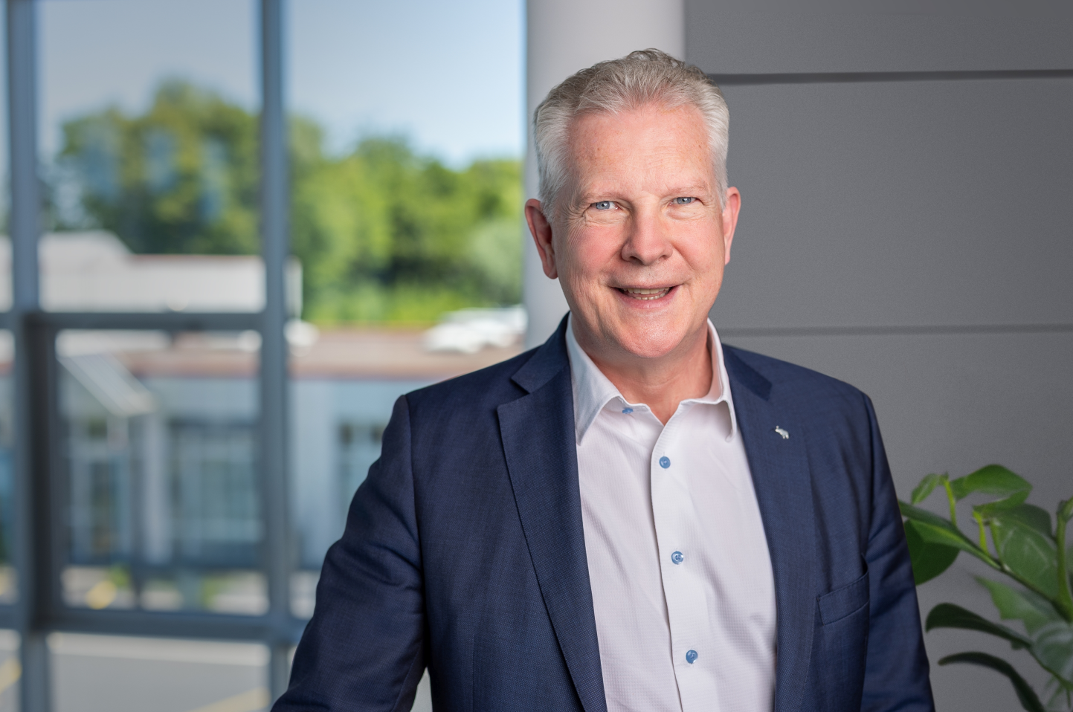
Andreas Schmitz, CEO Schmitz Cargobull
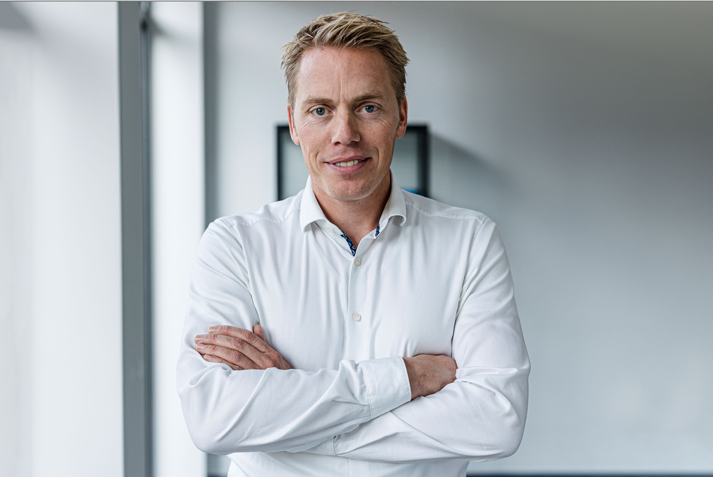
Michael Temminghoff, CEO Freighter Group

2026-130
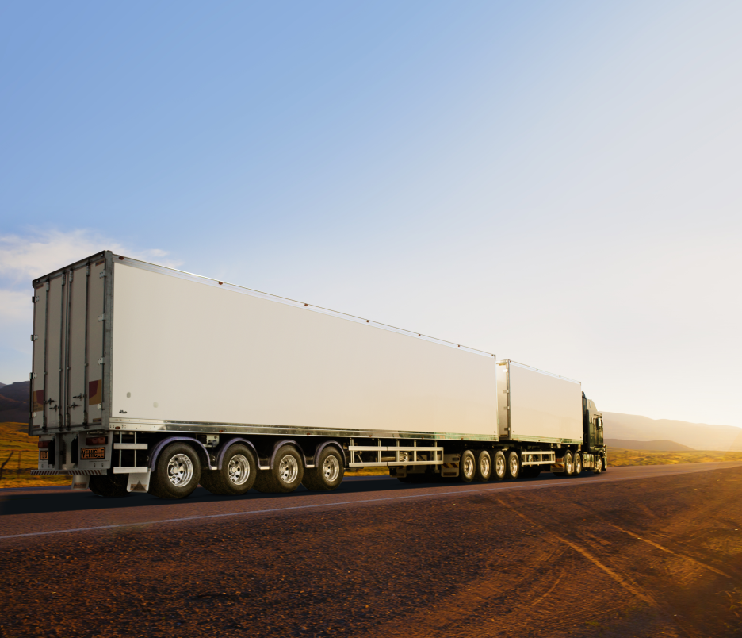
Freighter Maxi-CUBE Reefer

About Schmitz Cargobull
Schmitz Cargobull is the leading manufacturer of semi-trailers for temperature-controlled freight, general cargo and bulk goods in Europe, and a pioneer in digital solutions for trailer services and improved connectivity. The company also manufactures transport cooling units for refrigerated box body semi-trailers for temperature-controlled freight transport. With a comprehensive range of services from financing, spare parts supply, service contracts and telematics solutions to used vehicle trading, Schmitz Cargobull supports its customers in optimising their total cost of ownership (TCO) and digital transformation. Schmitz Cargobull was founded in 1892 in Muensterland, Germany. The family-run company produces around 50,000 vehicles per year with over 6,000 employees and generated a turnover of around € 2.16 billion in the financial year 2024/25. Its international production network is made up of factories in Germany, Lithuania, Spain, Turkey, Romania and the UK.
About Freighter Group
Freighter Group is a leading supplier of locally manufactured, heavy duty road transport trailer solutions, including trailer repairs, parts and service in Australia.
Synonymous with road transport in Australia through the manufacture of market leading brands Freighter, Maxi-CUBE, Lusty EMS, Hamelex White and Trout River, as well as the exclusive distribution of AZMEB, Freighter Group is the leading supplier of road transport equipment for the general freight, temperature-controlled freight and bulk transport market sectors.
To find out more about Freighter Group and its products, visit: www.freighter.com.au

For further information, please contact:
Schmitz Cargobull:
Anna Stuhlmeier +49 2558 81-1340 I anna.stuhlmeier@cargobull.com
Andrea Beckonert +49 2558 81-1321 I andrea.beckonert@cargobull.com
Silke Hesener +49 2558 81-1501 I silke.hesener@cargobull.com
Freighter Group:
Rick Challons
Marketing & Communications Manager
233-243 Learmonth Rd Wendouree VIC 3355
+61 3 5339 0300
rick.challons@freighter.com.au

