Press Release
2024-108

Schmitz Cargobull AG
Schmitz Cargobull selects its "Service Partners of the Year 2023"
Coveted award will be presented in 33 countries this year

February 2024 - Schmitz Cargobull has selected the best workshops and service centers from 33 countries in its Service Partner network for 2023.

The best workshop quality and customer service are the prerequisites for the coveted award. The partner workshop must deliver outstanding results, particularly in the "Breakdown assistance" and "Spare parts business development" assessment categories. Optimum cooperation in the handling of full-service contracts and warranty cases also has a major influence on the choice of Service Partner of the Year.

Schmitz Cargobull customers benefit from a comprehensive network of authorised and trained service partners in over 40 countries. At the same time, workshop customers have the advantage of well-trained service technicians specialising in Schmitz Cargobull products, who are regularly trained online or in person at the Cargobull Campus. This ensures the mobility of the vehicle fleet and minimises downtime. This applies to all workshop services, whether that’s related to the trailer, the tyres, the refrigeration units or the TrailerConnect® telematics system.
Above all, the acceptance rate of mediated breakdowns, but also the availability of spare parts and joint business development are important and are included in the evaluation. 33 Service Partner companies across Europe were named Schmitz Cargobull Service Partners of the Year in 2023. These workshops, in particular, and the teams that work for Schmitz Cargobull customers every day make Schmitz Cargobull a strong and reliable brand for service customers.

2024-108

Schmitz Cargobull congratulates the winners and thanks them for their excellent cooperation!

The winners are:
Austria: TIP Trailer Services Austria GmbH
Bosnia/Herzegovina: Transkop d.o.o. Tuzla, P.J. Truck - Service
Belgium: Trailer Service Lecluyse nv
Bulgaria: Intercamion Company EOOD
Switzerland: Etter's FrigoService
Czech Republic: Hoffmann & Žižák spol. s r.o.
Germany: Leven Nutzfahrzeuge GmbH & Co. KG
Denmark: Dansk Køleservice ApS
Estonia: Cargoservice OÜ
Spain: Talleres Pamendi S.L.
Finland: Helsingin Autokylmä Oy
France: Scania Alsace France S.A.S
Great Britain: J M Refrigeration
Greece: CargoCool Hellas
Croatia: Frigo-Lo
Hungary: He-Ge Kft.
Ireland: Mulvey Refrigeration Technology
Italy: Officina Alberti SRL
Kazakhsta: RTB Service-Center
Lithuania: Hanse Trailer UAB
Latvia: TEHPARK-D SIA
Macedonia: Truck Boss Dooel
Netherlands: Bouwheer Zeewolde B.V.
Norway: IPS Skala Service AS
Poland: KM Serwis W. Kożuchowski - J. Marciniak Spółka Komandytowa
Portugal: Confortruck
Romania: Trans Dan Mir S.R.L.
Serbia: Braca Crnomarkovic d.o.o.
2024-108

Sweden: HBG Transportkyla AB
Slovenia: SIGR d.o.o.
Slovakia: Central Europe Trailer s.r.o.
Turkey: DMS-AKTAŞ OTOMOTİV NAK.MAK.İNŞ.SAN.VE TİC.LTD.ŞTİ
Ukraine: Autokomplekt Ltd

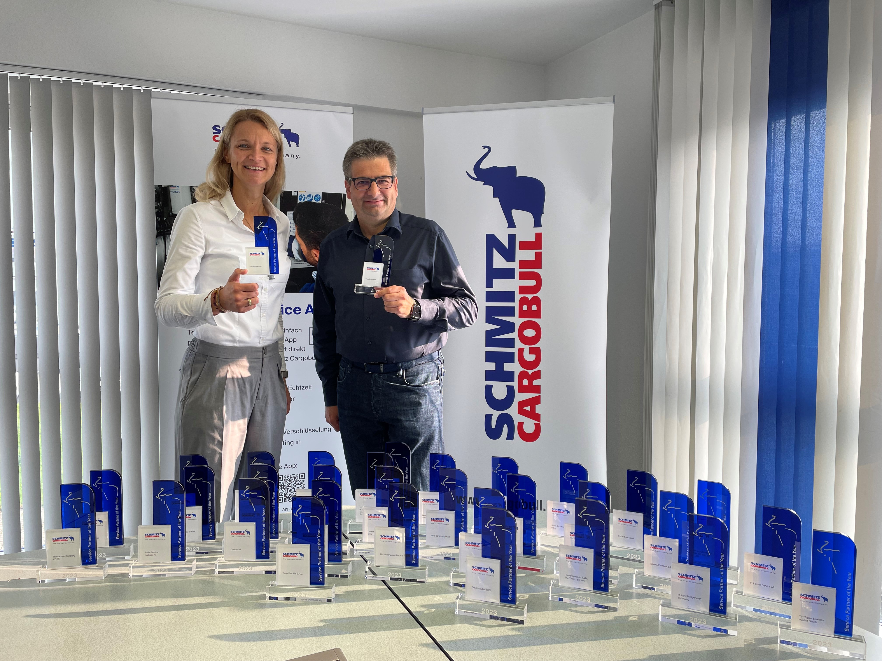
Caption: Britta Sprey, Managing Director Aftersales and Christoph Dehne, Director Aftersales - Service Net are delighted with the award winners

About Schmitz Cargobull
Schmitz Cargobull is the leading manufacturer of semi-trailers for temperature-controlled freight, general cargo and bulk goods in Europe and a pioneer in digital solutions for trailer services and improved connectivity. The company also manufactures transport refrigeration machines for refrigerated semi-trailers for temperature-controlled freight transport. With a comprehensive range of services from financing, spare parts supply, service contracts and telematics solutions to used vehicle trading, Schmitz Cargobull supports its customers in optimising their total cost of ownership (TCO) and digital transformation. Schmitz Cargobull was founded in 1892 in Münsterland, Germany. The family-run company produces around 60,000 vehicles per year with over 6,000 employees and generated a turnover of around 2.6 billion euros in the 2022/23 financial year. The international production network currently comprises ten plants in Germany, Lithuania, Spain, England, Turkey, Slovakia and Australia.

The Schmitz Cargobull press team:
Anna Stuhlmeier +49 2558 81-1340 I anna.stuhlmeier@cargobull.com
Andrea Beckonert +49 2558 81-1321 I andrea.beckonert@cargobull.com
Silke Hesener +49 2558 81-1501 I silke.hesener@cargobull.com

