Press Release
2025-306

Schmitz Cargobull AG
New standards in trailer lightweight construction
BERGER Fahrzeugtechnik and Schmitz Cargobull present the new Evolution generation, featuring the lightweight BERGERecotrail® chassis combined with a functional Schmitz Cargobull body.

June 2025 – Working in close cooperation with Schmitz Cargobull, BERGERecotrail® has created an innovative product family. The BERGER PerformanceCoil made its debut as the first model of the Evolution generation at the transport logistic trade fair in Munich in June.
The entry-level version of the new Performance generation starts from an unladen weight of 4.8 tonnes. The new generation trailers are among the lightest lightweight vehicles available on the market and are designed for maximum payload and efficiency. With the certified, universal Schmitz Cargobull body, the trailers are suitable for a wide range of industry applications, including beverage, automotive and tyre transportation, as well as chemical (octabin) and grain transportation.
The focus: Lightweight construction
“Lightweight, high-precision, hand-crafted – these aren’t trends. They’re part of our DNA.
We are driven by the search for better solutions. Together with Schmitz Cargobull, we have combined the best of two worlds – our ultra-light chassis and the extremely functional body created by the market leader,” explains Berger, entrepreneur, pioneer in lightweight construction and co-founder of BERGERecotrail.
It was Berger who managed to attract Oliver Hoffmann, former Chief Technical Officer at AUDI AG, to the project. Hoffmann is now bringing his experience and skills in innovation to BERGERecotrail in his role as managing director. “Technology has to make a difference. And that’s exactly what this trailer does – for transport companies, for drivers and for the environment,” says Hoffmann.
PerformanceCoil – Redefining efficiency
With is 8,200 mm long coil trough, the PerformanceCoil is specifically designed for transporting steel and metal coils, accommodating coils with a diameter from 800 to 2,100 mm. Thanks to its high-strength S700 fine grain steel, an optimised frame design based on the Reuleaux triangle and high-precision “Made in Tyrol” welding techniques, the chassis offers maximum stability with a minimum unladen weight.

2026-306
When combined with the optional POWER CURTAIN from Schmitz Cargobull – a tarpaulin with built-in aramid belts for certified structural rigidity – you get a trailer that offers a maximum payload of 27.5 tonnes (depending on the equipment and tractor unit) and thus reduces fuel consumption and carbon emissions.
Flexible and reliable – Schmitz Cargobull’s POWER CURTAIN body
Berger’s many years of experience in light-weight chassis and Schmitz Cargobull’s extensive expertise in the area of modular bodies generate significant customer benefits and enable vehicles to be used in a wide variety of applications.
When equipped with the POWER CURTAIN body, the vehicle is particularly well suited to meeting demands for efficiency and fast unloading. Without support laths, the body meets the rigidity requirements for certification according to DIN EN 12642 Code XL, including beverage certification. To meet these criteria, the side tarpaulins are equipped with vertical and horizontal reinforcements and also come with built-in anti-theft fabric as standard. This enables the vehicle to be loaded and unloaded quickly and easily without any time-consuming handling, while the lack of side laths helps to reduce the trailer weight.
Berger’s new generation of Evolution vehicles provide our customers with a wide range of bodies, therefore ensuring that there is the ideal solution for a wide range of transport requirements: conventional load securing certificates in accordance with EN 12642 XL along with additional certificates for beverage, automotive and tyre transportation and a certificate for chemical (octabin) and grain transportation. These certificates guarantee the highest standards of safety and quality.
Simple handling and reliable durability are available through a variety of body options, including the safety roof, POWER CURTAIN, VARIOS system and anodised aluminium front and rear panels with galvanised corner posts. These features contribute to a robust and durable design and also enable customers to meet a wide array of industry requirements.

2026-306
Technology meets service
The trailer is embedded within Schmitz Cargobull’s comprehensive eco-system: With TrailerConnect® telematics, bespoke financing options, 24h spare parts supply and a Europe-wide service network with over 1,400 partners, the cooperation not only has a product to offer, but a comprehensive solution for the future of transport logistics.
An overview of the new portfolio
In addition to the PerformanceCoil, the new product family also includes models for high-volume, construction material and pallet transportation – all based on the same, scalable lightweight construction concept.

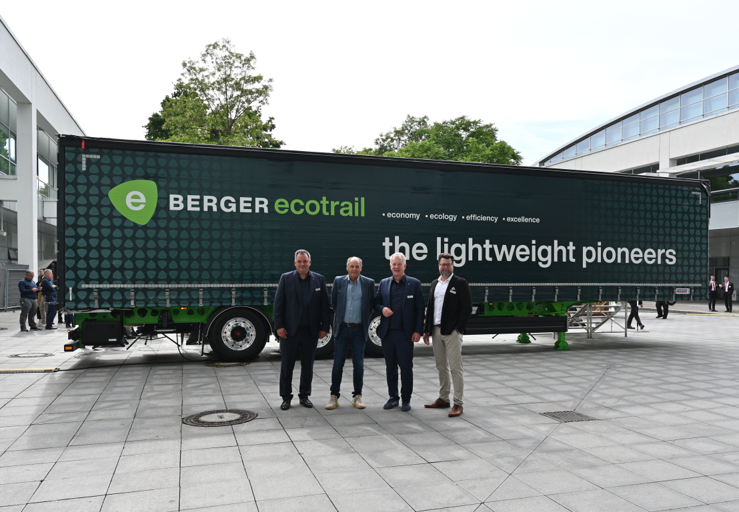
Caption: f.l. Ralph Kleideiter (CSO at Schmitz Cargobull), Gerhard Berger (co-founder of BERGERecotrail), Andreas Schmitz (CEO at Schmitz Cargobull) and Oliver Hoffmann (Managing Director of BERGERecotrail)

2025-306

About BERGERecotrail
The lightweight pioneers
Based in Tyrol, BERGERecotrail has spent the past 60+ years developing innovative lightweight chassis for European freight transport. The company embodies precision, efficiency and genuine hand-crafted quality – from the initial idea to the finished product.

About Schmitz Cargobull
Schmitz Cargobull is the leading manufacturer of semi-trailers for temperature-controlled freight, general cargo and bulk goods in Europe, and a pioneer in digital solutions for trailer services and improved connectivity. The company also manufactures transport cooling units for refrigerated box body semi-trailers for temperature-controlled freight transport. With a comprehensive range of services from financing, spare parts supply, service contracts and telematics solutions to used vehicle trading, Schmitz Cargobull supports its customers in optimising their total cost of ownership (TCO) and digital transformation.
Schmitz Cargobull was founded in 1892 in Münsterland, Germany. The family-run company produces around 60,000 vehicles per year with over 6,000 employees, and generated a turnover of around €2.4 billion in the 2023/24 financial year. The international production network currently comprises ten plants in Germany, Lithuania, Spain, England, Turkey, Slovakia and Australia.

The Schmitz Cargobull press team:
Anna Stuhlmeier +49 2558 81-1340 I anna.stuhlmeier@cargobull.com
Andrea Beckonert +49 2558 81-1321 I andrea.beckonert@cargobull.com
Silke Hesener +49 2558 81-1501 I silke.hesener@cargobull.com

