Press Release
2026-118

The Schmitz Cargobull AG
Schmitz Cargobull is the first trailer manufacturer to offer a certified trailer telematics system for Türkiye
April 2026 – Schmitz Cargobull has started offering its proven TrailerConnect® telematics system in a version certified specifically for the Turkish market. This provides transport companies operating in Türkiye or engaged in cross-border transportation with a fully approved and reliable solution for digital monitoring and control of trailer fleets.

Schmitz Cargobull equipped the product ranges with the TrailerConnect® telematics system as standard. The telematics system and its various services are tailored to the specific requirements of each transport task and vehicle. To date, more than 305,000 telematics units have been sold.

However, approval in individual countries requires compliance with country-specific regulatory requirements. In Türkiye, specific regulations governing the operation of telematics systems; these include the mandatory use of Turkish SIM cards and the transmission of data through servers controlled by national authorities.

"With the country-specific adaptation of TrailerConnect®, we guarantee the use of fully compliant and high-performance telematics for our customers in Türkiye," says Dr. Cafer İnce, Head of Product Line Digital Services at Schmitz Cargobull. "Compliance with BTK (Information and Communication Technologies Authority) requirements gives transport companies the necessary assurance to efficiently manage their fleets with real-time data and reliably meet all legal requirements."

TrailerConnect® – The platform for efficient and transparent fleet management
For shippers and logistics companies, cargo safety and smooth monitoring of the transportation process are of utmost importance. Accordingly, the importance of reliable real-time data along the entire logistics chain is increasing. TrailerConnect® provides a strong basis for this, enabling optimal control of networked transport processes,

2026-118

while also contributing significantly to increased efficiency and reduced total cost of ownership (TCO).

Schmitz Cargobull Türkiye has grown steadily since 2017
Kerem Taş, Managing Director of Schmitz Cargobull Türkiye, highlights the continuous growth of the plant in Sakarya-Erenler, which has been in operation since 2017. He emphasises that the product portfolio is being continuously expanded every year through new projects and developments. “Today, the plant is one of only two Schmitz Cargobull plants worldwide that produce Schmitz Cargobull axles. It is also the only plant manufacturing Schmitz Cargobull container chassis for markets worldwide,” says Taş.

Strong market position in Türkiye
Murat Tokatlı, Head of Sales and Marketing at Schmitz Cargobull Türkiye, highlights the strong performance of the Turkish semi-trailer market in recent years.
“Our S.CU transport refrigeration units are designed for all types of transport. With over 38,000 units sold, we are underlining our strong position in temperature-controlled transport and the cold chain. Furthermore, according to data from the Turkish Heavy Commercial Vehicle Manufacturers’ Association (TAID), the preference for two out of every three refrigerated semi-trailers sold in Türkiye has remained unchanged. This confirms that Schmitz Cargobull has been consolidating its leading position in this sector for years,” adds Tokatlı.

Increased efficiency, safety and sustainability
TrailerConnect® collects all relevant information from the trailer and transport refrigeration units – including position, EBS data, tyre pressure, door status, temperature data and other technical parameters – and transmits it to the TrailerConnect® portal in real time. This provides dispatchers with a reliable data set to make optimal use of capacities and avoid empty runs. Individual alarms and configurations in the portal make it easier to control the entire fleet. Historical data also helps with preventive maintenance planning. Early indications of wear and tear or abnormalities reduce unplanned downtime, shorten service stops and increase the availability of the vehicles. In addition to improving operational processes, TrailerConnect® also enhances safety and sustainability in daily transportation.

2026-118

In the event of deviations from predetermined routes or safety-related incidents, those responsible are promptly notified, significantly enhancing operational safety. At the same time, better trailer utilisation and reduced empty trips enable companies to operate more efficiently and with lower emissions. The tyre pressure monitoring functions also make an important contribution by reducing fuel consumption and thus significantly lowering CO₂ emissions. Furthermore, TrailerConnect® creates a high degree of transparency in overall fleet management through real-time data, reliable documentation, and structured reporting.

This enables well-informed operational and strategic decisions and supports transportation companies in optimising their processes sustainably.
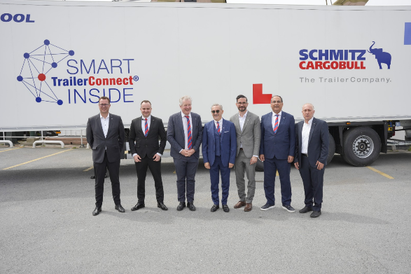

f. l. Dominik Henne (Director Procurement, Schmitz Cargobull AG, Ibrahim Sari (Product Marketing Manager, Schmitz Cargobull Türkiye), Andreas Schmitz (CEO, Schmitz Cargobull AG), Kerem Tas (Managing Director, Schmitz Cargobull Türkiye), Dr. Cafer Ince (Head of Product Line Digital Services, Schmitz Cargobull AG), Murat Tokatli (Head of Sales and Marketing, Schmitz Cargobull Türkiye), Mehmet Dinçer (Director Aftersales, Schmitz Cargobull Türkiye)
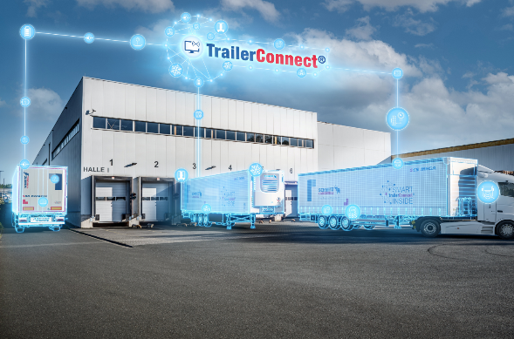
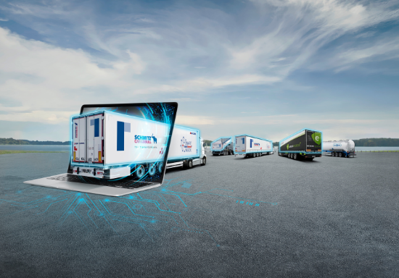

About Schmitz Cargobull
Schmitz Cargobull is the leading manufacturer of semi-trailers for temperature-controlled freight, general cargo and bulk goods in Europe, and a pioneer in digital solutions for trailer services and improved connectivity. The company also manufactures transport cooling units for refrigerated box body semi-trailers for temperature-controlled freight transport. With a comprehensive range of services from financing, spare parts supply, service contracts and telematics solutions to used vehicle trading, Schmitz Cargobull supports its customers in optimising their total cost of ownership (TCO) and digital transformation.
Schmitz Cargobull was founded in 1892 in Münsterland, Germany. The family-run company produces around 50,000 vehicles per year with over 6,000 employees and generated a turnover of around €2.16 billion in the financial year 2024/25. Its international production network is made up of factories in Germany, Lithuania, Spain, Türkiye, Romania and the UK.

The Schmitz Cargobull press team:
Anna Stuhlmeier +49 2558 81-1340 I anna.stuhlmeier@cargobull.com
Andrea Beckonert +49 2558 81-1321 I andrea.beckonert@cargobull.com
Silke Hesener +49 2558 81-1501 I silke.hesener@cargobull.com

