Press Release
2026-502

Schmitz Cargobull AG
The new S.BO MULTI: dry freight semi-trailer for changing transport requirements

January 2026 - With the S.BO MULTI, Schmitz Cargobull is expanding its dry freight portfolio with a versatile semi-trailer for frequently changing transport tasks. The newly developed dry freight semi-trailer is suitable for a wide range of loads - from palletised goods and general cargo to accommodating hanging clothing, vehicle parts and bulky or loose goods. This makes the S.BO MULTI particularly suitable for use in logistics centres, production sites and industrial applications with changing load and load securing requirements.

The central feature of the S.BO MULTI is the integrated double-decker system with keyhole plates, which enables higher utilisation with different loads. Aluminium double-decker rails with a length of 2,050mm and a spacing of 1,200mm enable the use of a second loading level. This allows up to 33 additional Euro pallets to be transported. The keyhole plates arranged between the rails allow flexible and precisely positioned load securing, and support numerous securing systems such as locking beams, clothes rails, tension belts or nets.

The side walls consist of a robust two-shell steel construction with reinforced pillars. While one pillar supports the double-decker rails, a second is used to mount galvanised keyhole plates and creates additional securing points. The galvanisation increases corrosion resistance compared to painted components and reduces wear and tear and the need for repairs in the long term. In addition, the keyholes are reinforced with a fully pronounced curvature to ensure a high load-bearing capacity even under intensive use.

As part of Schmitz Cargobull's modular dry freight system, the S.BO MULTI uses proven components from the S.BO EXPRESS, including a front wall made of aluminium planks, an insulated roof and continuous steel connecting profiles that link all body parts together. Aluminium doors or an optional aluminium roller shutter door from Schmitz Cargobull are

2026-502

available for the rear. The body can be supplemented with type B double-decker rails, steel base scuff plate or optional aluminium scuff plate.

The body is certified in accordance with DIN EN 12642 Code XL (payload 27,000kg). A modular, bolted and galvanised construction in a rolled design is available for the chassis, which is designed for standard transport requirements. For demanding applications and markets with permissible gross train weights of 44 tonnes or more, the X-TOUGH heavy-duty chassis is available as an option. The TrailerConnect® telematics system for the transparent display of trailer data is also integrated as standard.

The S.BO MULTI is also designed for cost-effectiveness when it comes to servicing. Repairs can be carried out using standard tools as well as glueing and riveting techniques, which supports short downtimes, low maintenance costs and high availability in fleet use. The body also contributes to more sustainable transport solutions, as the use of glueing and folding processes instead of conventional welding technology reduces energy requirements in production and lowers CO₂ emissions.

With its flexible design and high transport capacity, the S.BO MULTI offers an efficient, durable and future-orientated solution for demanding dry freight applications.
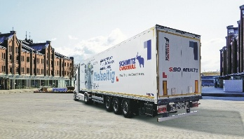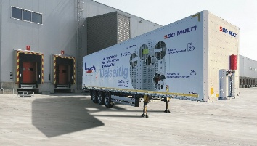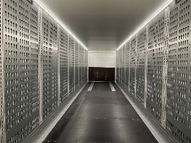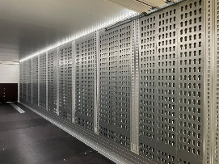
The new Schmitz Cargobull dry freight semi-trailer S.BO MULTI.

About Schmitz Cargobull
Schmitz Cargobull is the leading manufacturer of semi-trailers for temperature-controlled freight, general cargo and bulk goods in Europe, and a pioneer in digital solutions for trailer services and improved connectivity. The company also manufactures transport cooling units for refrigerated box body semi-trailers for temperature-controlled freight transport. With a comprehensive range of services from financing, spare parts supply, service contracts and telematics solutions to used vehicle trading, Schmitz Cargobull supports its customers in optimising their total cost of ownership (TCO) and digital transformation.
Schmitz Cargobull was founded in 1892 in Münsterland, Germany. The family-run company produces around 50,000 vehicles per year with over 6,000 employees and generated a turnover of around €2.16 billion in the financial year 2024/25. Its international production network is made up of factories in Germany, Lithuania, Spain, Turkey and the UK.

The Schmitz Cargobull press team:
Anna Stuhlmeier +49 2558 81-1340 I anna.stuhlmeier@cargobull.com
Andrea Beckonert +49 2558 81-1321 I andrea.beckonert@cargobull.com
Silke Hesener +49 2558 81-1501 I silke.hesener@cargobull.com

