Press Release
2023-129

Schmitz Cargobull AG
Schmitz Cargobull’s requirements engineering gains IREB recognition

Department in E/E Systems Engineering receives silver status from the International Requirements Engineering Board

May 2023 - Schmitz Cargobull's requirements engineering has been awarded silver status by the International Requirements Engineering Board (IREB).
This status confirms the professional communication, validation and organisation of requirements to provide added value benefits to customers. It recognises the high level of qualification of the requirements engineering staff.

To survive in the challenging world of transport and logistics, reliable, innovative and sustainable vehicles and services are essential. Schmitz Cargobull has strengthened its technological competence in recent years and further expanded the E/E area (electric-electronic development) to optimally implement these market and vehicle requirements for the customer.

Requirements engineering is an integral part of these development processes - from the initial innovation idea to the production-ready vehicle - and works hand in hand with product management and product architecture. To ensure the vehicles deliver the desired added value and benefits to the customer, the strategic requirements from product management are transformed into stakeholder, system and subsystem requirements in development projects.

Today, Schmitz Cargobull is no longer just a vehicle manufacturer but a system developer and provider that can offer customers everything from a single source. Examples of this are its many digital services, the high degree of automation in vehicle handling and the all-electric S.KOe COOL refrigerated box.

2023-133

The IREB is a non-profit organisation and the developer of the CPRE (Certified Professional for Requirements Engineering) certification model for employees in the fields of requirements engineering, business analysis, and software and systems development.
The board members are independent and internationally recognised experts from industry, consulting, research, and teaching. Schmitz Cargobull’s silver status is monitored by the IREB through certification audits.

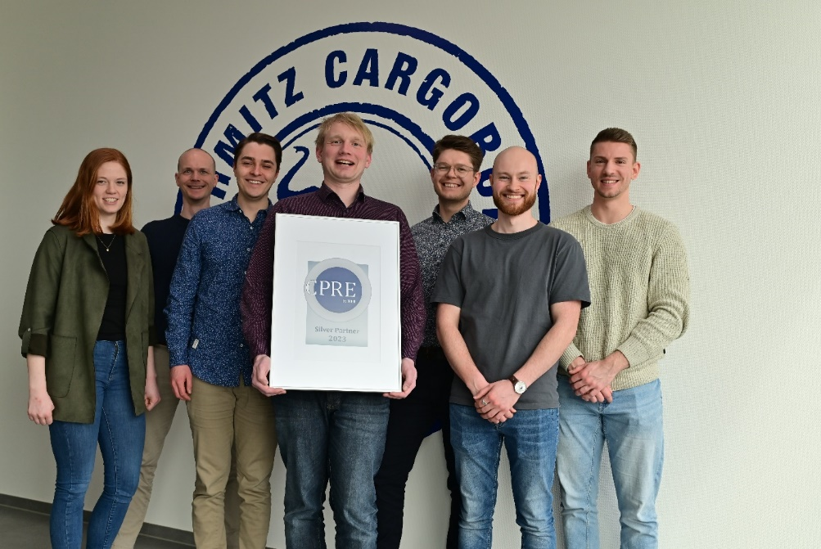
(f.l.) Anna Fißmann, Thomas Feldevert, Fabian van den Boom, Bernd Weyring, Maximilian Kemper, Philipp Fremann,
Oliver Scholz (Missing from the picture is Thorsten Berg)

About Schmitz Cargobull
With an annual production of around 61,000 trailers and with approximately 6,900 employees, Schmitz Cargobull AG is Europe’s leading manufacturer of semi-trailers, trailers and truck bodies for temperature-controlled freight, general cargo and bulk goods. The company achieved sales of around €2.3 billion in the 2021/22 financial year. As a pioneer in the industry, the North German company developed a comprehensive brand strategy early on and consistently established quality standards spanning every level: from research and development, through production and service contracts, to trailer telematics, financing, spare parts, and used vehicles.

The Schmitz Cargobull press team:
Anna Stuhlmeier +49 2558 81-1340 I anna.stuhlmeier@cargobull.com
Andrea Beckonert +49 2558 81-1321 I andrea.beckonert@cargobull.com
Silke Hesener: +49 2558 81-1501 I silke.hesener@cargobull.com

