Press Release
2025-158

Resilient and future-ready
Despite a decline in revenues and profits in what was a challenging financial year (2024/25), Schmitz Cargobull is demonstrating its resilience by investing in innovative technology and production capacities
      - Market share in Europe increased to 25% – Schmitz Cargobull remains the leading trailer manufacturer
      - Strategy 2030 underway – Focus on efficient customer solutions and sustainable profitability
      - Changes on the Management Board – Ralph Kleideiter becomes new Chief Sales Officer (CSO); Marnix Lannoije’s Management Board mandate extended for a further five years

September 2025 – In its ordinary general meeting on 23 September 2025, the Schmitz Cargobull AG Supervisory Board finalised the consolidated financial statements for financial year 2024/25 (1 April 2024 to 31 March 2025).
The financial year was shaped by a challenging market environment with ongoing investment restraint, excess capacity in this sector, and increasing cost and regulatory pressure. As a result of these underlying conditions, production volumes fell by around 6.5% to 42,353 units (previous year: 45,340 units).

Despite a drop in unit sales, Schmitz Cargobull – which employs approx. 6,400 people – was able to expand its share in the declining European trailer market to 25%, defending its position as the undisputed leader in the sector.

Decline in revenue and profits coinciding with high investment in innovative technology and production capacities
Due to the fall in unit sales, revenue decreased by 10.2% to around €2.16bn compared to the previous year. Increased costs for energy, staff and regulatory requirements placed significant strain on the consolidated group result, which came in at a level of around €1m.
“Despite the significant economic pressure, we have invested specifically in measures to increase productivity, as well as in research and development. Our goal is to provide our
2025-158
customers with reliable and economic transport solutions to help them run profitable businesses,” explains Andreas Schmitz, Chairman of the Board of Schmitz Cargobull AG. “Our products and services have to be a response to the challenges faced by our customers in their day-to-day business operations.”

In the previous financial year, Schmitz Cargobull invested over €73m in product development, the production network, and in digitalisation, automation, and sustainability. Over the next few years, more than €50m will be invested in the expansion of production capacities for refrigerated semi-trailers and box body vehicles at the Vreden site. At the heart of these plans is a new production hall equipped with cutting-edge technology and automated processes, which will enable capacity to be increased to 40 refrigerated vehicles per shift. At the same time, the cycle time per trailer will drop from 15 to 10 minutes – equivalent to an efficiency gain of around one third. An additional €13m will be invested in upgrades to the foaming machinery.

Strategy 2030 underway
At the end of financial year 2024/25, Schmitz Cargobull set its course for the future with the conclusion of its Strategy 2025. With the development of its new Strategy 2030, the company will continue to pursue its ambitious economic goals with adjusted measures and refine them even further. Under the motto Delivering profitable growth. Together. Focused. Sustainable., Schmitz Cargobull aims to continue improving its competitiveness and profitability, achieve its sustainability targets and act as a best-practice partner for its customers. All of this is based upon reliability, fair business relationships, and corporate responsibility.

International cooperation as a driver of growth
To strengthen its international business, Schmitz Cargobull relies on strategic cooperation. The goal is to offer high-quality solutions that have been adapted to local markets around the world, while also ensuring low operating costs, impressive durability, and strong resale values. Since January 2024, the lightweight BERGERecotrailer including Schmitz Cargobull Services has been available through the European sales network. Additional cooperation has taken place with Atlantis Global System to expand telematics solutions for cooling chains, with GT Trailers for curtainsider bodies for tractors and trailers, and with other project partners. Furthermore, Schmitz Cargobull and its partner GRW acquired the tanker arm of Van Hool during the period.
2025-158

Changes to the Management Board and Supervisory Board
On 1 April 2025, Ralph Kleideiter was appointed as the Management Board’s new CSO. He had been managing the division on an interim basis since August 2024. Marnix Lannoije, Chief Technology Officer (CTO), who is responsible for Research & Development, had his position on the Management Board extended early for an additional five years at the end of financial year 2024/25. Lannoije was actively involved in various developments, including the acquisitions of Van Hool and the Spanish telematics specialists AGS, Atlantis Global System.
Bernhard Schmitz was welcomed as a new member of the Supervisory Board on 24 September 2024. Schmitz is a shareholder, member of the Schmitz Cargobull Family Council and renowned industry expert.

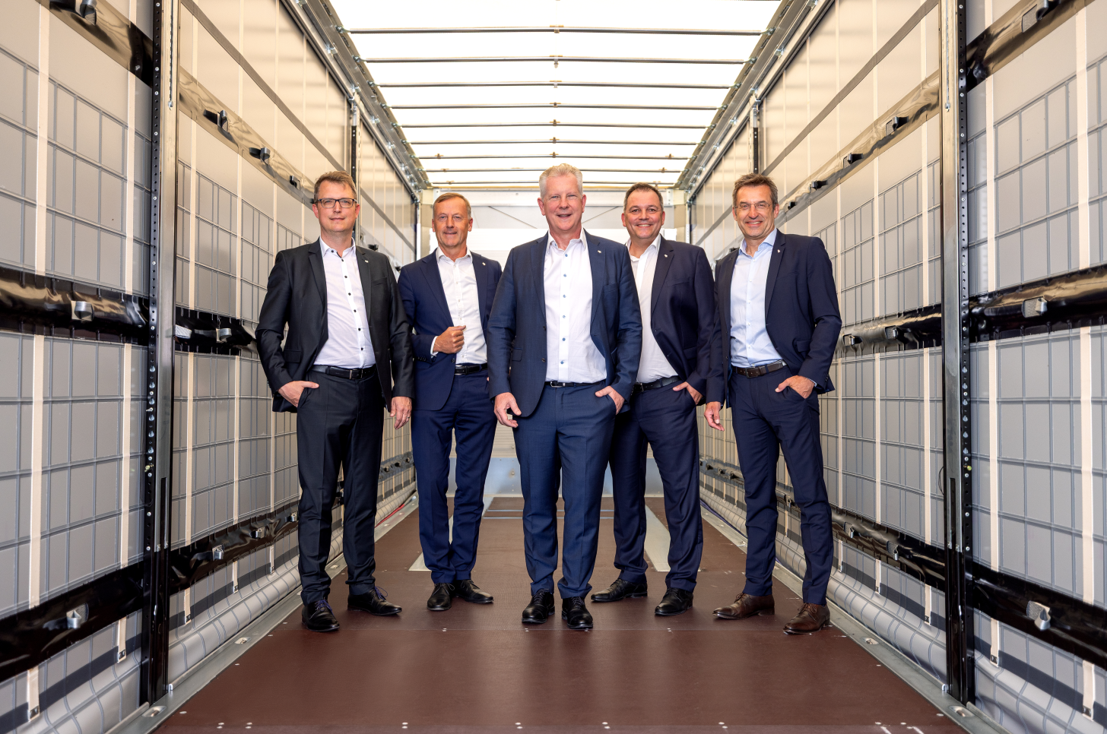
Schmitz Cargobull Management Board (from left: Marnix Lannoije (CTO), Andreas Busacker (CFO), Andreas Schmitz (CEO), Ralph Kleideiter (CSO), Dr Günter Schweitzer (COO))
About Schmitz Cargobull
Schmitz Cargobull is the leading manufacturer of semi-trailers for temperature-controlled freight, general cargo and bulk goods in Europe, and a pioneer in digital solutions for trailer services and improved connectivity. The company also manufactures transport cooling units for refrigerated box body semi-trailers for temperature-controlled freight transport. With a comprehensive range of services from financing, spare parts supply, service contracts and telematics solutions to used vehicle trading, Schmitz Cargobull supports its customers in optimising their total cost of ownership (TCO) and digital transformation.
Schmitz Cargobull was founded in 1892 in Münsterland, Germany. The family-run company produces around 50,000 vehicles per year with over 6,000 employees, and generated a turnover of around €2.16 billion in the financial year 2024/25. Its international production network is made up of factories in Germany, Lithuania, Spain, Turkey and the UK.

The Schmitz Cargobull press team:
Anna Stuhlmeier +49 2558 81-1340 I anna.stuhlmeier@cargobull.com
Andrea Beckonert +49 2558 81-1321 I andrea.beckonert@cargobull.com
Silke Hesener +49 2558 81-1501 I silke.hesener@cargobull.com

