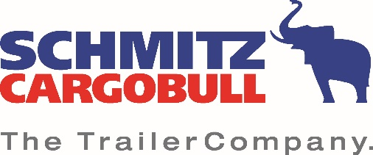

Press Release

Focus on customer benefit
Cargobull Telematics and Krone Telematics set digital milestone

October 2020 - Transport companies using telematics systems from the two leading trailer manufacturers Schmitz Cargobull and Krone can now access the data provided for all their vehicles via their individual access points - regardless of the telematics hardware installed or the telematics portal used. This straightforward and extremely convenient solution is made possible thanks to a cooperation between Cargobull Telematics and Krone Telematics: both manufacturers have opened their standardized interfaces for the respective other system.

"For transport companies, the topics of standardization, data consolidation and thus open interfaces are becoming the new focus of attention", explain Ralf Faust, Managing Director of Krone Service, and Marnix Lannoije, Managing Director of Schmitz Cargobull Telematics, in a joint statement. "The continuous analysis of trailer data to support business processes is becoming increasingly important. Standardization becomes an elementary building block for holistic fleet management and reduces internal process costs significantly. Open data processing becomes highly important not only for monitoring, securing and tracking the load, but for all automation processes around the trailer. Ultimately, our customers only look for one thing: they want to retrieve all vehicle data as quickly, easily and transparently as possible in order to manage their fleets even more efficiently. This we now assure with the compatibility of Cargobull Telematics and Krone Telematics.
Every customer can retrieve all the data they require in the preferred telematics portal. A real digital milestone for many transport companies".

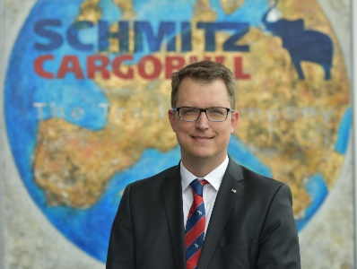
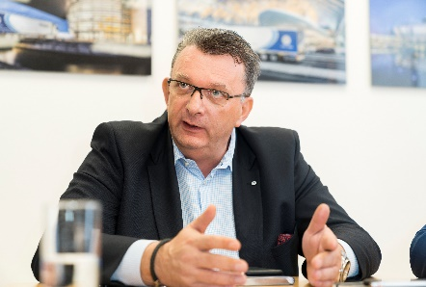
Marnix Lannoije Ralf Faust
Managing Director Schmitz Cargobull Telematics Geschäftsführer Krone Service

Contact:
Schmitz Cargobull AG Fahrzeugwerk Bernard Krone GmbH & Co. KG
Anna Stuhlmeier Stefan Oelker
Head of Marketing Communications & PR Leiter Marketing
Tel.: +49 2558 81-1340 Tel.: +49 5951 209-211
anna.stuhlmeier@cargobull.com stefan.oelke@krone.de

