Press Release
2018-707

Schmitz Cargobull AG
Thermal tipper

Thermal insulation for
- Schmitz Cargobull S.KI tipper trailer with a rounded steel body
- Schmitz Cargobull S.KI tipper trailer with an aluminium box body

June 2018 – With a particular emphasis on weight reduction, Schmitz Cargobull presents enhanced thermal insulation for the rounded steel body. To minimise payload loss, the thermal insulation of the S.KI SR rounded steel tipper body has been optimised again for 2018. The innovative insulation material has a low additional weight of approximately 310 kg, offering a robust and payload-optimised transport solution.

The newly designed insulation configuration, in which the insulating material and the outside panel are no longer connected, enables segmented insulation of the side wall. The advantage of this is that the individual segments can be easily replaced in the event of damage, e.g. through side impacts caused by wheeled loaders. A flexible and highly efficient organic-based insulating foam with very good acoustic and thermal insulating properties is used as the insulating material. Outstanding features, such as high temperature resistance and very low density characterise this lightweight champion of insulators, which meets the requirements of the notification from the German Federal Ministry of Transport and Digital Infrastructure and complies with the planned DIN standard. Another benefit of the segmented body is the easy disassembly of the insulation before carrying out welding work on the body (e.g. when welding on a scuff plate). This serves to prevent damage to the insulating material.

The modification of the floor area of the body makes it possible for the insulated design to retain the familiar low centre of gravity. In addition, the new insulation allows a greater variety of variants so that insulated bodies can also be configured for other European markets, for example in the system length SR 8.2 for the Belgian market. The model range for the rounded steel body (SR) with thermal insulation includes variants in the system length SR 7.2 for volumes of 24 m³ and 27 m³ (body height 1,460 and 1,660 mm), the system length SR 8.2 for the volume of 27 m³ (body height 1,460 mm) as well as for the SKI 18 7.2 2-axle tipper trailer with a body height of 1,460 mm.

A variety of different floor and side wall combinations can also be selected (side walls 3.2 / 4.0 / 5.0 mm, floors 4.0 / 5.0 / 6.0 mm). In addition, customers can also select a range of different tailgate variants and tarpaulin systems.

2018-707

Thermal insulation for the aluminium box body too.

Alongside the rounded steel body, the aluminium box body is also available with full insulation. This weight-optimised transport solution also complies with the required insulation standards while providing for a high payload thanks to its unladen weight of only 5.1 t. Because the body's external dimensions do not change significantly as a result, the tipper trailer retains its low centre of gravity and can be combined with any of the trough covering options from the standard range.

All Schmitz Cargobull thermal body cladding has two easily accessible measurement openings in each side wall which enable manual temperature measurement to be carried out safely from ground level directly into the freight area. It is therefore not necessary to stand in the danger area between the paver and the tipper during tipping (for temperature measurement in the paver or feeder bunker). In Germany this measuring method has now been equated with electronic temperature measurement.

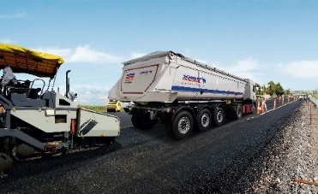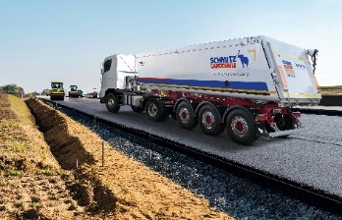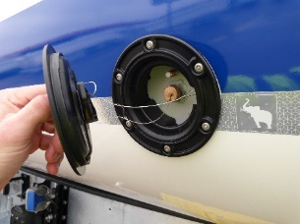

About Schmitz Cargobull
With an annual production of some 61,000* trailers and around 6,400* employees, Schmitz Cargobull AG is Europe's leading manufacturer of semi-trailers, trailers and truck bodies for temperature-controlled freight, general cargo and bulk goods. The company achieved sales of more than € 2.2* billion in the 2017/2018 financial year. As a pioneer in the industry, the North German company developed a comprehensive brand strategy early on and consistently established quality standards spanning every level: from research and development, to production and specialist services such as consulting, trailer telematics, financing, spare parts and used vehicles.
*Provisional figures for the 2017/2018 financial year. The figures for the past financial year (01/04/2017 – 31/03/2018) will be published by the Group in September 2018.
The Schmitz Cargobull press team:
Anna Stuhlmeier +49 2558 81-1340 I anna.stuhlmeier@cargobull.com
Andrea Beckonert +49 2558 81-1321 I andrea.beckonert@cargobull.com
Silke Hesener: +49 2558 81-1501 I silke.hesener@cargobull.com

