Press Release
2019-500

Schmitz Cargobull AG

25% more efficiency!

Long S.KO version delivered to the X5 Retail Group

Schmitz Cargobull offers full-length 16.80 metre side walls for the long version of the refrigerated box body
January 2019 – Schmitz Cargobull is the first trailer manufacturer in Europe to produce single-piece FERROPLAST® side walls for refrigerated box bodies with a total length of 16.80 metres. The full-length side walls are produced at Schmitz Cargobull’s Lithuanian plant in Panevėžys. In January 2019, Boris Billich, Sales Director Schmitz Cargobull, presented the first box semi-trailer to the Russian company X5 Retail Group N.V.

“25% more length means 25% more pallets, 25% fewer runs, lower fuel consumption and, thus, lower CO₂ emissions – meaning significantly more efficiency in the day-to-day transport business,” states Boris Billich. “With the
new manufacturing process, we offer customers real added value”.

With the new foaming line at the Lithuanian plant, the side walls can now be manufactured in one single piece for the full length. Customers benefit from the increased strength of the refrigerated box body, as well as optimised insulation. Space for 41 pallets provides a large transport volume while simultaneously reducing the number of transport runs. In addition, the body can also be mounted on a short chassis. This reduces the unladen weight and increases the payload.

To address the diverse legal requirements, Schmitz Cargobull is constantly developing country-specific solutions. As part of its project business, Schmitz Cargobull has long supplied markets such as Russia and South Africa, where total lengths of up to 20 metres are permissible, with refrigerated box trailers offered in custom lengths up to 16.80 metres. Until now, the sidewalls of these “extra-long” trailers were manufactured by combining several FERROPLAST panels. Schmitz

2019-500

Cargobull once again sets the standard for market-oriented customer solutions with this new production process.

“With the new 16.8 metre semi-trailer, we want to introduce a new transport format between the individual distribution centres and establish this within the group’s overall logistics process”, explains Kirill Kuzmenko, Director of Transport at the X5 Retail Group.

The X5 Retail Group N.V is a leading Russian food retailer and is regarded as one of the pioneers in the logistics and distribution sector. Schmitz Cargobull
and the X5 Group share a 13-year partnership. During this time, the X5 Group has purchased around 1,200 refrigerated vehicles from Schmitz Cargobull.

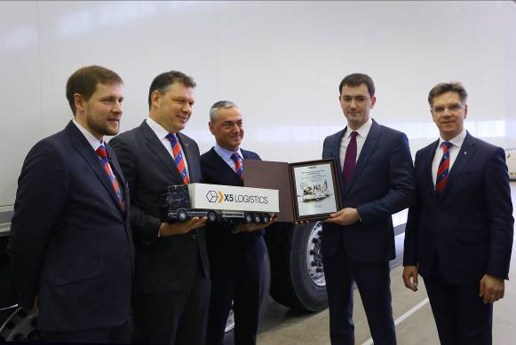
From l to r: Andrius Eiva - Head of Product Management Truck Bodies Schmitz Cargobull Baltic UAB, Boris Billich - Chief Sales Officer Schmitz Cargobull AG, Mile Mishevski – General Director Schmitz Cargobull Russland, Kirill Kuzmenko - General Director «Agro – Avto» (X5 RETAIL GROUP), Raimundas Petrauskas - Managing Director Schmitz Cargobull Baltic UAB

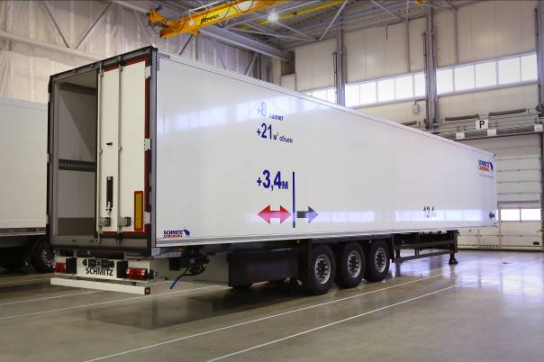

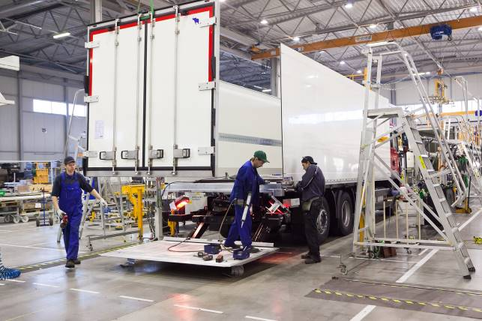
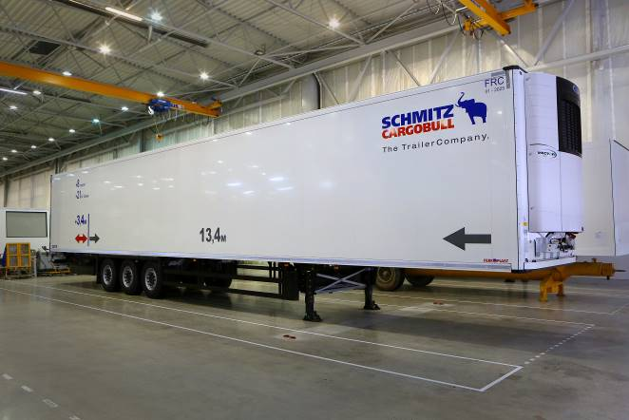

About Schmitz Cargobull
With an annual production of more than 61,000 trailers and with around 6,400 employees, Schmitz Cargobull AG is Europe's leading manufacturer of semi-trailers, trailers and truck bodies for temperature-controlled freight, general cargo and bulk goods. The company achieved sales of almost € 2.2 billion in the 2017/2018 financial year. As a pioneer in the industry, the North German company developed a comprehensive brand strategy early on and consistently established quality standards spanning every level: from research and development, to production and specialist services such as consulting, trailer telematics, financing, spare parts and used vehicles.
The Schmitz Cargobull press team:
Anna Stuhlmeier: +49 2558 81-1340 I anna.stuhlmeier@cargobull.com
Andrea Beckonert: +49 2558 81-1321 I andrea.beckonert@cargobull.com
Silke Hesener: +49 2558 81-1501 I silke.hesener@cargobull.com

