Press Release
2021-107

Schmitz Cargobull AG
Free smart app for tyre sensor positioning:
TrailerConnect® TyreManager reduces workshop visits

March 2021 – Schmitz Cargobull is not only focused on the continuous development of its trailers in order to achieve greater benefits for its customers; the services surrounding the trailers are becoming increasingly important and are the focal point of further developments. One of these developments is the new TrailerConnect® TyreManager application. With this application the tyre sensors can be easily configured by the customer themselves after a tyre change or tyre replacement, and all relevant tyre data is immediately available again in the TrailerConnect® portal. Time-consuming workshop visits are minimised and trailer availability is increased.

The application also enables sensors to be assigned to the new wheel position with just a few “clicks” after a tyre change or sensor replacement. This is done by simply scanning the QR code printed on the sensor with a mobile device and reconfiguring the sensor in the application. Here the new sensors are assigned by changing the position of individual tyres, swapping the axle position or teaching new sensors when a new wheel has been fitted.

All configurations are documented and clearly displayed for each trailer in the TrailerConnect® portal. A smartphone, tablet or PC is all that is needed to use the application. It is no longer necessary to visit a Service Partner, expensive downtimes
are reduced, and the trailer is back on the road in no time.

The application for configuring and managing the installed Schmitz Cargobull trailer tyre sensors is free. There are no costs for additional diagnostic software.
2021-107

A prerequisite is that the trailer is equipped with the TrailerConnect® CTU or CTU 3 telematics control unit. Customers interested in using TrailerConnect® TyreManager
can register at tyremanager.cargobull.com and start using the app immediately.

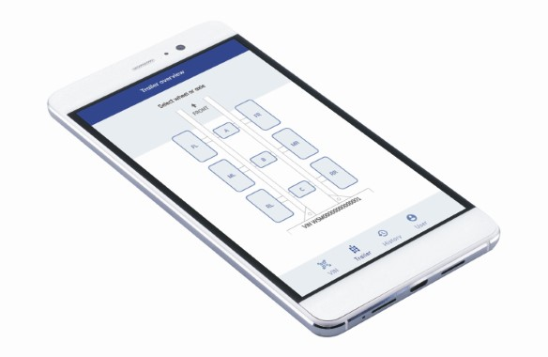

About Schmitz Cargobull
With an annual production of around 46,100 trailers and with around 5,700 employees, Schmitz Cargobull AG is Europe’s leading manufacturer of semi-trailers, trailers and truck bodies for temperature-controlled freight, general cargo and bulk goods. The company achieved sales of approximately €1.87 billion in the 2019/2020 financial year. As a pioneer in the industry, the North German company developed a comprehensive brand strategy early on and consistently established quality standards spanning every level: from research and development, through production and service contracts, to trailer telematics, financing, spare parts, and used vehicles.

The Schmitz Cargobull press team:
Anna Stuhlmeier +49 2558 81-1340 I anna.stuhlmeier@cargobull.com
Andrea Beckonert +49 2558 81-1321 I andrea.beckonert@cargobull.com
Silke Hesener +49 2558 81-1501 I silke.hesener@cargobull.com

