Press Release
2023-116

Schmitz Cargobull AG
Official opening: Schmitz Cargobull unveils its new UK plant
The new S.CS FREEPOST curtainsider semi-trailer is also presented to customers on site for the first time

30th March 2023 - Close to 200 customers, dignitaries and members of the press gathered at the Schmitz Cargobull factory in the UK to celebrate the official opening of the plant.

At the production facility in Wythenshawe, Greater Manchester, trailers have been specially developed for the UK & Ireland since the summer of 2021 – equipped according to market-specific customer requirements. In addition to the dry freight box S.BO PACE and the curtainsider S.CS FIXED ROOF, the "pillarless" curtainsider S.CS FREEPOST now complements the trailer portfolio manufactured in Manchester.

"Schmitz Cargobull stands for reliability and innovation and guarantees consistently high-quality standards worldwide, from vehicle configuration to the handover of the vehicle to the customer. The opening of the plant, here on site in Manchester, is therefore an important step. The plant joins our network of highly flexible production facilities, enabling us to respond quickly to local market requirements," says Andreas Schmitz, CEO at Schmitz Cargobull.

"The new Manchester plant enables us to bring trailers to our customers in the UK and Ireland that fit specific market demands, while offering the most reliable and proven chassis solutions in order to help achieve best total cost of ownership. In addition, transfer costs, CO2 emissions and throughput times are minimised," adds Boris Billich, Director of Sales at Schmitz Cargobull.

The new Schmitz Cargobull facility in the UK is the latest of a total of ten production sites in Germany (Altenberge, Vreden, Gotha), Lithuania, Spain, Slovakia, Turkey, Australia and South Africa. The 7,500 sq m production area in Manchester offers a total capacity of 60
units per week in single-shift operation. The 1,000 sq m spare parts warehouse ensures rapid local supply.

2023-116

Schmitz Cargobull employs a total of 72 people in the UK. The team is led by Paul Avery, Managing Director Operations, and Colin Maher, who has held the position of Managing Director Sales & Services since January 2023.

“We want to support transport companies in the UK and Ireland in the best possible way with our comprehensive range of reliable and innovative transport solutions. This includes vehicles with market-specific features, the shortest delivery times, an extensive 24/7 spare parts supply as well as our proven range of services from financing to telematics and used vehicle sales,” says Maher. “The introduction of the new semi-trailers means we now have our strongest ever product portfolio in the UK.”

“Manchester has proven the perfect location for us with its strong industrial heritage,” adds Avery. “We’re already seeing a significant influx in demand, and we only expect that to continue to grow in the years ahead.”
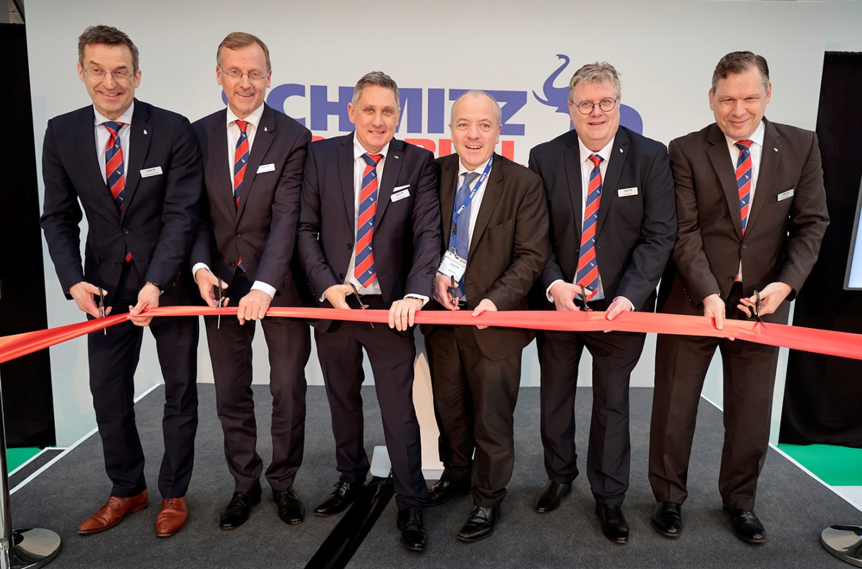
f.l.: Dr. Günter Schweitzer (Chief Operations Officer Schmitz Cargobull), Andreas Busacker (Chief Financial Offer Schmitz Cargobull), Colin Maher (Managing Director Sales & Services, Schmitz Cargobull UK), Mike Kane (Labour MP for Wythenshawe and Sale East), Paul Avery (Managing Director Operations Schmitz Cargobull UK), Boris Billich (Chief Sales Officer Schmitz Cargobull)

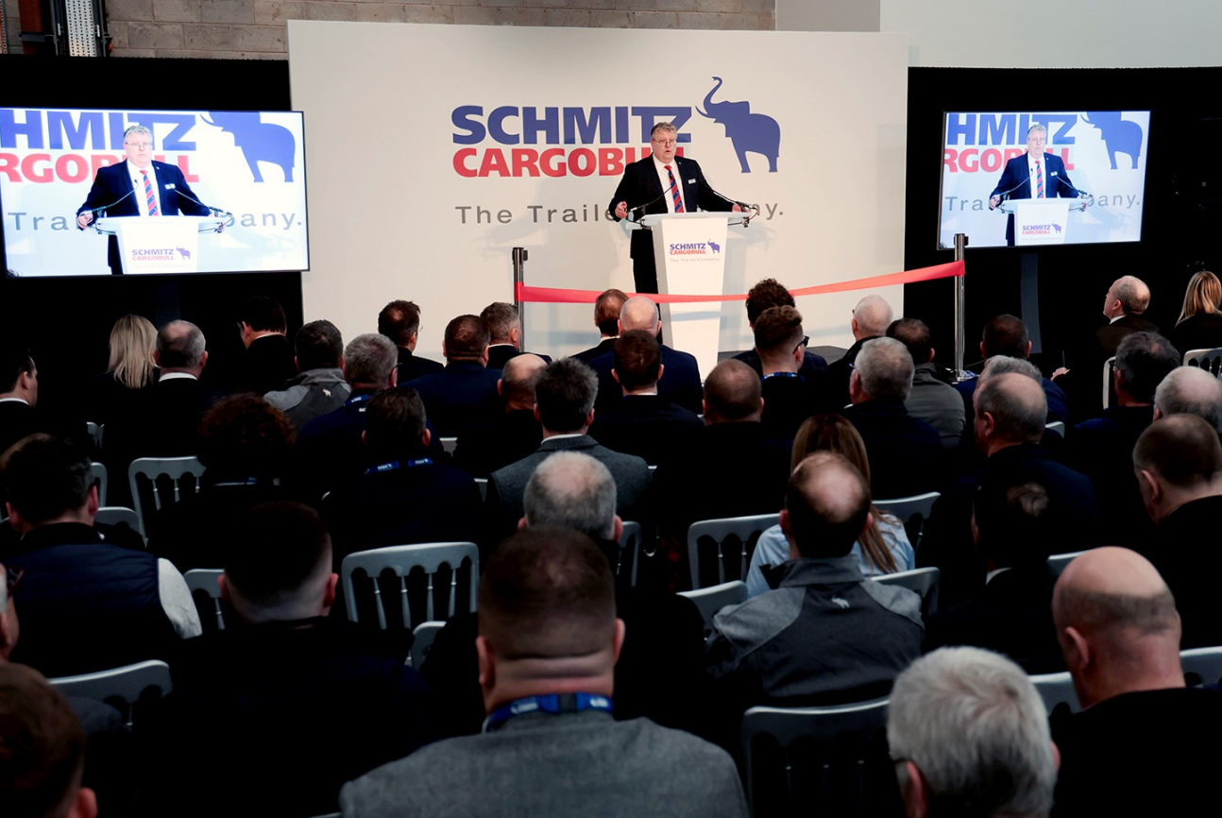
Paul Avery, Managing Director Operations

2023-116

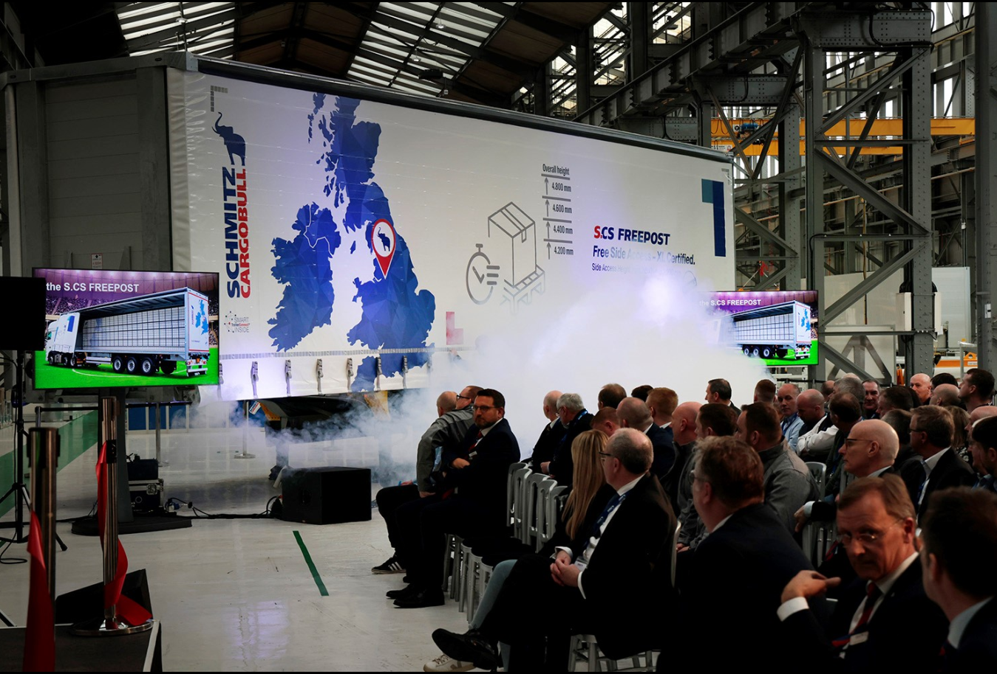

Presentation of the new curtainsider semit-trailer S.CS FREEPOST

About Schmitz Cargobull
With an annual production of around 61,000 trailers and with approximately 6,900 employees, Schmitz Cargobull AG is Europe’s leading manufacturer of semi-trailers, trailers and truck bodies for temperature-controlled freight, general cargo and bulk goods. The company achieved sales of around €2.3 billion in the 2021/22 financial year. As a pioneer in the industry, the North German company developed a comprehensive brand strategy early on and consistently established quality standards spanning every level: from research and development, through production and service contracts, to trailer telematics, financing, spare parts, and used vehicles.

The Schmitz Cargobull press team:
Anna Stuhlmeier +49 2558 81-1340 I anna.stuhlmeier@cargobull.com
Andrea Beckonert +49 2558 81-1321 I andrea.beckonert@cargobull.com
Silke Hesener: +49 2558 81-1501 I silke.hesener@cargobull.com

