Press Release
2024-103

Schmitz Cargobull
Primafrio strengthens its fleet with 200 S.KO COOL refrigerated semi-trailers from Schmitz Cargobull
- All S.KO COOL reefer semi-trailers are equipped with the Schmitz Cargobull S.CU d80 transport refrigeration unit.
- With the new trailers, Primafrio is expanding its fleet to 2,800 vehicles, serving the most important markets in Europe.
- The new acquisition is in line with Primafrio Group's innovation strategy, which focuses on sustainability and the energy transition.

February 2024 - The Primafrio Group, an international logistics service provider and European market leader in the temperature-controlled road transport of fruit and vegetables, has added 200 S.KO COOL reefer semi-trailers from Schmitz Cargobull to its fleet. The latest generation of reefer semi-trailers are equipped with the S.CU d80 transport refrigeration unit and the TrailerConnect® telematics system from Schmitz Cargobull.
"This acquisition represents an important milestone for our company, as we are using Schmitz Cargobull's innovative vehicles for the first time, reinforcing our commitment to excellent logistics and impeccable service for our customers. Schmitz Cargobull's reputation gives us unwavering confidence in the quality and efficiency of its semi-trailers," said José Esteban Conesa, President of Primafrio.
Andreas Schmitz, CEO of Schmitz Cargobull, expressed his satisfaction with the partnership during his visit to the Primafrio Group's headquarters: "We are delighted to be working with a leading company like Primafrio. This collaboration reflects our shared commitment to excellence and innovation in refrigerated transport. We are excited about the journey we have embarked on together and are confident this partnership will be beneficial for both parties".

2024-103
The 200 S.KO COOL reefer semi-trailers have a galvanised chassis for which Schmitz Cargobull offers a 10-year anti-corrosion warranty. To achieve optimum cooling performance, the semi-trailers are equipped with the powerful S.CU d80 transport refrigeration unit. This is characterised by low noise and an emission-optimised engine. A solar panel on the roof of the transport refrigeration unit protects the battery from deep discharge and ensures a constant energy supply.
The trailers are equipped with additional features such as the digital temperature recorder, the new air distribution system and a full-service package that includes maintenance, wear and tear repairs and breakdown assistance.
Primafrio relies on TrailerConnect® telematics for efficient, sustainable fleet and temperature management. This enables real-time monitoring of important parameters, such as temperature, tyre pressure, trailer location, etc. It also gives the operator a better overview and improved control over his trailers and load. And lastly, it is in line with the Primafrio Group's ambition to offer the highest quality standards and ensure the delivery of all types of goods under optimal conditions.
For the financing of the new S.KO COOL refrigerated semi-trailers, Primafrio has opted for a leasing model from Cargobull Finance, which offers greater financial flexibility.
Primafrio is committed to sustainability and innovation.
The Primafrio Group has been working for years to reduce the impact of its activities on the environment through an action programme aligned with the Sustainable Development Goals (SDGs). One of the company's main commitments is to be sustainable and to maintain the highest standards for the care and protection of the environment in which it operates. The company is leading and setting standards in the industry by establishing clear plans for current and future challenges. For this reason, various lines of action have been implemented with the

2024-103
aim of offering services that promote the development of a circular economy, the use of more efficient energy sources, the decarbonisation of the logistics and transport sector and the neutralisation of emissions.
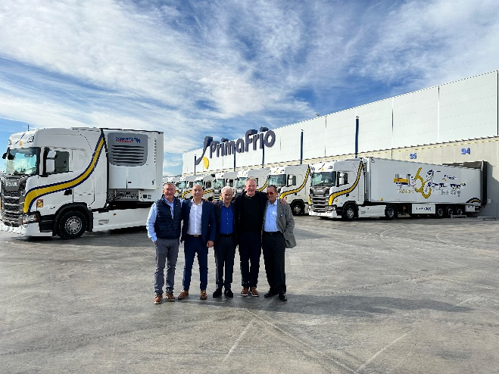
Caption (from left): Miguel Iglesias (Commercial Manager Schmitz Cargobull Ibérica), Javier Espliego (Key Account Manager at Schmitz Cargobull Ibérica), José Esteban Conesa (President of Primafrio), Andreas Schmitz (CEO of Schmitz Cargobull) and Miguel Arroyo (Sales Manager in Andalusia).
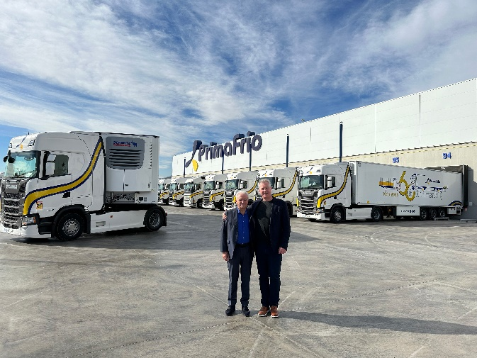
Caption (from left): José Esteban Conesa, (President of Primafrio) and Andreas Schmitz (CEO of Schmitz Cargobull)

About the Primafrio Group
Primafrio is the leading international logistics company specialising in export services and groupage transport of temperature-controlled fruit and vegetable products from the growing regions in Spain and Portugal to more than 25 different destinations in Europe, with Germany, the United Kingdom, France and the Iberian Peninsula being the most important markets. In addition, the company offers transport solutions for pharmaceutical products and high-value products such as technical equipment, telecommunications, industry and cosmetics. The company has a fleet of more than 2,800 vehicles operating in more than 45 logistics centres in Europe. The company is a global benchmark for technological innovation and its sustainability model and strategy as well as ESG are pioneers in the industry.

2024-103
About Schmitz Cargobull
Schmitz Cargobull is the leading manufacturer of semi-trailers for temperature-controlled freight, general cargo and bulk goods in Europe and a pioneer in digital solutions for trailer services and improved connectivity. The company also manufactures transport refrigeration machines for refrigerated semi-trailers for temperature-controlled freight transport. With a comprehensive range of services from financing, spare parts supply, service contracts and telematics solutions to used vehicle trading, Schmitz Cargobull supports its customers in optimising their total cost of ownership (TCO) and digital transformation.
Schmitz Cargobull was founded in 1892 in Münsterland, Germany. The family-run company produces around 60,000 vehicles per year with over 6,000 employees and generated a turnover of around 2.6 billion euros in the 2022/23 financial year. The international production network currently comprises ten plants in Germany, Lithuania, Spain, England, Turkey, Slovakia and Australia.

The Schmitz Cargobull press team:
Anna Stuhlmeier +49 2558 81-1340 I anna.stuhlmeier@cargobull.com
Andrea Beckonert +49 2558 81-1321 I andrea.beckonert@cargobull.com
Silke Hesener +49 2558 81-1501 I silke.hesener@cargobull.com

