**Press Release**

**2025-131**

**Schmitz Cargobull AG**   
**For the safe and reliable transport of pharmaceuticals – GDP certificate extended for Schmitz Cargobull**

**TÜV Süd confirms renewed Good Distribution Practice (GDP) certification for the TrailerConnect® telematics system**

April 2025 – Schmitz Cargobull has successfully had its GDP certificate renewed for the TrailerConnect® telematics system, enabling it to continue offering pharma customers certified vehicles ex works.

“TrailerConnect®’s certification enables our customers to present an important certificate for GDP audits in temperature-controlled transport, confirming that our products meet high standards of safety, security and quality,” explains Marnix Lannoije, Chief Development Officer at Schmitz Cargobull AG. “Thanks to our GDP certificate, customers can guarantee and document full process reliability across the entire process chain; from data recording in the trailer, and data storage and visualisation in the portal, through to the forwarding of data via the API [interface for forwarding data to third-party systems].”

The European Commission introduced the guidelines for the GDP of medicinal products for human use as early as 2013 for the purposes of quality assurance and protection against counterfeit medicines. Manufacturers, pharmaceutical wholesalers and pharmacists are required to subject their processes to yearly audits. The criteria for certification in accordance with GDP are reviewed every two years. Following a comprehensive audit by the TÜV Süd authorities, Schmitz Cargobull’s TrailerConnect® telematics system was once again recertified for another two years.

As part of the audit, the following subject areas were examined in detail: interface description, data storage, data protection, risk analysis for software development, software updates and data backup, organisational processes and structures in the company, software manual, sensor specification, company description, the quality management manual and the ISO 9001.

**2025-125**

Schmitz Cargobull holds an official certificate with a test and accreditation number from TÜV Süd. The certificate for the GDP audit can be requested from Schmitz Cargobull at any time.

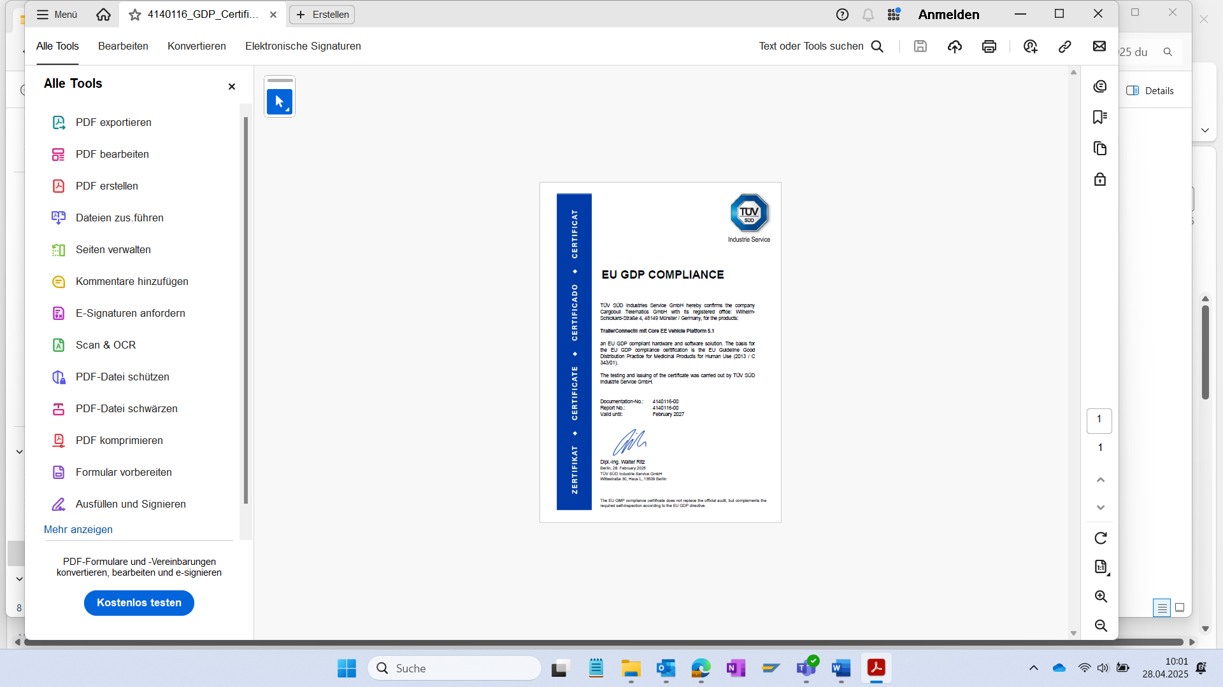

Caption: The GDP certificate for Schmitz Cargobull has been renewed

**About Schmitz Cargobull**

Schmitz Cargobull is the leading manufacturer of semi-trailers for temperature-controlled freight, general cargo and bulk goods in Europe, and a pioneer in digital solutions for trailer services and improved connectivity. The company also manufactures transport cooling units for refrigerated box body semi-trailers for temperature-controlled freight transport. With a comprehensive range of services from financing, spare parts supply, service contracts and telematics solutions to used vehicle trading, Schmitz Cargobull supports its customers in optimising their total cost of ownership (TCO) and digital transformation.

Schmitz Cargobull was founded in 1892 in Münsterland, Germany. The family-run company produces around 60,000 vehicles per year with over 6,000 employees, and generated a turnover of around €2.4 billion in the 2023/24 financial year. The international production network currently comprises ten plants in Germany, Lithuania, Spain, England, Turkey, Slovakia and Australia.

**The Schmitz Cargobull press team:**

Anna Stuhlmeier +49 2558 81-1340 I [anna.stuhlmeier@cargobull.com](mailto:anna.stuhlmeier@cargobull.com)

Andrea Beckonert +49 2558 81-1321 I [andrea.beckonert@cargobull.com](mailto:andrea.beckonert@cargobull.com)  
Silke Hesener +49 2558 81-1501 I [silke.hesener@cargobull.com](mailto:silke.hesener@cargobull.com)