Press Release
2024-109

Schmitz Cargobull AG

Schmitz Cargobull is one of the TOP 100
Company honoured for its innovative strength

February 2024 – Newly crowned innovation champion: Schmitz Cargobull AG, Europe's market leader for semi-trailers, has been named as a TOP 100 Innovator 2024. The honour is awarded to particularly innovative medium-sized companies in Germany. At the award ceremony on 28 June, in Weimar, science journalist Ranga Yogeshwar will personally congratulate Schmitz Cargobull on this success. Yogeshwar has been mentoring the TOP 100 innovation competition for 12 years.
"The top priority at Schmitz Cargobull is to offer our customers real added value. We are only satisfied with our innovations when they help our customers to increase their profitability and achieve the lowest total cost of ownership so that they can offer their own customers a more reliable service," says Andreas Schmitz, CEO of Schmitz Cargobull AG. "We are proud to be one of the TOP 100 most innovative companies in Germany. This award confirms the commitment of the entire Schmitz Cargobull team and spurs us on to continue investing in innovative vehicle concepts and transport solutions. For us, innovation is not an end in itself. Our focus is always on the benefits for our customers. We can look back on a large number of our developments that have had a major impact, be it the FERROPLAST superstructure, the electric reefer semi-trailer with generator axle or the aerodynamic EcoGeneration curtainsiders, which significantly reduce diesel consumption and CO2 emissions. Innovation management is hugely important for the company, allowing us to continue to offer our customers value-added solutions in the future."
On behalf of compamedia – the organiser of the competition – innovation researcher Prof. Dr Nikolaus Franke, from the Vienna University of Economics and Business, and his team examined the innovative strength of all participants. Considerations are based on more than 100 criteria from five categories: innovation-promoting top management, innovation climate, innovative processes and organisation, external orientation/open innovation and innovation success. The following questions are analysed during the review: are the

2024-109
companies able to create new products, new services, new processes and new business models? And are these achievements just coincidences or the result of a structured and targeted approach? It is also important how and whether innovations and product improvements have been able to establish themselves on the market (further information on the test criteria can be found at www.top100.de/pruefkriterien). Schmitz Cargobull prevailed in this scientific selection process to be selected as one of the top innovators.

To ensure equal opportunities, the TOP 100 seal is awarded in three size categories:
up to 50, 51 to 200, and more than 200 employees. In the 31st edition of the innovation competition, around 400 SMEs applied for the award. 287 were successful and have carried the TOP 100 seal since February 1, 2024. A maximum of 100 companies can be awarded per size category.

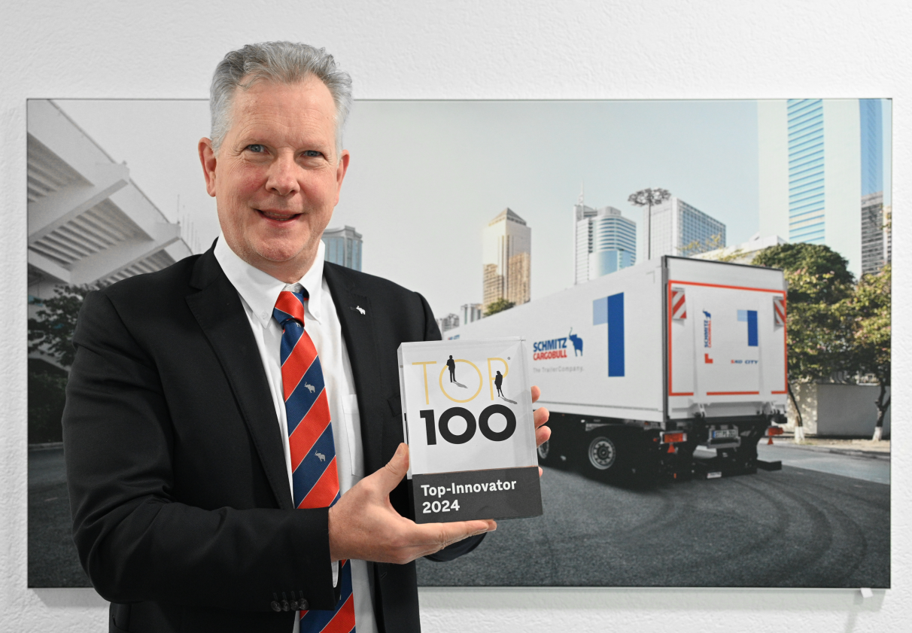
Andreas Schmitz, CEO Schmitz Cargobull AG, is delighted with the TOP 100 award.

About the TOP 100 competition
Since 1993, compamedia has been awarding the TOP 100 seal for special innovative strength and above-average innovation success to medium-sized companies. The scientific management has been in the hands of Prof. Dr. Nikolaus Franke since 2002. Franke is the founder and director of the Institute for Entrepreneurship and Innovation at the Vienna University of Economics and Business. With 26 research awards and over 200 publications, he is one of the leading innovation researchers internationally. The mentor of TOP 100 is the science journalist Ranga Yogeshwar. Project partners are the Fraunhofer Society for the Promotion of Applied Research and the BVMW association of small and medium-sized enterprises. The magazines manager magazin and impulse accompany the company comparison as media partners, ZEIT für Unternehmer is a cooperation partner. More information and registration at www.top100.de.

About Schmitz Cargobull
Schmitz Cargobull is the leading manufacturer of semi-trailers for temperature-controlled freight, general cargo and bulk goods in Europe and a pioneer in digital solutions for trailer services and improved connectivity. The company also manufactures transport refrigeration machines for refrigerated semi-trailers for temperature-controlled freight transport. With a comprehensive range of services from financing, spare parts supply, service contracts and telematics solutions to used vehicle trading, Schmitz Cargobull supports its customers in optimising their total cost of ownership (TCO) and digital transformation. Schmitz Cargobull was founded in 1892 in Münsterland, Germany. The family-run company produces

2024-109

around 60,000 vehicles per year with over 6,000 employees and generated a turnover of around 2.6 billion euros in the 2022/23 financial year. The international production network currently comprises ten plants in Germany, Lithuania, Spain, England, Turkey, Slovakia and Australia.

The Schmitz Cargobull press team:
Anna Stuhlmeier +49 2558 81-1340 I anna.stuhlmeier@cargobull.com
Andrea Beckonert +49 2558 81-1321 I andrea.beckonert@cargobull.com
Silke Hesener +49 2558 81-1501 I silke.hesener@cargobull.com

