Press Release
2024-123

Schmitz Cargobull AG

Sebastian Terhechte is the new Head of Cargobull Trailer Store
May 2024 - Sebastian Terhechte has been appointed as the new Head of the Cargobull Trailer Store (CTS) headquarters, in Altenberge. He took over the role of "Head of Used Trailer" on 1 April 2024, succeeding Anselm Steinhaus, who has managed the Schmitz Cargobull used vehicle business since 2010 and substantially shaped and reformed it. Since April of this year, Steinhaus has represented the Group's interests in the Fleetloop joint venture, among other things.
From 2009 to 2019, Terhechte (38) was already active at CTS as a used vehicle salesman and country manager. He has in-depth knowledge of the used vehicle business thanks to his many years of experience. From 2022 to 2023, he was also Interim Managing Director Sales and Aftersales at Schmitz Cargobull UK & Ireland. Most recently, he served as International Key Account Manager at Schmitz Cargobull AG.
With second-hand trailers, emphasis is placed on high-quality vehicles that have extensive warranties and are subject to a comprehensive quality assurance system. In 41 Cargobull Trailer Stores, Schmitz Cargobull offers more than 10,000 used vehicles of various brands throughout Europe every year. The trailers are available at short notice and cover all variants – from curtainsider semi-trailers to refrigerated semi-trailers. In order to offer maximum service from a single source, the used vehicle sales department has access to leasing and financing offers from Cargobull Finance, as well as Full Service contracts from Cargobull Parts & Services. Products are also offered to bridge short-term transport bottlenecks. The Cargobull Trailer Stores support Schmitz Cargobull's new vehicle business by trading in individual trailers or entire fleets at market prices.

2024-123

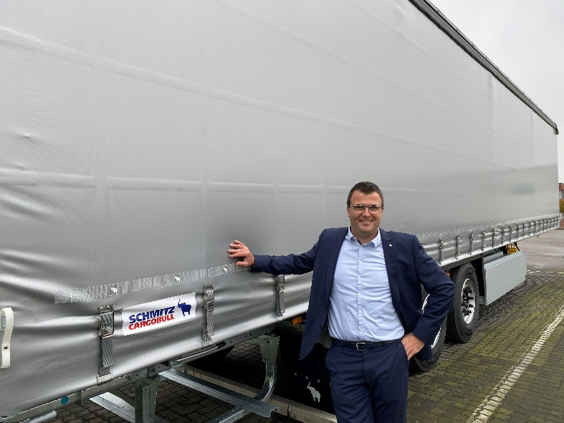
Caption: Sebastian Terhechte, Head of Used Trailer, Cargobull Trailer Store, Schmitz Cargobull

About Schmitz Cargobull
Schmitz Cargobull is the leading manufacturer of semi-trailers for temperature-controlled freight, general cargo and bulk goods in Europe and a pioneer in digital solutions for trailer services and improved connectivity. The company also manufactures transport refrigeration machines for refrigerated semi-trailers for temperature-controlled freight transport. With a comprehensive range of services from financing, spare parts supply, service contracts and telematics solutions to used vehicle trading, Schmitz Cargobull supports its customers in optimising their total cost of ownership (TCO) and digital transformation. Schmitz Cargobull was founded in 1892 in Münsterland, Germany. The family-run company produces
around 60,000 vehicles per year with over 6,000 employees and generated a turnover of around 2.6 billion euros in the 2022/23 financial year. The international production network currently comprises ten plants in Germany, Lithuania, Spain, England, Turkey, Slovakia and Australia.

The Schmitz Cargobull press team:
Anna Stuhlmeier +49 2558 81-1340 I anna.stuhlmeier@cargobull.com
Andrea Beckonert +49 2558 81-1321 I andrea.beckonert@cargobull.com
Silke Hesener +49 2558 81-1501 I silke.hesener@cargobull.com

