Press Release
2023-193

Schmitz Cargobull AG
Dr. Günter Schweitzer confirmed as
Chief Operations Officer at Schmitz Cargobull for a further five years

December 2023 - On November 28, 2023, the Supervisory Board of Schmitz Cargobull AG unanimously extended the mandate of Dr. Günter Schweitzer as Chief Operations Officer for a further five years. Dr. Schweitzer has been a member of the Executive Board since September 1, 2021. In this position he is responsible for the areas of purchasing, logistics, supply chain and the production site network at the leading manufacturer of semi-trailers for temperature-controlled freight, general cargo and bulk goods in Europe.

"With his many years of experience in production, logistics and procurement,
Dr. Schweitzer makes an important contribution to the success of Schmitz Cargobull. In his role, he makes a significant contribution to increasing efficiency and flexibility within our production network and is constantly driving forward the digitalisation of our production processes. With him, we are putting cooperation with our suppliers on a broad footing, and we are pleased that we are continuing on the path we have taken with Dr. Schweitzer. This provides continuity within the company in a challenging external environment," explains Andreas Schmitz, CEO of Schmitz Cargobull AG.

In his position as Chief Operations Officer, Dr. Schweitzer is also responsible for the sustainability strategy at Schmitz Cargobull. The company assumes ecological and social responsibility along the entire value chain and is pursuing the ambitious goal of making both the production processes in the entire network and the product portfolio sustainable.

The sustainability report in accordance with the GRI reporting standard is available on the website: Download Sustainability Report 2022/23

2023-193
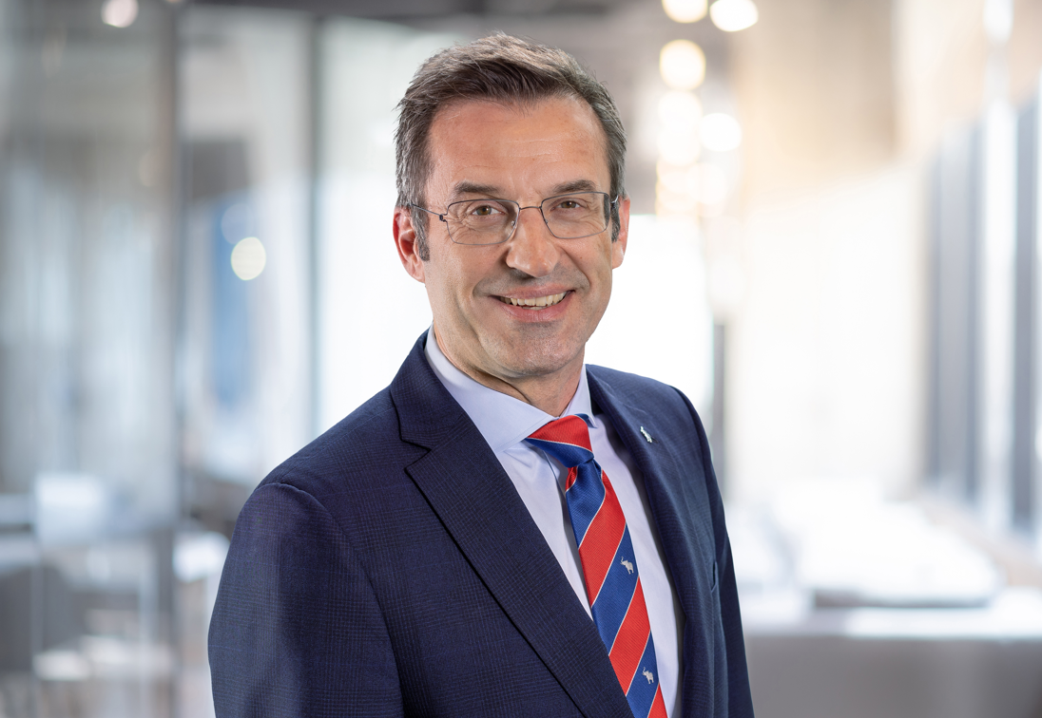
Dr. Günter Schweitzer, Chief Operations Officer at Schmitz Cargobull

About Schmitz Cargobull
Schmitz Cargobull is the leading manufacturer of semi-trailers for temperature-controlled freight, general cargo and bulk goods in Europe and a pioneer in digital solutions for trailer services and improved connectivity. The company also manufactures transport refrigeration machines for refrigerated semi-trailers for temperature-controlled freight transport. With a comprehensive range of services from financing, spare parts supply, service contracts and telematics solutions to used vehicle trading, Schmitz Cargobull supports its customers in optimising their total cost of ownership (TCO) and digital transformation.
Schmitz Cargobull was founded in 1892 in Münsterland, Germany. The family-run company produces around 60,000 vehicles per year with over 6,000 employees and generated a turnover of around 2.6 billion euros in the 2022/23 financial year. The international production network currently comprises ten plants in Germany, Lithuania, Spain, England, Turkey, Slovakia and Australia.

The Schmitz Cargobull press team:
Anna Stuhlmeier +49 2558 81-1340 I anna.stuhlmeier@cargobull.com
Andrea Beckonert +49 2558 81-1321 I andrea.beckonert@cargobull.com
Silke Hesener +49 2558 81-1501 I silke.hesener@cargobull.com

