Press Release
2023-179

Schmitz Cargobull AG
S.CS X-TOUGH curtainsider shortlisted for
I-NNOVATION Award
- S.CS X-TOUGH trailer features a robust and durable chassis
- I-NNOVATION Award will be handed over at the Solutrans trade fair in Lyon

October 2023 - The Schmitz Cargobull S.CS X-TOUGH curtainsider, which will celebrate its premiere at the SOLUTRANS trade fair in Lyon, has made it onto the shortlist for the
I-NNOVATION Award. This award is presented at the fair for the most innovative products and solutions in the field of commercial vehicle and urban delivery transport.

"We designed the S.CS X-TOUGH specifically to meet the high demands of French customers and are delighted that it has been nominated for the shortlist. The vehicle will be presented to the public for the first time at Solutrans as one of our innovations that we will be showcasing at the trade fair," said Boris Billich, Chief Sales Officer at Schmitz Cargobull.

The robust S.CS X-TOUGH curtainsider semi-trailer has been specially developed for France and countries with a total weight of 44 tonnes, fitting seamlessly into the Schmitz Cargobull chassis range with galvanised and bolted chassis. It has cross members in the chassis structure making it particularly robust. The stability of the chassis proves its worth, especially with rear loading and high frequency of forklift loads.

The chassis can be combined with various superstructures such as the slatless POWER CURTAIN or the quick-opening SPEED CURTAIN. Schmitz Cargobull offers a 10-year warranty against rust-through on all galvanised parts in the chassis. The galvanisation makes the chassis corrosion-resistant and offers optimum protection against rust-through.

The I-NNOVATION Awards include prizes in four different categories. The winners will be selected by a high-caliber jury of industry experts and journalists and announced at an evening event on November 21, 2023, at the GROUPAMA STADIUM.

2023-179

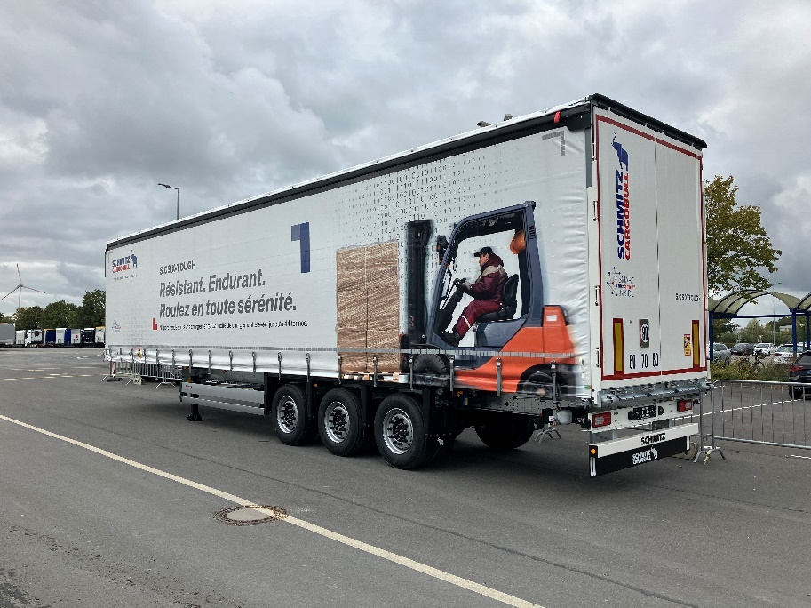

Schmitz Cargobull S.CS X-TOUGH curtainsider semi-trailer

About Schmitz Cargobull
Schmitz Cargobull is the leading manufacturer of semi-trailers for temperature-controlled freight, general cargo and bulk goods in Europe and a pioneer in digital solutions for trailer services and improved connectivity. The company also manufactures transport refrigeration machines for refrigerated semi-trailers for temperature-controlled freight transport. With a comprehensive range of services from financing, spare parts supply, service contracts and telematics solutions to used vehicle trading, Schmitz Cargobull supports its customers in optimising their total cost of ownership (TCO) and digital transformation.
Schmitz Cargobull was founded in 1892 in Münsterland, Germany. The family-run company produces around 60,000 vehicles per year with over 6,000 employees and generated a turnover of around 2.6 billion euros in the 2022/23 financial year. The international production network currently comprises ten plants in Germany, Lithuania, Spain, England, Turkey, Slovakia and Australia.

The Schmitz Cargobull press team:
Anna Stuhlmeier +49 2558 81-1340 I anna.stuhlmeier@cargobull.com
Andrea Beckonert +49 2558 81-1321 I andrea.beckonert@cargobull.com
Silke Hesener +49 2558 81-1501 I silke.hesener@cargobull.com

