Press release
2021-119

Schmitz Cargobull AG
Digital front-runner - Schmitz Cargobull is "Digital- Champion 2021"

April 2021 - The German business magazine Focus Money and Deutschland Test recently commissioned a survey which analysed around 13,000 companies in the fields of digitalisation, technology and innovation. In the category Vehicle Manufacturers, Schmitz Cargobull is ranked among the "Digital-Champions 2021".

"We are very pleased to receive this award, as it reflects the importance of digitalisation at Schmitz Cargobull. As a reliable and innovative trailer manufacturer, we have been offering digital products and services for many years, which ensure the uptime of our trailers. They help our customers to meet the requirements in the transport and logistics industry more in a more efficient, reliable and more comfortable way. Industrial production would not be possible without systematic digitalisation in our production network. We are also working intensively to further digitalise our internal business processes and to develop new business models with the use of digital data and new information technology," explains Andreas Schmitz, CEO of Schmitz Cargobull.

To guarantee the ability to act and be competitive, a modern and functional online presence is becoming increasingly important and is seen as a further opportunity to better cope with crises. The Corona pandemic has put even more focus on the topic of digitalisation. This was the background to the study "Digital-Champions 2021" was conducted by the IMWF Institute for Management and Economic Research with scientific support from the Hamburg Institute of International Economics (HWWI) on behalf of Focus Money and Deutschland Test. Criteria for successful participation were, for example, the status of digitalisation, the type of use of digital data, such as the use of cloud services, measures to protect data security, training and investment in the digital competence of employees, and digitalisation projects that have already been implemented.

2021-119

The evaluation of the "Digital-Champions 2021" survey was based in equal parts on social listening on the topics of digitalisation, technology and innovation, as well as on a questionnaire on online reputation completed by the companies surveyed.

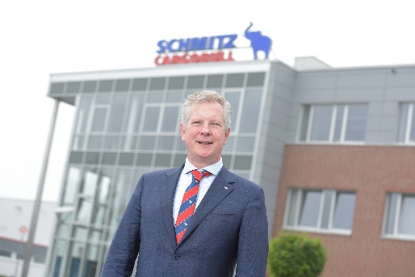
Caption: Andreas Schmitz, CEO Schmitz Cargobull AG
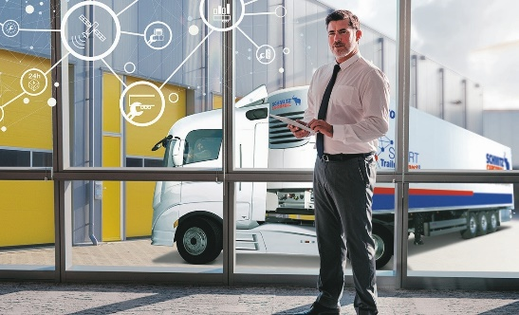
Caption: Schmitz Cargobull is digital front-runner

About Schmitz Cargobull
With an annual production of around 46,100 trailers and with around 5,700 employees, Schmitz Cargobull AG is Europe’s leading manufacturer of semi-trailers, trailers and truck bodies for temperature-controlled freight, general cargo and bulk goods. The company achieved sales of approximately €1.87 billion in the 2019/2020 financial year. As a pioneer in the industry, the North German company developed a comprehensive brand strategy early on and consistently established quality standards spanning every level: from research and development, through production and service contracts, to trailer telematics, financing, spare parts, and used vehicles.

The Schmitz Cargobull press team:
Anna Stuhlmeier +49 2558 81-1340 I anna.stuhlmeier@cargobull.com
Andrea Beckonert +49 2558 81-1321 I andrea.beckonert@cargobull.com
Silke Hesener: +49 2558 81-1501 I silke.hesener@cargobull.com

