Press Release
2023-137

Schmitz Cargobull AG
Schmitz Cargobull production plant in Lithuania achieves environmental certification

August 2023 – Schmitz Cargobull’s site in Panevėžys, Lithuania has received its environmental management certification according to the ISO 14001 standard.

This recognition means that environmental management processes with clear goals
and guidelines is now fully implemented at Schmitz Cargobull Baltic. It comes two years after the company’s production site in Altenberge received its environmental management certification.

Preparations for the environmental management standard began as early as summer 2022. After completion of documentation and an internal audit, an external audit of the environmental management system was completed in May 2023. The certification process must be repeated every three years.

In the course of implementing the environmental management system, Justina Kardokaite and Dainius Pabreza and their colleagues have already been able to achieve many improvements – for example in the areas of energy and waste.
They are making a significant contribution to achieving the environmental goals of
the Schmitz Cargobull sustainability strategy.

As part of the production network, Schmitz Cargobull is working on key environmental issues across all plants and has set itself the goal of having all major production sites certified to the ISO 14001 standard. The sustainability strategy sets out the ambitious goals the company is pursuing in the areas of energy and climate protection, among others. In this context, environmental management and the responsible use of resources are of particular importance at the production sites.

2023-137

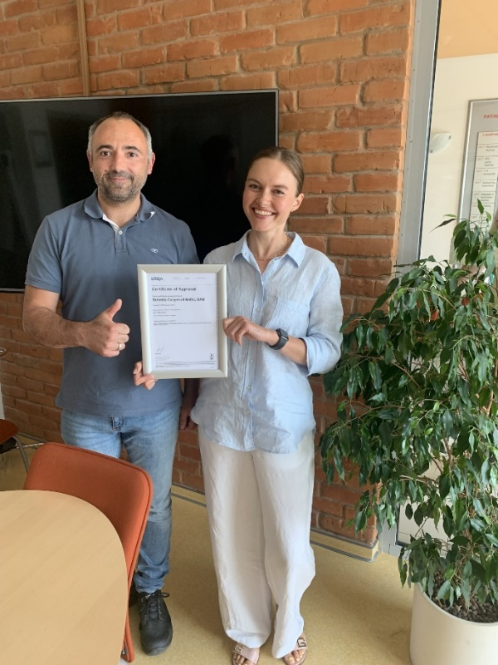
Photo caption: Dainius Pabreza and Justina Kardokaite with the ISO 14001 environmental management certificate

About Schmitz Cargobull
With an annual production of around 61,000 trailers and with approximately 6,900 employees, Schmitz Cargobull AG is Europe’s leading manufacturer of semi-trailers, trailers and truck bodies for temperature-controlled freight, general cargo and bulk goods. The company achieved sales of around €2.3 billion in the 2021/22 financial year. As a pioneer in the industry, the North German company developed a comprehensive brand strategy early on and consistently established quality standards spanning every level: from research and development, through production and service contracts, to trailer telematics, financing, spare parts, and used vehicles.

The Schmitz Cargobull press team:
Anna Stuhlmeier +49 2558 81-1340 I anna.stuhlmeier@cargobull.com
Andrea Beckonert +49 2558 81-1321 I andrea.beckonert@cargobull.com
Silke Hesener: +49 2558 81-1501 I silke.hesener@cargobull.com

