Press Release
2021-130

Schmitz Cargobull wins again!

A double win for Schmitz Cargobull at the Image Award Europe’s leading trailer manufacturer has once again won the coveted title from VerkehrsRundschau – this time for both trailers and bodies
June 2021 – Schmitz Cargobull claims a double win in the important ‘Truck bodies’ and ‘Trailers & semi-trailers’ categories. The coveted Image Award from the German trade magazine, VerkehrsRundschau, goes to Schmitz Cargobull for the ninth time. Once again, the blue elephant sets a new benchmark as the fleet managers’ ‘preferred brand’.

Schmitz Cargobull’s Chairman of the Board, Andreas Schmitz, accepted the winner’s trophies for the two first places from Gerhard Grünig, the magazine’s editor-in-chief, at the award ceremony in Neuss. “Our customers have consistently given our products high ratings for many years,” states Andreas Schmitz happily. “We owe this success with both the bodies and the trailers to the entire Schmitz Cargobull team. Thanks to our employees’ valuable dedication, our customers can be certain that we will maintain our quality, reliability and innovation for years to come. Working tirelessly to deliver and develop the best customer-oriented transport solutions is what drives us. This is the only way to maintain and expand our position at the forefront of the market.”

The coveted Image Award is presented annually by the renowned German magazine VerkehrsRundschau. In a representative poll, the market research institute, Interrogare, asked 969 representative managers from German transport companies as well as fleet managers for their opinions concerning the image of commercial vehicle providers and those offering services in the sector. Market share and registration figures in Germany, a comprehensive nationwide presence as well as the brand’s renown were the key factors among the decision-makers. This year’s image awards included 122 manufacturer brands in twelve categories: vans, light trucks, heavy trucks, trailers & semi-trailers, truck bodies, tyres, fuel cards, truck and trailer rental, OEM telematics, third-party telematics, forklifts, loading & storage equipment, as well as truck loading cranes.

2021-130

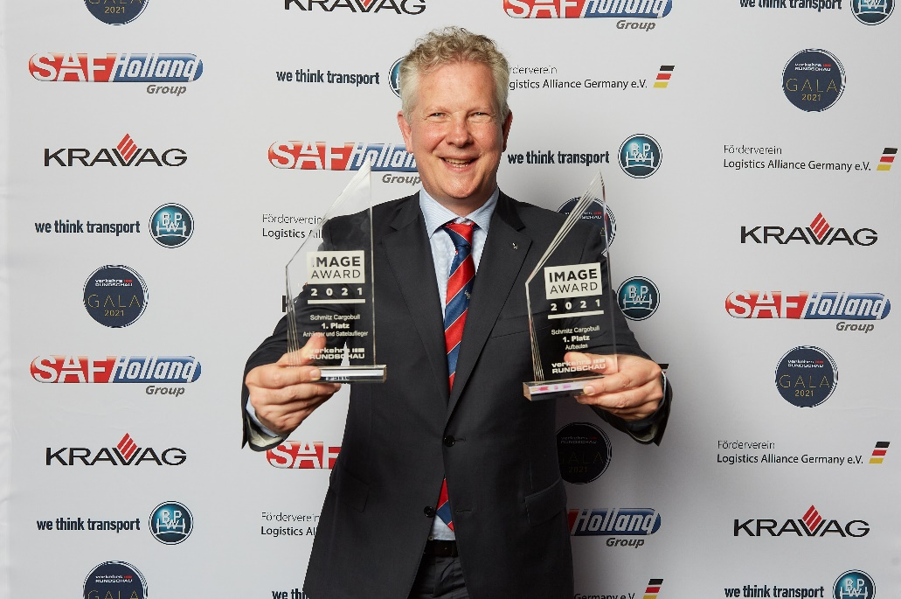

Caption: Proud winners in both trailer categories: Andreas Schmitz, Chairman of the Board of Schmitz Cargobull AG

About Schmitz Cargobull
With an annual production of around 46,100 trailers and with around 5,700 employees, Schmitz Cargobull AG is Europe’s leading manufacturer of semi-trailers, trailers and truck bodies for temperature-controlled freight, general cargo and bulk goods. The company achieved sales of approximately €1.87 billion in the 2019/2020 financial year. As a pioneer in the industry, the North German company developed a comprehensive brand strategy early on and consistently established quality standards spanning every level: from research and development, through production and service contracts, to trailer telematics, financing, spare parts, and used vehicles.

The Schmitz Cargobull press team:
Anna Stuhlmeier +49 2558 81-1340 I anna.stuhlmeier@cargobull.com
Andrea Beckonert +49 2558 81-1321 I andrea.beckonert@cargobull.com
Silke Hesener: +49 2558 81-1501 I silke.hesener@cargobull.com

