Press Release
2025-165

Schmitz Cargobull AG
Schmitz Cargobull and AddSecure announce Europe-wide partnership
Comprehensive solution for data transfer between truck & trailer announced

October 2025 - Schmitz Cargobull, Europe's leading trailer manufacturer, and AddSecure, Europe's leading provider of IoT connectivity and end-to-end solutions, are expanding their existing collaboration.

As part of the partnership, a fully integrated telematics solution for trucks and trailers will be introduced, which also includes data from the tyre pressure monitoring system (TPMS). This solution is designed to optimise fleet management, drive digitalisation and provide scalable systems for fleet operators.

In the future, transport and logistics companies will benefit from a standardised application that seamlessly transfers telematics data from Schmitz Cargobull vehicles and various truck manufacturers to AddSecure's FleetVision portal. This data is provided via Schmitz Cargobull's own TrailerConnect® Data Management Centre (DMC). The integration takes place without additional hardware or manual set-up, is immediately ready for use and significantly reduces the workload for IT departments. This saves time and costs and improves data connectivity.
"Our goal is to offer our customers the best telematics services together with AddSecure," explains Dr Cafer Ince, Head of Product Line Digital Services and Managing Director of Cargobull Telematics & KubikX GmbH.

Claes Ödman, President AddSecure Smart Transport, adds: "The partnership with Schmitz Cargobull enables us to deliver a solution that sets new standards across Europe. The automatic integration of vehicle data in FleetVision enables next-generation fleet management - safe, intelligent and sustainable."

2025-165

All Schmitz Cargobull vehicles are equipped with TrailerConnect® trailer telematics as standard. The TrailerConnect® portal serves as a central data platform on which all relevant telematics data is collated and made available, regardless of the hardware used. With the TrailerConnect® Data Management Centre, Schmitz Cargobull supports hauliers in their daily transport business by enabling order-relevant data to be transmitted selectively and securely to clients and customers. It is ready for immediate use without additional IT implementation, enables centralised monitoring and control of the entire fleet and offers interfaces to common real-time visibility platforms and telematics systems. Users retain full control over their data, deciding on selective release themselves to protect their business and haulage network.

In order to utilise the available real-time data even more effectively, Schmitz Cargobull relies on strategic partnerships with over 40 established providers. Using the DMC's import function, customers can map their entire fleet - across all manufacturers - on the TrailerConnect® platform.

Beyond the market launch, Schmitz Cargobull and AddSecure are planning to further expand their collaboration in the area of retrofit solutions for refrigerated transport.

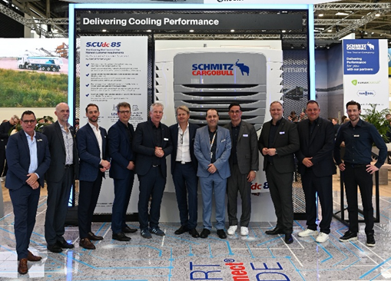

Picture caption: Together with Andreas Schmitz, CEO Schmitz Cargobull (5th from left) and Claes Ödman, President, AddSecure Smart Transport (centre), representatives of both companies met at the Schmitz Cargobull stand at transport logistic 2025. (From left): Kim Kristiansen, VP Sales AddSecure; Johan Norrman, VP products & technology AddSecure;
Grzegorz Janas, Strategic Alliance & Program Director AddSecure; Marnix Lannoije, CTO Schmitz Cargobull AG; Andreas Schmitz, CEO Schmitz Cargobull AG; Claes Ödman, President, AddSecure Smart Transport; Rafael del Pinto Clemente, CEO Atlantis Global System; Dr. Cafer Ince, Head of Product Line Digital Services; Managing Director Cargobull Telematics & KubiKx; Stefan Grawe, Managing Director Schmitz Cargobull Overseas GmbH; Ralph Kleideiter, CSO Schmitz Cargobull AG; Florian Hesse, Head of Digital Service Sales, Schmitz Cargobull.

2025-165

About AddSecure
AddSecure is a leading European provider of secure IoT connectivity and end-to-end solutions. We help our customers optimise their operations, increase business value and secure critical functions. By combining connected, data-driven and sensor-based solutions with world-class expertise, we fulfil our customers' needs regardless of industry. We provide both managed services and connectivity for all devices that require secure communication and data transmission. The only limit is imagination.
Our secure IoT solutions are used in buildings, alarm systems, transport and logistics, personal protection and security, healthcare, construction, municipalities, schools, emergency services, power grids and more.
AddSecure is headquartered in Stockholm, Sweden. Our main market is Europe, but we supply customers all over the world. With over 1,100 employees, we contribute to making the world safer, smarter and more sustainable.

About Schmitz Cargobull
Schmitz Cargobull is the leading manufacturer of semi-trailers for temperature-controlled freight, general cargo and bulk goods in Europe, and a pioneer in digital solutions for trailer services and improved connectivity. The company also manufactures transport cooling units for refrigerated box body semi-trailers for temperature-controlled freight transport. With a comprehensive range of services from financing, spare parts supply, service contracts and telematics solutions to used vehicle trading, Schmitz Cargobull supports its customers in optimising their total cost of ownership (TCO) and digital transformation.
Schmitz Cargobull was founded in 1892 in Münsterland, Germany. The family-run company produces around 50,000 vehicles per year with over 6,000 employees and generated a turnover of around €2.16 billion in the financial year 2024/25. Its international production network is made up of factories in Germany, Lithuania, Spain, Turkey and the UK.

The Schmitz Cargobull press team:
Anna Stuhlmeier +49 2558 81-1340 I anna.stuhlmeier@cargobull.com
Andrea Beckonert +49 2558 81-1321 I andrea.beckonert@cargobull.com
Silke Hesener +49 2558 81-1501 I silke.hesener@cargobull.com

