Press Release
2025-167

Schmitz Cargobull AG
Successful EcoDuo pilot project:
TÜV Rheinland confirms reduction in infrastructure load; manufacturers call for inclusion in positive network

October 2025 – After a year of intensive practical testing between Wolfsburg, Lehrte and Barcelona, the EcoDuo pilot project in Germany has been successfully completed. The EcoDuo, a vehicle combination consisting of two standard semi-trailers connected by a dolly and pulled by a single tractor unit, has proven to be efficient, safe and climate-friendly in the pre- and post-run of combined transport.

The project was initiated by the German Association of the Automotive Industry (VDA) and conducted in collaboration with Sesé, Kombiverkehr, Volkswagen Group Logistics, TÜV Rheinland and Schmitz Cargobull.

Andreas Schmitz, CEO of Schmitz Cargobull AG, says: “Compared to previous long truck concepts, the EcoDuo meets all safety standards and is ideally suited for combined transport, as standard semi-trailers can be loaded onto trains without any complications. The EcoDuo is available now and without expensive investments and can make an immediate direct contribution to CO₂ reduction in road freight transport.”

Focus on efficiency and climate protection
TÜV Rheinland provided scientific support for the EcoDuo pilot project, and the results confirm the significant savings potential, and efficiency gains available. Compared to using two tractor units, each with a standard semi-trailer, the EcoDuo reduced diesel consumption and the corresponding CO₂ footprint by 27.6 per cent. Road freight transport can be made more efficient by significantly reducing the number of journeys undertaken, while maintaining the same transport volume. The standard semi-trailers are fully rail-compatible, allowing seamless integration into existing intermodal logistics processes. Reduced CO₂ emissions and lower road load per axle make an active contribution to protecting the climate and infrastructure. In addition, TÜV Rheinland states that there is a significant reduction in the load on roads and bridges.

2025-167

Andreas Schmitz says: "Schmitz Cargobull will continue to campaign for the EcoDuo concept to be included in the positive network for long trucks in Germany and cross-border transport in Europe. I urge political decision-makers to pave the way for this. We must urgently create framework conditions that actively promote the transition to climate-friendly freight transport without additional burdens. Only in this way can we strengthen the competitiveness and innovative power of Europe as a business location."

Technical concept and use:
- The EcoDuo consists of two standard three-axle semi-trailers connected by an unsteered dolly.
- It is compatible with any tractor unit and rail transport.
- The total length is 31.7 metres, and the permissible total weight varies depending on the country (44 tonnes in the German pilot project, up to 72 tonnes in Spain, and up to 76 tonnes in the Scandinavian countries).
- The weight is distributed across ten axles, which reduces the load on the road.
- Since 2018, the EcoDuo concept has been tested and further developed in various European countries.
- Following successful pilot projects in Finland, Sweden, Spain and Germany, the concept has received several accolades, including the Green Truck Innovation Award 2019, the European Transport Prize for Sustainability 2020 and ‘The Future of Logistics’ award at IAA Transportation 2024.
- Effective 1 December 2023, EcoDuo will be approved for up to 74 tonnes in Sweden.
- Spain will approve the concept as a ‘duo trailer’ in 2024 with 72 tonnes.
- At the end of September 2025, the one-year pilot project in Germany, which was scientifically monitored by TÜV Rheinland, was successfully completed.

2025-167

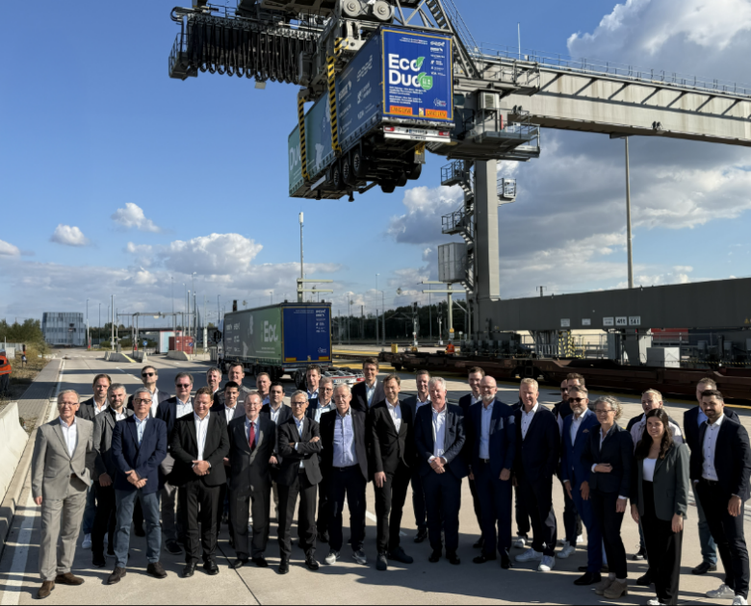

EcoDuo pilot project closing event (Copyright: VDA)

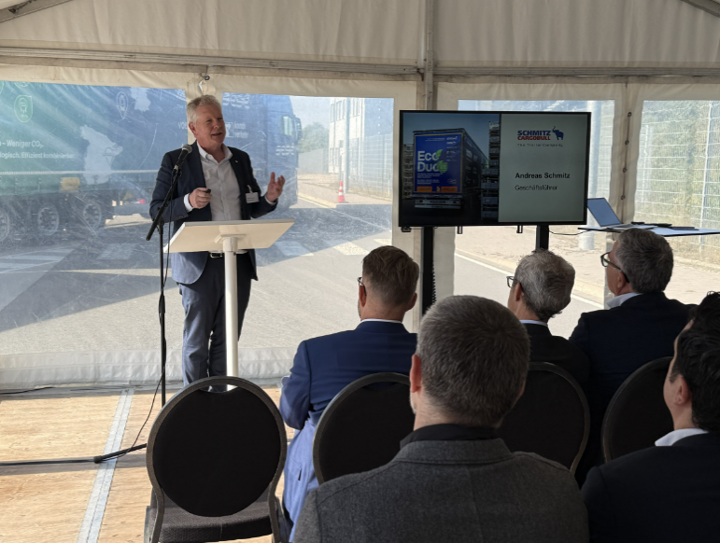

Andreas Schmitz (CEO, Schmitz Cargobull AG) at the closing event

About Schmitz Cargobull
Schmitz Cargobull is the leading manufacturer of semi-trailers for temperature-controlled freight, general cargo and bulk goods in Europe, and a pioneer in digital solutions for trailer services and improved connectivity. The company also manufactures transport cooling units for refrigerated box body semi-trailers for temperature-controlled freight transport. With a comprehensive range of services from financing, spare parts supply, service contracts and telematics solutions to used vehicle trading, Schmitz Cargobull supports its customers in optimising their total cost of ownership (TCO) and digital transformation.
Schmitz Cargobull was founded in 1892 in Münsterland, Germany. The family-run company produces around 50,000 vehicles per year with over 6,000 employees, and generated a turnover of around €2.16 billion in the financial year 2024/25. Its international production network is made up of factories in Germany, Lithuania, Spain, the UK and the Republic of Türkiye.

The Schmitz Cargobull press team:
Anna Stuhlmeier +49 2558 81-1340 I anna.stuhlmeier@cargobull.com
Andrea Beckonert +49 2558 81-1321 I andrea.beckonert@cargobull.com
Silke Hesener +49 2558 81-1501 I silke.hesener@cargobull.com

