Press Release
2023-192

Schmitz Cargobull AG

Schmitz Cargobull wins two sustainability awards

Schmitz Cargobull wins the ’European Transport Award for Sustainability 2024’ in the ’Semi-trailer’ category for the fully electric S.KOe COOL refrigerated semi-trailer and in the ’Service contracts’ category for the Full Service Retread Tyres contract.

December 2023 - Schmitz Cargobull secures the coveted sustainability award from Huss-Verlag (Germany) for 2024 - in two categories. At the award ceremony on 30 November, Marnix Lannoije, Chief Technical Officer at Schmitz Cargobull, received the awards for the fully electric S.KOe COOL refrigerated semi-trailer in the ’Semi-trailer’ category and for the Full Service Retread Tyres contract in the ’Rental, Leasing, Financing, Service Contracts’ category.

"We want to drive forward the decarbonisation of freight transport with practical, sustainable solutions that are economical for the transport company and do not represent an additional burden. We are therefore delighted with the awards for the S.KOe COOL and the service contract with retread tyres. The awards are not only a confirmation of our work, but also an obligation to further expand our range of economical and environmentally friendly solutions for our customers. There is still a lot of potential for growth here in our industry," said Lannoije at the awards ceremony.

"We are particularly proud that we have also impressed with our new Full Service Retread Tyres contract this year. With the full service contract with retread tyres, our customers increase the availability of their trailers and also make a major contribution to resource conservation, waste reduction, and the circular economy."

The Full Service Retread Tyres contract covers wear-related tyre changes to retread tyres as well as regular tyre and air pressure checks. The retread tyres save up to 80 percent of raw materials when compared to new tyres, with almost the same mileage. By retreading, the tyre life is optimised and valuable raw materials are used in the long term.

With the fully electric S.KOe COOL, Schmitz Cargobull has designed a refrigerated semi-trailer that is an economical solution for emission-free and fuel-saving transport without compromising on payload.

2023-192

The refrigerated trailer is equipped with the S.CU ep85 electric refrigeration unit, which delivers the same cooling capacity as a diesel-powered refrigeration unit. The electric generator axle recuperates energy above a certain speed and during braking, thus extending the operating time of the refrigeration machine and reducing the recharging times of the battery taking place on the power grid.

The ’European Transport Award for Sustainability’ is awarded every two years by an independent commission of experts in various categories. It is intended to encourage companies from the transport and commercial vehicle industry to act sustainably and help to firmly anchor the principles of sustainable development. The jury is made up of renowned experts from business, science, associations, and the media with in-depth knowledge of the commercial vehicle industry.

Schmitz Cargobull has won several of these awards in recent years, most recently in
2022 for the aerodynamic S.CS EcoFLEX curtainsider semi-trailer, a curtainsider from
the EcoGeneration series, in the ’Semi-trailer’ category.

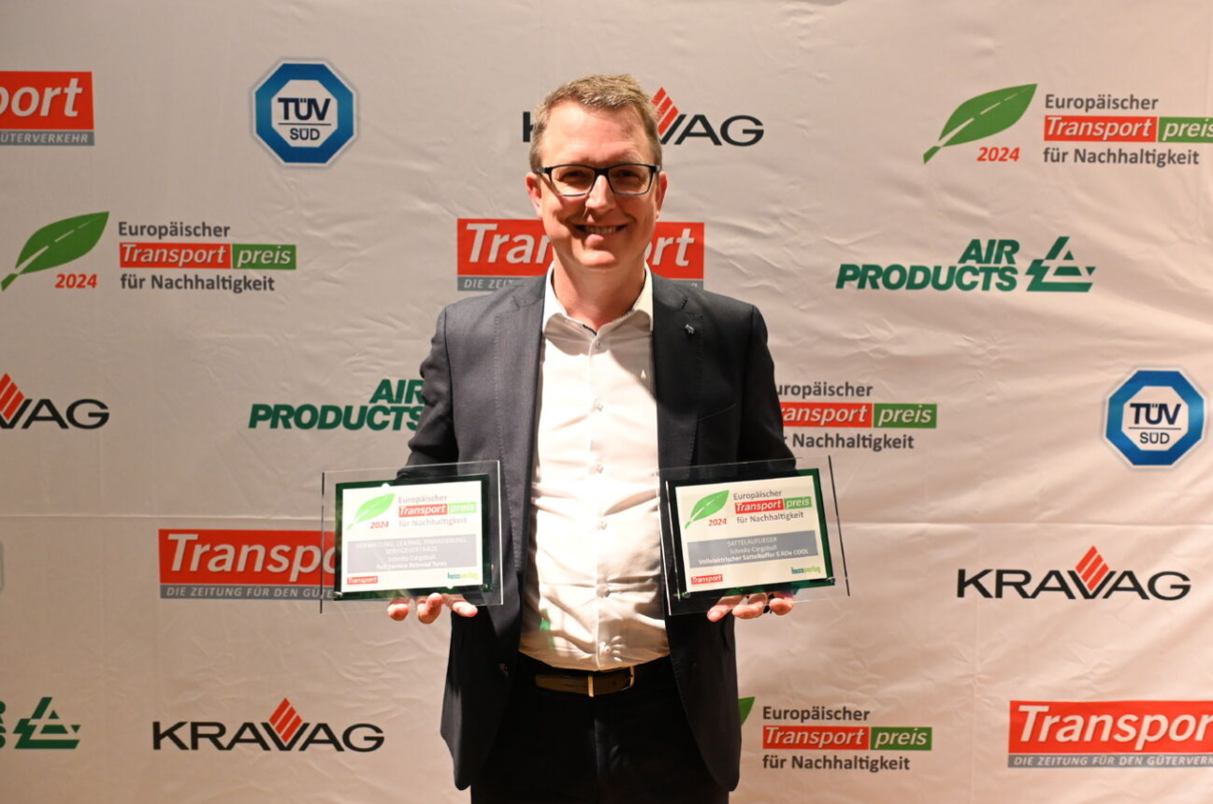
Marnix Lannoije, Chief Technical Officer at Schmitz Cargobull

About Schmitz Cargobull
Schmitz Cargobull is the leading manufacturer of semi-trailers for temperature-controlled freight, general cargo and bulk goods in Europe and a pioneer in digital solutions for trailer services and improved connectivity. The company also manufactures transport refrigeration machines for refrigerated semi-trailers for temperature-controlled freight transport. With a comprehensive range of services from financing, spare parts supply, service contracts and telematics solutions to used vehicle trading, Schmitz Cargobull supports its customers in optimising their total cost of ownership (TCO) and digital transformation.
Schmitz Cargobull was founded in 1892 in Münsterland, Germany. The family-run company produces around 60,000 vehicles per year with over 6,000 employees and generated a turnover of around 2.6 billion euros in the 2022/23 financial year. The international production network currently comprises ten plants in Germany, Lithuania, Spain, England, Turkey, Slovakia and Australia.

The Schmitz Cargobull press team:
Anna Stuhlmeier +49 2558 81-1340 I anna.stuhlmeier@cargobull.com
Andrea Beckonert +49 2558 81-1321 I andrea.beckonert@cargobull.com
Silke Hesener +49 2558 81-1501 I silke.hesener@cargobull.com

