Press Release
2026-103

Schmitz Cargobull AG
Schmitz Cargobull hands over the 1,000th S.KO COOL refrigerated trailer to NORDFROST
Successful collaboration with Schmitz Cargobull continues as operator celebrates its 50th anniversary

January 2026 - Schmitz Cargobull has handed over the 1,000th refrigerated trailer to NORDFROST GmbH & Co. KG. The handover ceremony took place at the Schneiderkrug site and marked two special events: The family-owned company NORDFROST celebrated its 50th anniversary in 2025; and its continuing successful collaboration with Schmitz Cargobull, which has lasted more than 30 years.

"We are delighted about the delivery of the 1,000th refrigerated trailer by Schmitz Cargobull as a reliable partner who fulfils our high demands on quality and flexibility - two crucial aspects for our customers from the food industry, wholesale and retail, import and export, to be able to offer optimal transport solutions throughout Europe," says Britta Bartels, owner of NORDFROST.

Schmitz Cargobull delivered the first vehicles to NORDFROST back in the mid-1990s. Today, the logistics company is the market leader in frozen food logistics with 40 branches throughout Germany. NORDFROST relies on state-of-the-art technology: the vehicles used are equipped with double-evaporator refrigeration systems that enable transportation in two temperature ranges - a prerequisite for flexibility and efficiency in temperature-controlled logistics.

"Every S.KO COOL refrigerated lorry is a building block for smooth refrigerated transport. The handover of the 1,000th refrigerated trailer to NORDFROST is a strong signal: NORDFROST relies on reliability and Schmitz Cargobull supplies the technology for this. We are delighted to contribute to the successful temperature-controlled logistics of our customer with our vehicles," says Frank Reppenhagen, Director for Western Europe at Schmitz Cargobull.

2026-103

NORDFROST GmbH & Co. KG is the market leader in frozen food logistics and offers customers from the entire food industry comprehensive and customised solutions in warehousing, transport and port logistics. The family-owned company also provides services for non-food, pharmaceuticals and breakbulk (project shipments) as well as container-related services, primarily at its port locations. With 2,300 employees, the logistics company operates 40 locations across Germany with a capacity of around 1 million pallet spaces as well as a Europe-wide groupage transport network specialising in the fine distribution of frozen goods. NORDFROST is managed from the European headquarters in Schortens, Lower Saxony, by Britta Bartels (Chairwoman of the Management Board) and the Managing Directors Philipp Brandstrup and Dennis Gloystein. Founded in 1975 by Horst Bartels, the company is 100% family owned.

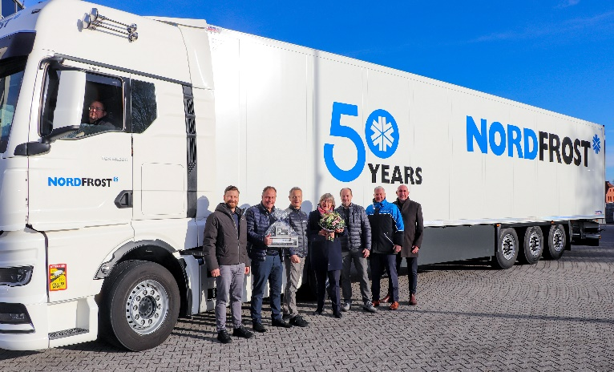
Caption: From left: Mathias Liebezeit, Sales Manager Northern Germany, Schmitz Cargobull; Rene Lemke, Head of Sales Area Bielefeld, Schmitz Cargobull; Frank Reppenhagen, Director Region Western Europe Schmitz Cargobull; Britta Bartels (Chairwoman of the Management Board NORDFROST); Frank Wronn (Head of Transport Logistics Division NORDFROST); Illja Vossig (Branch Manager Schneiderkrug NORDFROST); Ingo Weber (Special Representative International Transport Logistics NORDFROST).

About Schmitz Cargobull
Schmitz Cargobull is the leading manufacturer of semi-trailers for temperature-controlled freight, general cargo and bulk goods in Europe, and a pioneer in digital solutions for trailer services and improved connectivity. The company also manufactures transport cooling units for refrigerated box body semi-trailers for temperature-controlled freight transport. With a comprehensive range of services from financing, spare parts supply, service contracts and telematics solutions to used vehicle trading, Schmitz Cargobull supports its customers in optimising their total cost of ownership (TCO) and digital transformation.
Schmitz Cargobull was founded in 1892 in Münsterland, Germany. The family-run company produces around 50,000 vehicles per year with over 6,000 employees and generated a turnover of around €2.16 billion in the financial year 2024/25. Its international production network is made up of factories in Germany, Lithuania, Spain, Turkey and the UK.

The Schmitz Cargobull press team:
Anna Stuhlmeier +49 2558 81-1340 I anna.stuhlmeier@cargobull.com
Andrea Beckonert +49 2558 81-1321 I andrea.beckonert@cargobull.com
Silke Hesener +49 2558 81-1501 I silke.hesener@cargobull.com

