Press Release
2025-155

Schmitz Cargobull AG
Schmitz Cargobull Invests in Sub Zero to Expand Cold Chain Capabilities in India
- Strategic stake in leading refrigerated truck body manufacturer aligns with rapid market growth and drive to cut food wastage
- Modernization of production processes and introduction of advanced technologies at Sub Zero’s Pune facility

Horstmar / Pune, August 2025 – Schmitz Cargobull AG, Europe’s leading manufacturer of semi-trailers, has announced a strategic investment in Sub Zero Insulation Technologies (SZIT), one of India’s top producers of refrigerated and dry freight truck bodies. Under the agreement, Schmitz Cargobull will acquire a 27.5% equity stake in SZIT, with an option to increase its shareholding over the coming years. This partnership marks a significant milestone in Schmitz Cargobull’s global expansion strategy and strengthens its presence in the rapidly growing Indian cold chain logistics market.

“India’s cold chain sector is evolving rapidly, and Sub Zero has demonstrated strong potential to lead this transformation. By combining Schmitz Cargobull’s engineering expertise with Sub Zero’s market reach, we aim to deliver high-quality, efficient transport solutions across India and beyond. This is not just about business growth; it’s about enabling infrastructure that can help reduce the 30–40% of perishable produce lost annually due to inadequate cold-chain facilities - losses that also contribute significantly to greenhouse gas emissions” says Andreas Schmitz, CEO Schmitz Cargobull AG.

A Shared Vision for the Future
The partnership is grounded in a strong cultural alignment. Both Schmitz Cargobull and SZIT are family-led businesses that share a long-term vision, strong values, and a focus on innovation and customer-centric development. The Khira family’s legacy in vehicle body

2025-155

building in India dates back to 1949, and Sub Zero has carried this legacy forward with a focus on modern design, quality, and high efficiency bodies since 2015.

Sub Zero is today a leading Indian manufacturer of insulated and refrigerated truck bodies, producing over 1,500 units annually and serving as an approved supplier for major OEMs, including Tata Motors, Mahindra, Ashok Leyland, Volvo Eicher, Isuzu, and Bharat Benz.

“This partnership represents a pivotal moment for Sub Zero and for India’s cold chain ecosystem. With Schmitz Cargobull as our partners, we are entering a new era of quality, technology, and international standards. By improving cold-chain efficiency, we can drastically cut wastage, boost farmer incomes, improve food availability, and significantly lower the carbon footprint from decomposing perishables. We remain committed to our customers, and our mission to deliver best-in-class transport solutions across India and emerging markets” says Deep Khira, Founder & CEO of Sub Zero.

Key Collaboration Areas:
- Modernization of production processes at Sub Zero’s Pune facility.
- Introduction of Schmitz Cargobull’s advanced technologies, including insulated panels and trailer telematics.
- Training & knowledge exchange programs between the Indian and German teams.
- Export of easy to assembly modular kits for refrigerated and dry freight truck body applications to support both domestic and international markets.

This investment supports Schmitz Cargobull’s broader strategy to expand its footprint in emerging markets and promote sustainable, locally adapted solutions that raise the standard of transport infrastructure globally.

2025-155


Deep Khira, Founder & CEO of Sub Zero Andreas Schmitz, CEO Schmitz Cargobull AG

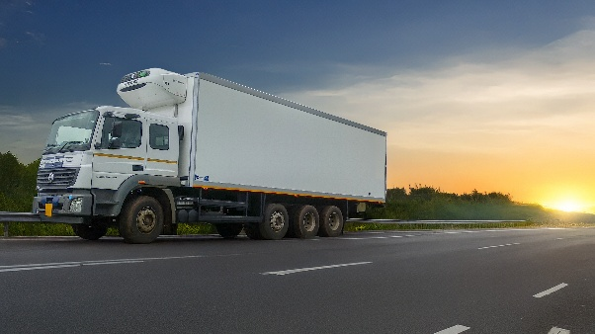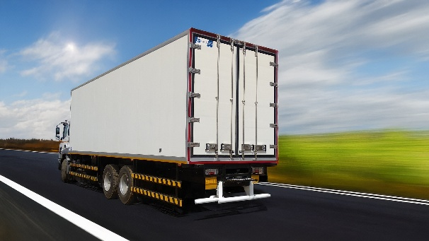
Refrigerated trailer from Sub Zero Insulation Technologies

About Sub Zero Insulation Technologies
Founded in 2015 and based in Pune, Sub Zero is one of India’s leading manufacturers of refrigerated and dry freight truck bodies. With about 120 employees, the business is producing about 1,500 bodies per year.
Building on the Khira family’s rich legacy in automotive body building, the company is recognized for its use of durable reefer boxes, superior thermal performance, and commitment to quality.

About Schmitz Cargobull
Schmitz Cargobull is the leading manufacturer of semi-trailers for temperature-controlled freight, general cargo and bulk goods in Europe, and a pioneer in digital solutions for trailer services and improved connectivity. The company also manufactures transport cooling units for refrigerated box body semi-trailers for temperature-controlled freight transport. With a comprehensive range of services from financing, spare parts supply, service contracts and telematics solutions to used vehicle trading, Schmitz Cargobull supports its customers in optimising their total cost of ownership (TCO) and digital transformation. Schmitz Cargobull was founded in 1892 in Münsterland, Germany. The family-run company produces around 60,000 vehicles per year with over 6,000 employees and generated a turnover of around €2.4 billion in the 2023/24 financial year. The international production network currently comprises ten plants in Germany, Lithuania, Spain, England, Turkey, Slovakia and Australia.

The Schmitz Cargobull press team:
Anna Stuhlmeier +49 2558 81-1340 I anna.stuhlmeier@cargobull.com
Andrea Beckonert +49 2558 81-1321 I andrea.beckonert@cargobull.com
Silke Hesener +49 2558 81-1501 I silke.hesener@cargobull.com

