Press Release
2025-157

Schmitz Cargobull AG
Schmitz Cargobull receives validation for net-zero targets from the Science Based Targets initiative (SBTi)
- SBTi confirms short- to long-term emission reduction targets

- Clear commitment to our net-zero target by fiscal year 2044/45 across the
entire value chain

September 2025 – Schmitz Cargobull AG has received official confirmation from the Science Based Targets initiative (SBTi) that its short- to long-term targets for reducing greenhouse gas emissions meet the SBTi criteria. This means that the targets submitted have been validated according to climate science-based standards and are in line with the Paris Agreement's goal of limiting global warming to below 2 degrees. The measures to achieve the targets include decarbonising the cold chain, the materials used and the company's own transport logistics.
“Our goal is to align our economic activity and our products for a sustainable transport industry with climate protection. As a leading European manufacturer of semi-trailers, we have integrated our sustainability goals into our overall strategy as part of our corporate responsibility. We are committed to fair CO₂ pricing and market-based incentives instead of distorting subsidies. The validation of our net-zero targets by the SBTi underlines the credibility of our commitment,” says Dr Günter Schweitzer, COO, Schmitz Cargobull AG.
“The validation is also recognition of the excellent work of the entire Schmitz Cargobull team on the road to our science-based net-zero target. We have set ourselves this goal for fiscal year 2044/45.”

Commitment to long-term net-zero target by 2045
Specifically, Schmitz Cargobull is committed to reach net-zero greenhouse gas emissions across the value chain by the financial year 2044/45. When it comes to short-term targets, Schmitz Cargobull is committed to reducing absolute greenhouse gas emissions in Scope 1 and 2 by 90 per cent by the financial year 2029/30 compared to the base financial year 2021/22. In addition, absolute greenhouse gas emissions in Scope 3 are to be

2025-157
reduced by 35 per cent by the financial year 2034/35 compared to the base financial year 2021/22.
The long-term target is to maintain a minimum of 90% absolute scope 1 and 2 GHG emissions reductions from financial year 2029/30 through financial year 2044/45 from a base financial year 2021/22.
Schmitz Cargobull also commits to reducing its absolute greenhouse gas emissions in Scope 3 by 90 per cent by the financial year 2044/45 from a base financial year FY2021/22.
The target boundaries include land-related emissions and removals from bioenergy feedstocks.
These targets have been validated by the SBTi and meet the requirements of the current SBTi standard.

Guidelines for responsible entrepreneurship
Schmitz Cargobull’s sustainability strategy is consistently focused on three areas of action: products & services, the environment and people, and involves all Schmitz Cargobull locations. This focus is based on eight areas of action. Key areas have been defined for each area of action, which include targets, milestones and operational measures.

About the Science Based Targets initiative (SBTi):
The SBTi is a joint initiative of the global non-profit environmental organisation Carbon Disclosure Project (CDP), the UN Global Compact, the World Resources Institute (WRI) and the World Wide Fund for Nature (WWF). It supports companies in achieving emission reduction targets in line with current climate science. An essential basis for this is the Paris Agreement, in which the signatory states committed themselves to limiting global warming to below 2 degrees Celsius compared to pre-industrial levels.

2025-157



Dr. Günter Schweitzer – Chief Operations Officer, Schmitz Cargobull

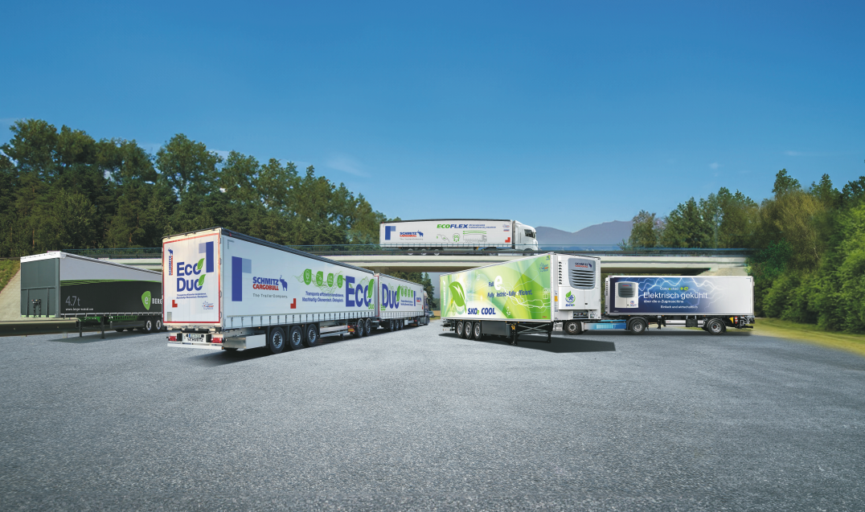

Schmitz Cargobull Eco-Portfolio



About Schmitz Cargobull
Schmitz Cargobull is the leading manufacturer of semi-trailers for temperature-controlled freight, general cargo and bulk goods in Europe, and a pioneer in digital solutions for trailer services and improved connectivity. The company also manufactures transport cooling units for refrigerated box body semi-trailers for temperature-controlled freight transport. With a comprehensive range of services from financing, spare parts supply, service contracts and telematics solutions to used vehicle trading, Schmitz Cargobull supports its customers in optimising their total cost of ownership (TCO) and digital transformation. Schmitz Cargobull was founded in 1892 in Münsterland, Germany. The family-run company produces around 60,000 vehicles per year with over 6,000 employees and generated a turnover of around €2.4 billion in the 2023/24 financial year. The international production network currently comprises ten plants in Germany, Lithuania, Spain, England, Turkey, Slovakia and Australia.

The Schmitz Cargobull press team:
Anna Stuhlmeier +49 2558 81-1340 I anna.stuhlmeier@cargobull.com
Andrea Beckonert +49 2558 81-1321 I andrea.beckonert@cargobull.com
Silke Hesener +49 2558 81-1501 I silke.hesener@cargobull.com

