Press Release
2026-506

Schmitz Cargobull AG
S.BO OPENSIDER: More flexibility in dry freight transport
Schmitz Cargobull is expanding its portfolio with the side-opening S.BO OPENSIDER, a dry freight box for fast and efficient loading and unloading processes

June 2026 – The dry freight semi-trailer S.BO OPENSIDER is designed for applications where fast access to the goods, flexible loading processes and short throughput times are paramount. The vehicle is based on the previous S.KO folding wall semi-trailer.

The side walls, which open completely, allow direct access to the load even in locations with limited rear access, especially in urban use. This significantly accelerates loading and unloading processes and reduces downtimes at ramps. Occupational safety is also improved by minimising the need to step on the trailer.

The S.BO OPENSIDER is available for different application requirements: as an EU variant for 4x2 semi-trailer tractors with a 7,700mm wheelbase and as a Nordic variant for a 6x2 semitrailer tractor with a wheelbase of 8,130mm. For maximum flexibility, sidewalls that open on one or both sides are available, depending on the application.

Another focus is on safety and reliability in daily use. The FERROPLAST® box body meets the requirements of DIN EN 12642 Code XL, reliably protects the load from external influences and is therefore suitable for the transport of demanding dry freight.

The trailer offers a variety of equipment options for individual adaptation to different transport requirements. These include flexible solutions for load securing, double-decker systems and other optional specifications for special applications.

2026-506

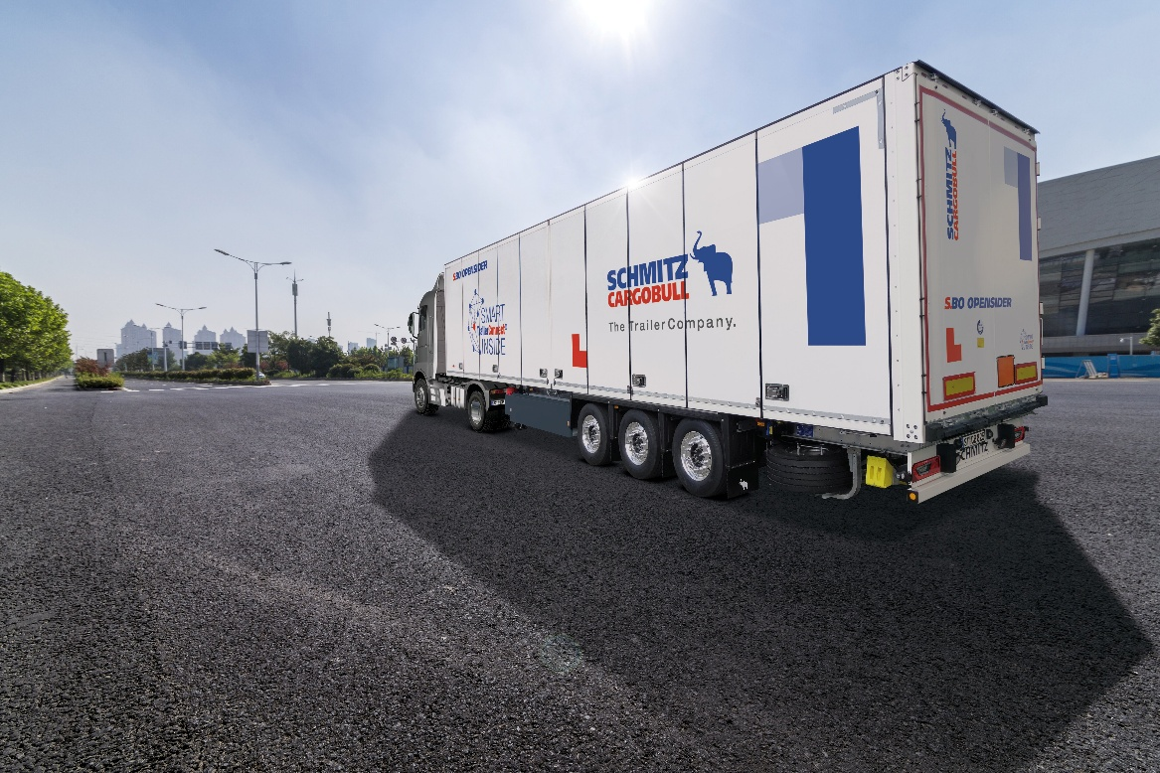
Caption: The new Schmitz Cargobull dry freight box S.BO OPENSIDER for fast and efficient loading and unloading processes

About Schmitz Cargobull
Schmitz Cargobull is the leading manufacturer of semi-trailers for temperature-controlled freight, general cargo and bulk goods in Europe, and a pioneer in digital solutions for trailer services and improved connectivity. The company also manufactures transport cooling units for refrigerated box body semi-trailers for temperature-controlled freight transport. With a comprehensive range of services from financing, spare parts supply, service contracts and telematics solutions to used vehicle trading, Schmitz Cargobull supports its customers in optimising their total cost of ownership (TCO) and digital transformation.
Schmitz Cargobull was founded in 1892 in Münsterland, Germany. The family-run company produces around 50,000 vehicles per year with over 6,000 employees and generated a turnover of around €2.16 billion in the financial year 2024/25. Its international production network is made up of factories in Germany, Lithuania, Spain, Turkey, Romania and the UK.

The Schmitz Cargobull press team:
Anna Stuhlmeier +49 2558 81-1340 I anna.stuhlmeier@cargobull.com
Andrea Beckonert +49 2558 81-1321 I andrea.beckonert@cargobull.com
Silke Hesener +49 2558 81-1501 I silke.hesener@cargobull.com

