Press Information
2019-134

Schmitz Cargobull AG
“Green Truck Future Innovation” Award 2019 goes to Schmitz Cargobull for its EcoDuo concept
The long HGV concept impressed the expert jury

June 2019 – VerkehrsRundschau and TRUCKER have awarded Schmitz Cargobull the “Green Truck Future Innovation” Award 2019 for its EcoDuo long HGV concept. The market leader convinced the expert jury with the vehicle combination which is capable of achieving CO2 savings of 25% for long-distance international freight transport. During the kick-off event for the transport logistic trade show in Munich, the editorial officers awarded the coveted environmental prize for the ninth time in eight categories: Truck, Light Truck, Van, Innovation, Future Innovation, Trailer Innovation, Body Solution as well as Logistics Solution. Boris Billich, Sales Director at Schmitz Cargobull AG, accepted the award from Gerhard Grünig, the magazine’s editor-in-chief.

With the EcoDuo concept, Schmitz Cargobull advocates the Europe-wide introduction of a transport concept which places no further burden on the existing infrastructure and reduces CO2 emissions despite the rising transport volumes, while also taking into account current trailer and logistics standards in the transport industry and is optimally designed for point-to-point transport using the primary road network.

“We are very pleased to receive this award and truly stand behind this concept. This vehicle combination is currently only used in Scandinavia and is being tested in individual European countries. However, we regard the EcoDuo concept as an ecologically and economically efficient Europe-wide transport solution over the long term,” explains Billich.

The EcoDuo system consists of two standard curtainsider semi-trailers connected via a dolly and coupled to a tractor unit. The total tractor-trailer weight of the tractor unit and the first trailer remains unchanged at 40 tonnes and the train weight of the second trailer can vary to up to 36 tonnes, which complies with the regulations

2019-134

in Scandinavia. This vehicle combination is currently being tested in Spain with a tractor-trailer weight of 40 tonnes for the first trailer and 30 tonnes for the second.
Schmitz Cargobull presents a concept which has already been successfully established in other European countries. It makes a key contribution to reducing transport and, thus, minimising pollution. According to the expert jury, this concept also has the potential to make a positive contribution in Germany.

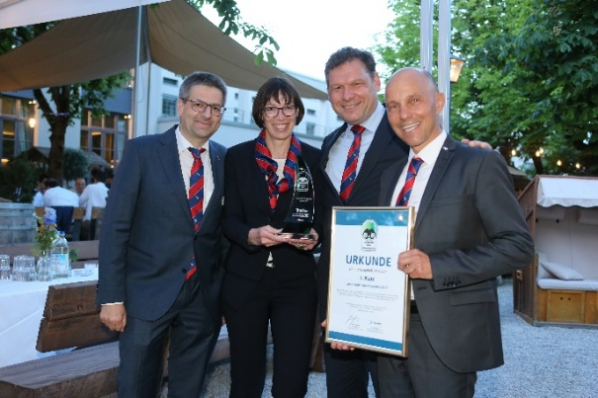
Image 1 - Copyright: Karel Sefrna/VerkehrsRundschau Image 2 - Copyright: Schmitz Cargobull

Picture captions:
Image 1:
From left: Christoph Dehne (Director Region Central Europe at Schmitz Cargobull),
Anna Stuhlmeier (Head of Marketing Communications & PR at Schmitz Cargobull),
Boris Billich (Chief Sales Officer at Schmitz Cargobull), Jörg Irsfeld (Director International Key Account Management at Schmitz Cargobull)
Image 2:
EcoDuo - The long HGV concept impressed the expert jury

About Schmitz Cargobull
With an annual production of more than 61,000 vehicles and approximately 6400 employees, Schmitz Cargobull AG is Europe’s leading manufacturer of semi-trailers, trailers and vehicle bodies for temperature control freight, general cargo and bulk goods. The company achieved sales of almost €2.2 billion in the 2017/2018 financial year. As a pioneer in the industry, the North German company developed a comprehensive brand strategy early on and consistently established quality standards at all levels: from research and development to production and service contracts, trailer telematics, financing, spare parts supply and used vehicle trade.

The Schmitz Cargobull press team:
Anna Stuhlmeier: +49 2558 81-1340 I anna.stuhlmeier@cargobull.com
Andrea Beckonert: +49 2558 81-1321 I andrea.beckonert@cargobull.com
Silke Hesener: +49 2558 81-1501 I silke.hesener@cargobull.com

