Press Release
2019-115

Schmitz Cargobull AG
Schmitz Cargobull expands its production capacity for insulated trailers and semi-trailers
New foaming press commissioned at the Lithuanian plant

April 2019 – On 22 March, the new foaming press for the manufacture of the FERROPLAST® insulation system was commissioned in an official ceremony at the Lithuanian Schmitz Cargobull plant in Panevėžys. With the new equipment
the company expands its production capacity from the previous number of 10 insulated trailers to
30 trailers per day.

“Whether in the transport of fresh or frozen foods or of sensitive pharmaceutical products, this capacity expansion has a positive effect for customers. They benefit not only
from higher flexibility, which results, among other things, in shorter delivery times, but also from more trailer variants, which we can manufacture in a more country-specific manner with the new equipment“, said Roland Klement, Chief Technical Officer at Schmitz Cargobull during the commissioning.

Besides S.CS curtainsider semi-trailers and S.KO reefer semi-trailers, M.KO truck box bodies for trucks and vans from 12 t as well as Z.KO central axle box trailers and A.KO box trailers are also manufactured at the Lithuanian factory. The additional capacity from the new foaming system will be used especially for the further expansion of the product range in the box body and trailer area.
The trucks with the M.KO body are used mainly for the inner-city distribution of goods as well as for local transport. It is for these vehicle bodies in particular that the new foaming system provides better insulation properties. The bolted subframe ensures compatibility with all the leading truck manufacturers. The finely-adjusted hole patterns in the subframe permit the body to be force-fitted to the manufacturer-specific and vehicle-specific attachment points. Depending on the task at hand and the customer’s requirements, the body can also be adjusted to meet various lengths and load requirements. Schmitz
2019-115

Cargobull is continuously developing its transport solutions in close cooperation with the customers.
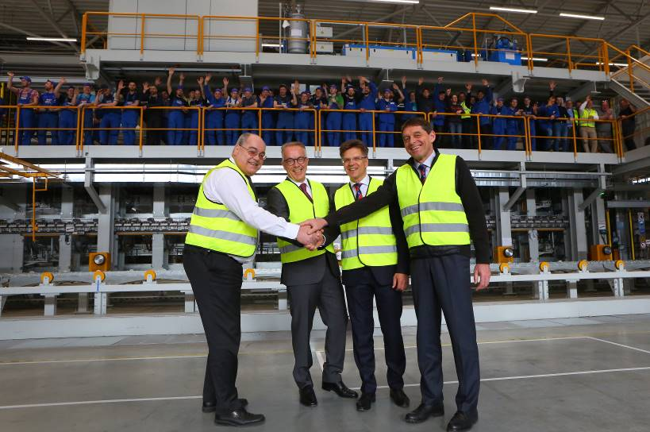
From l to r: Alois Schmid - Managing Director Hennecke, Dietrich Zaps – Supervisory Board Member of Schmitz Cargobull AG, Raimundas Petrauskas – Managing Director Schmitz Cargobull Baltic UAB, Roland Klement – Chief Technical Officer Schmitz Cargobull AG
About Schmitz Cargobull
With an annual production of more than 61,000 trailers and with around 6,400 employees, Schmitz Cargobull AG is Europe's leading manufacturer of semi-trailers, trailers and truck bodies for temperature-controlled freight, general cargo and bulk goods. The company achieved sales of almost € 2.2 billion in the 2017/2018 financial year. As a pioneer in the industry, the North German company developed a comprehensive brand strategy early on and consistently established quality standards at all levels: from research and development to production and through to specialist services such as consulting, trailer telematics, financing, spare parts and used vehicles.
The Schmitz Cargobull press team:
Anna Stuhlmeier: +49 2558 81-1340 I anna.stuhlmeier@cargobull.com
Andrea Beckonert: +49 2558 81-1321 I andrea.beckonert@cargobull.com
Silke Hesener: +49 2558 81-1501 I silke.hesener@cargobull.com

