Press Release
2019-300

Schmitz Cargobull AG

Robust trailer solution for a total weight of up to 50 tonnes
The new curtainsider semi-trailer for the Scandinavian market: the S.CS UNIVERSAL with the KP+ equipment variant offers an increased fifth wheel load of up to 18 tonnes.
March 2019 - In Scandinavia, long truck-trailer combinations with higher permissible total weights than in the rest of Europe have been operating on the region’s roads for many years. In Denmark, the longitudinal dimension of trucks is restricted to the usual European values - 18.75 m for truck-trailers and 16.5 m for articulated vehicles. However, higher total weights are permitted.
With the S.CS UNIVERSAL curtainsider semi-trailer with KP+ equipment (King Pin Plus), Schmitz Cargobull presents a chassis that can be driven with a permissible total weight of up to 50 tonnes.

The new S.CS UNIVERSAL curtainsider semi-trailer with KP+ increases efficiency in the fleet and improves handling and safety. Due to the reinforced chassis construction, a fifth wheel load of up to 18 tonnes is possible. The extended offset area and a 8,130 mm wheelbase are further key product characteristics. This increases the payload and offers more flexibility in partial loading, as there is less risk of the drive axle being overloaded. Particularly in winter or when driving on rough roads, the resulting increased traction on the drive axle is a major advantage.

The S.CS UNIVERSAL with KP+ also increases flexibility in the fleet. Besides 2-axle tractor units, the trailer can also be towed by 3-axle tractor units (6x2 and 6x4) with a larger turning circle. The bolted and galvanised chassis offers extra carrying capacity due to an increased distributed load and is less susceptible to

2019-300
environmental impacts. Thanks to the Schmitz Cargobull modular design principle, it also offers improved ease-of-repair, as individual components can be quickly and easily exchanged - a plus for durability and increased resale value.

The new KP+ equipment package is also available for platform vehicles. Thus it also offers possibilities for the transport of extra wide and bulky goods, building materials and other freight that does not need protection against the effects of the weather.

Whether with VARIOS or POWER CURTAIN – the new S.CS UNIVERSAL with KP+ equipment can be combined with all Schmitz Cargobull curtainsider body variants. When it comes to rapid turnaround times and easy load securing in everyday transport operations, the trailer can be optionally equipped with the POWER CURTAIN body, which does not require support laths. The trailer is equipped with the proven Schmitz Cargobull axle unit as standard. Schmitz Cargobull offers a warranty of a million kilometres or six years on the axle (excluding wear parts).

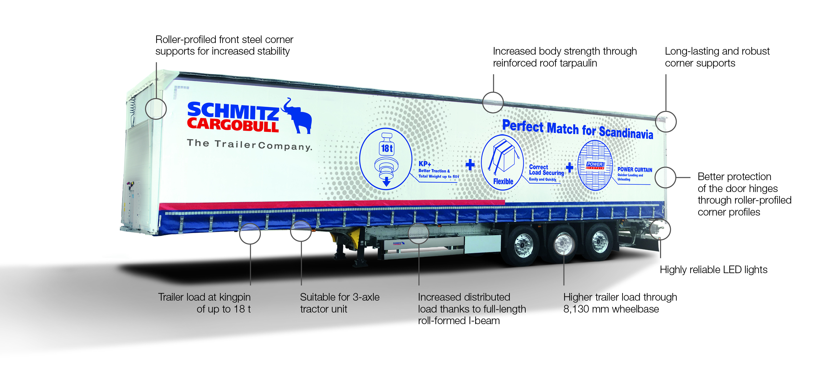

About Schmitz Cargobull
With an annual production of more than 61,000 trailers and with around 6,400 employees, Schmitz Cargobull AG is Europe's leading manufacturer of semi-trailers, trailers and truck bodies for temperature-controlled freight, general cargo and bulk goods. The company achieved sales of almost € 2.2 billion in the 2017/2018 financial year. As a pioneer in the industry, the North German company developed a comprehensive brand strategy early on and consistently established quality standards at all levels: from research and development to production and service contracts, trailer telematics, financing, spare parts supply and used vehicle trade.
The Schmitz Cargobull press team:
Anna Stuhlmeier: +49 2558 81-1340 I anna.stuhlmeier@cargobull.com
Andrea Beckonert: +49 2558 81-1321 I andrea.beckonert@cargobull.com
Silke Hesener: +49 2558 81-1501 I silke.hesener@cargobull.com

