Press Release
2023-147

Schmitz Cargobull AG
First 100% all-electric reefer from Schmitz Cargobull for Finland
PNO Rental takes delivery of Schmitz Cargobull's fully electric S.KOe COOL for end customer Kylmästi Paras

June 2023 - The success story of the S.KOe COOL all-electric semi-trailer continues. After vehicle deliveries in Romania and Germany, the first all-electric vehicle has now been handed over in Finland. This also makes it the first series-produced all-electric Schmitz Cargobull semi-trailer in Scandinavia.
Together with other representatives of Schmitz Cargobull AG, Felix Müller, Key Account Manager at Schmitz Cargobull and Tuomas Koskinen, Sales, After Sales and Service Sales Manager at Schmitz Cargobull Finland, handed over the fully electric semi-trailer to Kai Mäkinen, Key Account Manager at PNO Finland and Jani Närhi, CEO and Minna Lindeqvist COO from the end customer Kylmästi Paras. During the ceremonial handover at the Schmitz Cargobull site in Vantaa, Finland, the advantages of the all-electric semi-trailer were presented in detail and its mode of operation was demonstrated in practice.
"PNO is one of the main players in Finland when it comes to sustainable transport. The all-electric reefer is part of a long-term sustainability strategy and we are pleased that Kylmästi Paras is the first Finnish carrier to include this vehicle in its fleet," says Kai Mäkinen.
"Both PNO Rental and Kylmästi Paras are long-standing business partners and we are pleased to be able to provide them with an efficient and sustainable vehicle for temperature-controlled transport in the form of the S.KOe COOL all-electric reefer," says Felix Müller.
The vehicle will be used in the Helsinki metropolitan area for inner-city distribution transport to local grocery stores. It is equipped with an electric Volvo tractor unit, making it a 100% electric vehicle combination.

2023-147

The emission free, all-electric S.KOe COOL semi-trailer is equipped with an all-electric refrigeration unit with integrated power electronics, a high-voltage battery and an axle generator. The electrified vehicle is also extremely quiet, enabling deliveries in urban areas in the early morning hours as well as in the late evening. The electrically powered S.CU ep85 refrigeration unit is designed for emission-free cooling and heating of the load. It offers a cooling capacity of up to 15,800 watts and a heating capacity of 10,500 watts. Batteries on the support winch replace the diesel tank, and also offer the option of installing an additional pallet box with space for 36 pallets. The electrified Schmitz Cargobull trailer axle recuperates energy during braking, among other things, and therefore extends the operating time of the refrigeration machine or reduces the recharging times of the battery via the power grid.
Schmitz Cargobull is the market leader in the manufacture of semi-trailers and offers reliable and innovative transport solutions for customers all over the world. With over 130 years of experience in the manufacture of semi-trailers and a dedicated team of professionals, Schmitz Cargobull is renowned for the quality, performance and innovation of its products. The company has invested in research and development for sustainable and energy-efficient transport solutions for many years, making it one of the pioneers in innovation in the trailer industry.
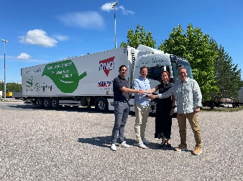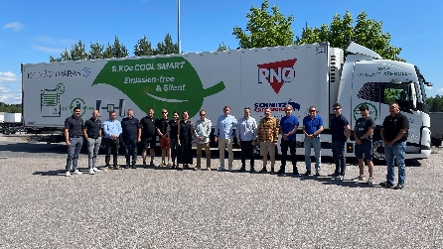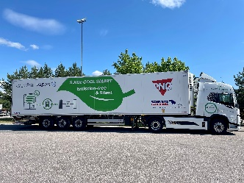
Caption: from left: Handshake in front of the new semi-trailer: Kai Mäkinen, PNO Rental, Jani Närhi and Minna Lindeqvist, Kylmästi Paras and Felix Müller, Schmitz Cargobull.
Caption 2: Working together for more sustainability in road transport: Representatives of PNO, Kylmästi Paras and Schmitz Cargobull
Caption 3: The all-electric box body semi-trailer S.KOe COOL

About Schmitz Cargobull
With an annual production of around 61,000 trailers and with approximately 6,900 employees, Schmitz Cargobull AG is Europe’s leading manufacturer of semi-trailers, trailers and truck bodies for temperature-controlled freight, general cargo and bulk goods. The company achieved sales of around €2.3 billion in the 2021/22 financial year. As a pioneer in the industry, the North German company developed a comprehensive brand strategy early on and consistently established quality standards spanning every level: from research and development, through production and service contracts, to trailer telematics, financing, spare parts, and used vehicles.

The Schmitz Cargobull press team:
Anna Stuhlmeier +49 2558 81-1340 I anna.stuhlmeier@cargobull.com
Andrea Beckonert +49 2558 81-1321 I andrea.beckonert@cargobull.com
Silke Hesener: +49 2558 81-1501 I silke.hesener@cargobull.com

