Press Release
2022-112

Schmitz Cargobull AG
Complete trust in TrailerConnect®
Danish transport company FREJA Transport & Logistics is a major customer of Schmitz Cargobull's own trailer telematics from the very beginning.

March 2022 – Reliable trailers and high-quality transports – that's what the FREJA Transport and Logistics company trusts in. The company, based in Skive in Denmark, has relied on Schmitz Cargobull trailers and services for almost two decades. But there was another round-number anniversary to celebrate about two years ago: The TrailerConnect® telematics system from Schmitz Cargobull had been in use on vehicles of the Danish transport company for exactly ten years. Due to the continuing coronavirus situation, it’s only now that representatives from FREJA and Schmitz Cargobull's subsidiary Cargobull Telematics met in Münster to officially celebrate the anniversary.

FREJA's S.KO box body semi-trailers as well as all its S.CS curtainsiders and S.KO 25 dry-freight box semi-trailers are equipped with the TrailerConnect® telematics system. As well as indicating the location of the trailer, the trailer telematics system provides intelligent networking and a rapid diagnosis of all the trailer components, together with reliable integrated temperature management in the refrigerated vehicles. The telematics system enables processes to be optimised and transport safety to be increased. Currently over 2,000 trailers in the fleet are equipped with the TrailerConnect® telematics system, ensuring reliable transparency and process optimisation.

2022-112

"We were among the very first customers to equip their vehicles with trailer telematics from Schmitz Cargobull. In intensive cooperation with the product experts from Schmitz Cargobull, we were able to define the individual configurations that were important for us. With the telematics application,
we can plan our fleet even better and reduce CO₂ emissions by avoiding empty runs," reports Lars Bakkegaard, Group CFO at FREJA Transport & Logistics.

The Danes’ fleet currently consists mainly of Schmitz Cargobull vehicles. More than 75 percent of these are S.CS curtainsiders, but the inventory also includes S.KO semi-trailers for temperature-controlled goods.
With the many Schmitz Cargobull vehicles on the roads of Europe for FREJA, carrying clothing, pharmaceutical products and general cargo, among other things, reliable trailer service is essential. Here too, FREJA relies on full service contracts from Schmitz Cargobull "A broad-based service partner network and fast, uncomplicated processing is very important to us. This increases vehicle availability and saves costs," explains Lars Bakkegaard. FREJA's full-service package includes tyre and trailer service. This means that the transport company is reliably covered not only in Denmark, but throughout Europe.

FREJA Transport & Logistics offers dedicated transport, logistics and warehousing solutions in Europe and around the world, including customised and personalised service as well as guaranteed quality. The company has been privately owned since its founding in 1985 and is one of Northern Europe's leading logistics companies with branches in Denmark, Sweden, Norway, Finland, Poland and China.

2022-112

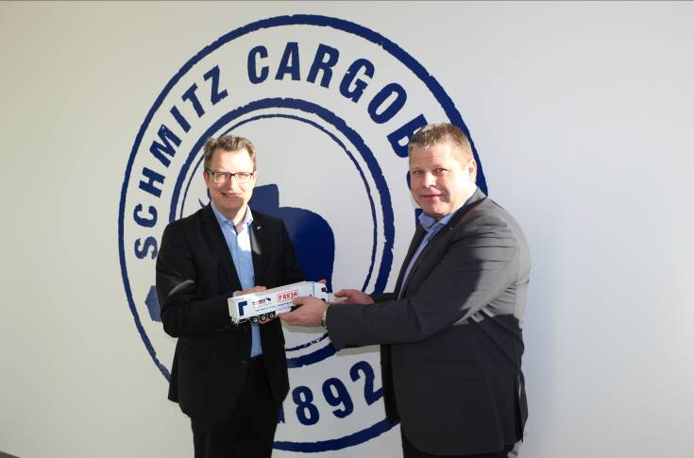
Caption: from left: Marnix Lannoije, Head of Product Line Digital Services Cargobull Telematics GmbH;
Lars Bakkegaard, Group CFO FREJA Transport & Logistics

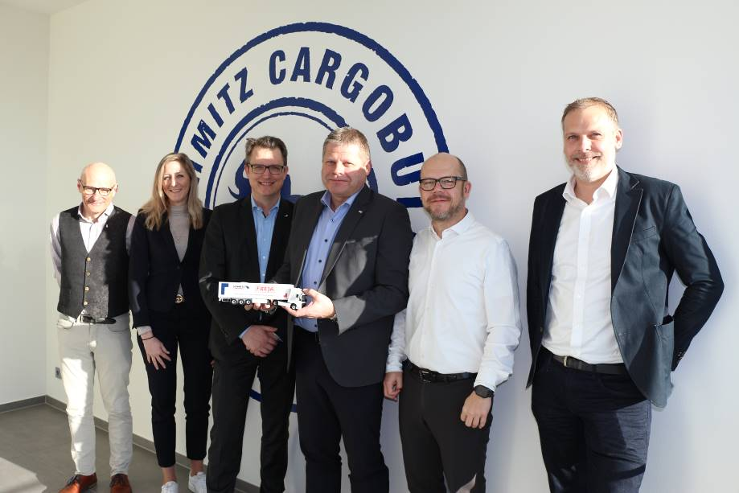
Caption: from left: Sören Danielsen, Manager Digital Service Solutions, Cargobull Telematics GmbH, Leoni Nathaus, Head of Product Management & Service Sales, Cargobull Telematics GmbH; Marnix Lannoije,
Head of Product Line Digital Services Cargobull Telematics GmbH; Lars Bakkegaard, Group CFO, FREJA Transport & Logistics; Morten Søgaard, Group IT Director, FREJA Transport & Logistics; Henrik Dejgaard,
IT Manager, FREJA Transport & Logistics

About Schmitz Cargobull
With an annual production of around 42,500 trailers and with around 5,700 employees, Schmitz Cargobull AG is Europe’s leading manufacturer of semi-trailers, trailers and truck bodies for temperature-controlled freight, general cargo and bulk goods. The company achieved sales of approximately €1.74 billion in the 2020/21 financial year. As a pioneer in the industry, the North German company developed a comprehensive brand strategy early on and consistently established quality standards spanning every level: from research and development, through production and service contracts, to trailer telematics, financing, spare parts, and used vehicles.

The Schmitz Cargobull press team:
Anna Stuhlmeier +49 2558 81-1340 I anna.stuhlmeier@cargobull.com
Andrea Beckonert +49 2558 81-1321 I andrea.beckonert@cargobull.com
Silke Hesener: +49 2558 81-1501 I silke.hesener@cargobull.com

