Press Release
2023-162

Schmitz Cargobull AG
Schmitz Cargobull joins forces with US-market leader Utility Trailer
Schmitz Cargobull transport refrigeration units now also in the USA
- Schmitz Cargobull and Utility Trailer Manufacturer launch "Cargobull North America" joint venture

- US-market leader Utility Trailer uses refrigeration technology & trailer telematics from Schmitz Cargobull

- Major American retailer – Kroger – places first order of the new, efficient, and sustainable hybrid refrigeration machines and will be the pilot customer for fully-electric transport solution

September 2023 – Two market leaders combine their know-how: Schmitz Cargobull and the US trailer manufacturer Utility Trailer Manufacturer Company LLC have founded a joint venture - "Cargobull North America" (CBNA). As a first step, the partners have developed two transport refrigeration units (TRUs), based on the Schmitz Cargobull S.CU. The 625 Hybrid and 655 MT (Multi Temp) are specially designed to meet the strict emissions requirements of California. The units come equipped with Schmitz Cargobull’s TrailerConnect® telematics system, which is exclusively installed in Utility Trailer's refrigerated trailers.
The new company and the two transport refrigeration units for the North American market will make their debut at "IFDA Distribution Solutions 2023", from September
11-13, in Fort Worth, Texas (USA). Major American retailer Kroger will be CBNA’s first customer, starting with refrigerated trailers from Utility Trailer's 3000R series and the 625 Hybrid and 655 MT (MultiTemp) Hybrid transport refrigeration machines.

"This joint venture gives us access to the American market and is an important step for the growth of Schmitz Cargobull," says Andreas Schmitz, CEO of Schmitz Cargobull AG. "We are pleased to be working with Utility Trailer, the US-market leader in temperature-controlled transport vehicles. We are convinced that Cargobull North America will create real added value for our new American customers as well as customers worldwide. The same units will eventually become available in other markets, including Germany and Europe. By pooling our resources and expertise

2023-162

we can continue our technology leadership on Transport Refrigeration Units (TRU) and Telematics.”

Joint venture starts in North America
“Our joint venture with Cargobull further positions Utility Trailer as a global leader in sustainability, fuel efficiency, and emission reduction,” Utility Trailer President and CEO Jeff Bennett said. “We don’t just want to be the biggest, but also the best, holistic destination for everything reefer customers need, from strong and lightweight boxes to energy-efficient TRUs and high-tech telematics – all in one trailer.”

CBNA’s first offering includes two energy-efficient transport refrigeration machines. The 625 Hybrid and 655 MT (MultiTemp) Hybrid models are specifically designed to meet the demanding requirements of North American refrigerated freight haulers. Both refrigeration machines are equipped with a common rail diesel engine and a hybrid-power-trail. They even meet the stringent emissions requirements of the California Air Resources Board (CARB). The next step will be the introduction of fully electric, TÜV-homologated models with battery-powered recuperation axle – which are already being successfully used in Europe.

Similar company culture
"Both Utility Trailer and Schmitz Cargobull rely on the same recipe for success: Our company culture as family-run trailer manufacturers drives us to continuously develop the best trailer technology and supply customers with an entire eco-system, including services, telematics, and optimum cargo space availability," explains Andreas Schmitz. “The fact that Utility Trailer selected our energy-efficient units in competition with other global transport refrigeration unit suppliers confirms the quality of our products and development work.”

With the Schmitz Cargobull TrailerConnect® telematics system, CBNA is entering the North American market with the most advanced offering available. The system allows customers to monitor and control the temperature, fuel consumption, vehicle position and other important parameters of their refrigerated vehicles in real time. The advanced telematics unit with LTE communications and global roaming is integrated as standard on every TRU from CBNA.

2023-162

The technology enables a state-of-the-art front end and the use of mobile applications for iOS and Android smartphones from drivers to dispatchers to fleet owners. As an open system with extensive cyber security, it gives customers the choice of how they want to utilize their data. From ERP systems to truck telematics to third-party providers or even their transportation management systems, the customer is a data owner and can choose to route their data via a simple API. In addition, telematics offers monitoring of the premium ABS modulators with all fault codes, tire pressure, door status and predictive maintenance, as well as intelligent remote control of the CBNA refrigeration unit.

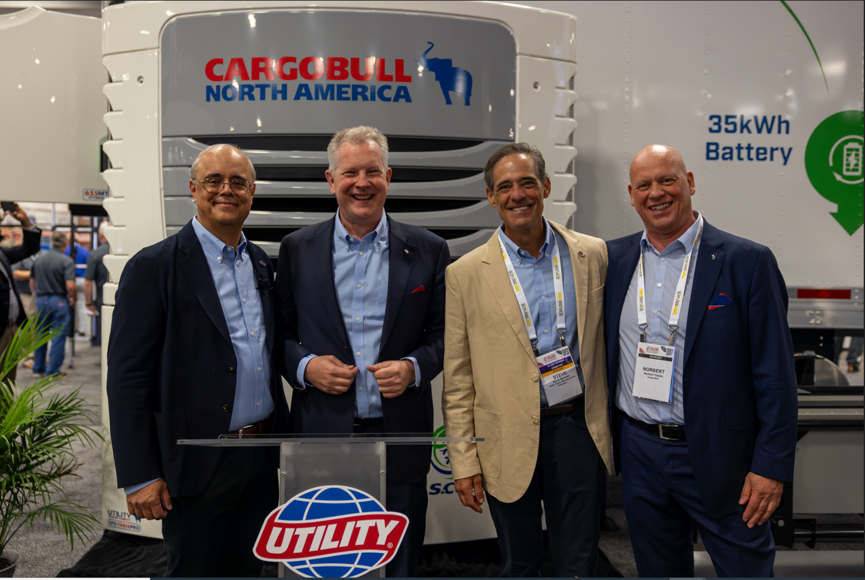
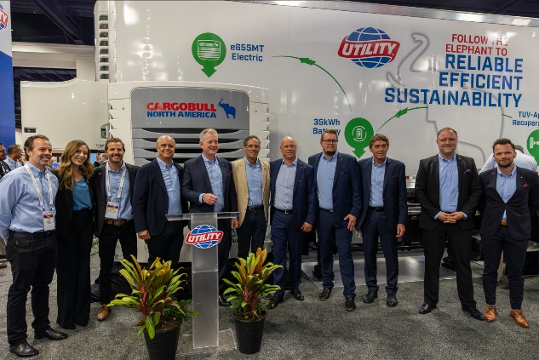
f.l..: Jeff Bennett (CEO Utility Trailers), Andreas Schmitz (CEO Schmitz Cargobull), Steve Bennett (COO Utility Trailers),
Norbert Flacke (Managing Director Cargobull Cool)

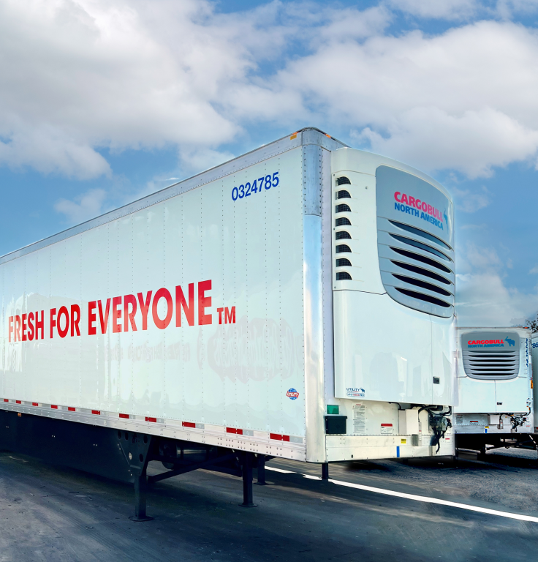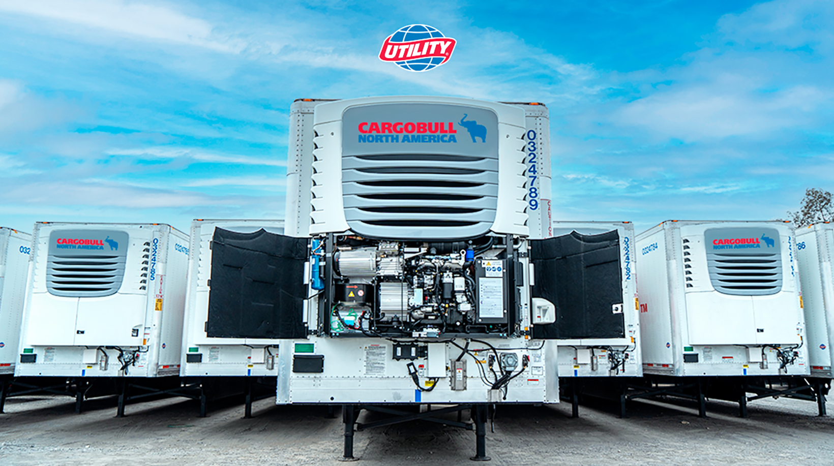

2023-162

About Utility Trailer Manufacturing Company, LLC
Utility Trailer Manufacturing Company, LLC is America’s oldest privately owned, family-operated trailer manufacturer. Founded in 1914, Utility Trailer’s history of innovation and customer-value focus have helped it become the largest producer of refrigerated trailers and one of the largest dry van, reefer, and flatbed manufacturers in the United States. With six manufacturing facilities and a network of more than 100 dealers across North and South America, the company produces more than 50,000 trailers per year and owns more than 50% market share among refrigerated trailer units. To learn more, visit utilitytrailer.com.

Über Schmitz Cargobull
Mit einer Jahresproduktion von rund 61.000 Trailern und etwa 6.900 Mitarbeitern ist die Schmitz Cargobull AG Europas führender Hersteller von Sattelaufliegern, Trailern und Motorwagenaufbauten für temperierte Fracht, General Cargo sowie Schüttgüter. Im Geschäftsjahr 2021/22 wurde ein Umsatz von ca. 2,3 Mrd. Euro erzielt. Als Vorreiter der Branche entwickelte das Unternehmen aus dem Münsterland frühzeitig eine umfassende Markenstrategie und setzte konsequent Qualitätsstandards auf allen Ebenen: von der Forschung und Entwicklung über die Produktion und Service Verträgen bis hin zu Trailer-Telematik, Finanzierung, Ersatzteilversorgung und Gebrauchtfahrzeughandel.

Press Contact Schmitz Cargobull
Anna Stuhlmeier +49 2558 81-1340 I anna.stuhlmeier@cargobull.com
Andrea Beckonert +49 2558 81-1321 I andrea.beckonert@cargobull.com
Silke Hesener +49 2558 81-1501 I silke.hesener@cargobull.com

