Press Release
2021-175

Schmitz Cargobull AG
EcoGeneration wins again!
Schmitz Cargobull curtainsider semi-trailers win the German Sustainability Award for Design 2022

December 2021 – Schmitz Cargobull’s EcoGeneration trailers impressed the jury presenting the German Sustainability Award for Design 2022. The aerodynamic curtainsider semi-trailer faced off against more than 1,000 entries competing for the coveted award. Roland Klement, Board Member for Research and Development, at Schmitz Cargobull, accepted the award on behalf of the company at the hybrid award ceremony held on 2 December 2021 in Düsseldorf.

“The aerodynamic S.CS curtainsider with its three versions, EcoFLEX, EcoVARIOS and EcoFIX, drastically reduces aerodynamic drag. Fuel savings of up to 10% have been achieved during road tests”, explains Roland Klement, adding: “We are very pleased that the EcoGeneration has been recognised as an industry-oriented solution for the transport sector. The EcoGeneration curtainsiders can significantly reduce both fuel costs and the carbon footprint, without requiring expensive and damage-prone add-on attachments.”

The full height of the cargo area in the EcoFLEX and EcoVARIOS curtainsiders can be made available in moments by raising the roof at the rear when more interior volume is needed.

The German Sustainability Award is Europe’s largest award of this kind. The Design category recognises outstanding solutions for sustainable design and high transformation potential in which a positive impact on sustainability represented a key aspect in their development.
Assessment teams from econcept and Kearney evaluated the applications and determined first the nominees, then the finalists, and finally the winners from among the applicants.

2021-175

Further information about the aerodynamic principle and handling of the EcoGeneration can be found at:
https://schmitz.cargobull.com/semitrailer-ecogeneration

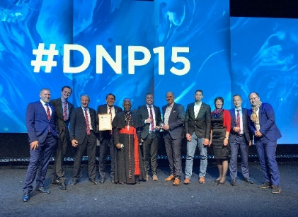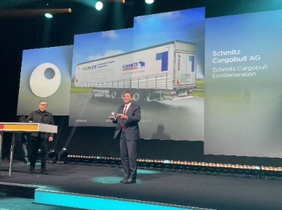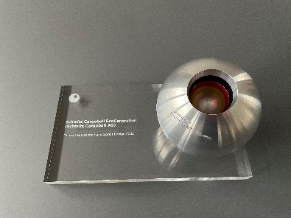
Caption1: Together with Research and Development Member of the Board Roland Klement (4th from left), other representatives of Schmitz Cargobull accept the award and are delighted together with the EcoGeneration users from the very beginning, Hans Wormser AG, represented here by Martin Nether, Chairman of the Board (5th from right), Mirco Fritsche, Freight Forwarding Manager (right) and Michael Hoffmann, Service Manager (4th from right). Also in the picture is Curia Cardinal Peter Turkson (5th from left), one of the evening's laudators.
Caption2: Roland Klement, Director of Research and Development Schmitz Cargobull AG accepts the award for the EcoGeneration. The event was held under 2G+ rules.
Caption3: BU3: German Sustainability Award Design for the Schmitz Cargobull EcoGeneration

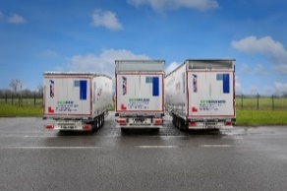
Caption: The EcoGeneration curtainsider semi-trailers: Reduced aerodynamic drag and greater fuel savings through adjustable, aerodynamic superstructures

About Schmitz Cargobull
With an annual production of around 42,500 trailers and with around 5,700 employees, Schmitz Cargobull AG is Europe’s leading manufacturer of semi-trailers, trailers and truck bodies for temperature-controlled freight, general cargo and bulk goods. The company achieved sales of approximately €1.74 billion in the 2020/21 financial year. As a pioneer in the industry, the North German company developed a comprehensive brand strategy early on and consistently established quality standards spanning every level: from research and development, through production and service contracts, to trailer telematics, financing, spare parts, and used vehicles.

The Schmitz Cargobull press team:
Anna Stuhlmeier +49 2558 81-1340 I anna.stuhlmeier@cargobull.com
Andrea Beckonert +49 2558 81-1321 I andrea.beckonert@cargobull.com
Silke Hesener: +49 2558 81-1501 I silke.hesener@cargobull.com

