Press Release
2023-145

Schmitz Cargobull AG
Schmitz Cargobull successfully extends GDP certificate for reliable pharmaceutical transportation

Following an extensive audit, TÜV Süd continues to confirm certification of the TrailerConnect® trailer telematics system in accordance with Good Distribution Practice (GDP)

August 2023 - Schmitz Cargobull has successfully extended the GDP certificate for its TrailerConnect® trailer telematics system, ensuring it continues to provide its pharmaceutical customers with factory-certified vehicles.

"Through the certification of TrailerConnect®, our customers can present an important certificate for their GDP audits, which attests to the high quality and safety of our products," reports Boris Billich, Sales Director at Schmitz Cargobull AG. "With our GDP certificate, we can guarantee and document full process safety for customers throughout the entire process chain. From the recording of data in the trailer, to data storage, to display in the portal or forwarding in the API (interface for data forwarding to third-party systems)."

Back in 2013, the European Commission introduced the Good Distribution Practice (GDP) of medicinal products for human use for quality assurance and protection against counterfeit medicines. Manufacturers, pharmaceutical wholesalers and pharmacists must subject their processes to annual GDP audits. The requirements for certification are reassessed every two years.

In an extensive audit by TÜV Süd, the Schmitz Cargobull trailer telematics system TrailerConnect® was again certified for a further two years. The audit includes a thorough examination of interface description, data storage, data backup, risk analysis for software development / software update / data backup, organisational processes and structures in the company, software manual, specification of sensor technology, company description, the quality management manual and ISO 9001.

Schmitz Cargobull successfully passed and receives an official certificate with a test and accreditation number from TÜV Süd. The certificate for the GDP audit can be requested from Schmitz Cargobull at any time.

2023-145

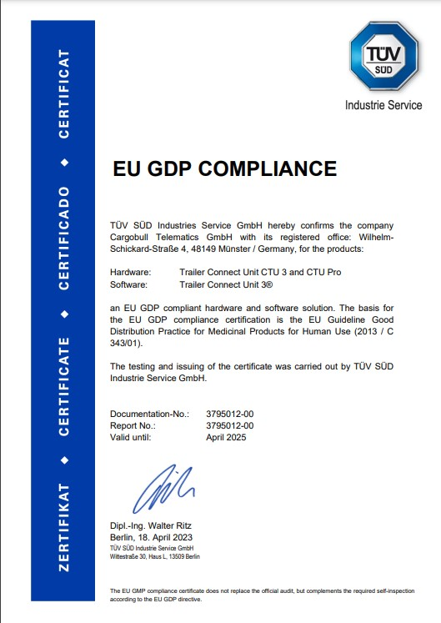

About Schmitz Cargobull
With an annual production of around 61,000 trailers and with approximately 6,900 employees, Schmitz Cargobull AG is Europe’s leading manufacturer of semi-trailers, trailers and truck bodies for temperature-controlled freight, general cargo and bulk goods. The company achieved sales of around €2.3 billion in the 2021/22 financial year. As a pioneer in the industry, the North German company developed a comprehensive brand strategy early on and consistently established quality standards spanning every level: from research and development, through production and service contracts, to trailer telematics, financing, spare parts, and used vehicles.

The Schmitz Cargobull press team:
Anna Stuhlmeier +49 2558 81-1340 I anna.stuhlmeier@cargobull.com
Andrea Beckonert +49 2558 81-1321 I andrea.beckonert@cargobull.com
Silke Hesener: +49 2558 81-1501 I silke.hesener@cargobull.com

