**Press Release**

**2025-111**

Schmitz Cargobull AG

**Digital natives – Schmitz Cargobull S.KI tipper semi-trailers are digital pioneers for the construction site**

April 2025 – Schmitz Cargobull is equipping all S.KI tipper semi-trailers with the TrailerConnect® telematics system as standard. This system contains a range of monitoring and control functions, which can be compiled individually according to customer requirements and are designed to help increase vehicle and occupational safety, improve transparency in the fleet and enhance planning reliability.

Telematics is also becoming increasingly important in the transport of bulk goods thanks to the intelligent networking and diagnostics, seamless documentation and centralised display and operation it allows for. It offers the operator many advantages that make day-to-day transport in the construction industry more convenient, safer, more transparent, more efficient and therefore more cost-effective.

Alongside standard functions, including GPS, fleet management, data transfer and a tyre pressure monitoring system (TPMS), there are optional functions. These include an on-board weighing system and brake pad wear indicator. These functions help prevent breakdowns and accidents and increase efficiency. TrailerConnect® telematics can therefore be used to optimally meet the requirements of the construction industry.

Vehicle operators can also customise the TrailerConnect® telematics system. In addition to standard functions, they can now also opt for the tyre pressure monitoring system (TPMS) with auto-location function. The TPMS monitors the tyres in real time and warns of sudden or gradual loss of pressure. This helps to avoid flat tyres and costly consequential damage, at the same time as minimising tyre wear and fuel consumption. Thanks to the auto-location function, Schmitz Cargobull TPMS sensors are automatically detected when a tyre is replaced and can then be assigned to the

**2025-111**

respective wheel position, meaning that the long-winded, error-prone teach-in process is no longer required.

This saves both customers and workshops time and money. Via the TrailerConnect® portal, the status of the tyres and the entire trailer can be monitored in real time. In the event of anomalies, alarm messages are sent by email, SMS or notification in the beSmart app for drivers, or in the beUpToDate app for fleet managers and dispatchers. The TrailerConnect® beUpToDate app also offers a real-time overview of the most important fleet data, and shows the location of trailers on a Google Maps-based fleet map in the telematics portal.

Upgrading to the CTU Pro telematics hardware activates additional functions, such as the read-out and transfer of EBS operating data, the TrailerConnect® brake pad wear indicator and the on-board weighing system that can be controlled via the beSmart app. Extra optional safety features include the tilt angle warning function, which issues an acoustic and visual signal to warn the driver of an unfavourable lateral tilt angle, and also the tipping angle warning system, which warns the driver when the body is tipped. The automatic deceleration function also comes into play here. While the vehicle is moving and the body is tipped, the semi-trailer is automatically braked, thereby increasing occupational safety for the driver and helping to avoid accidents.

The following options are also available to increase efficiency and enhance safety. If the pneumatic underride guard is fitted, the sensors record the driving and unloading position, which means that the underride guard can be operated safely from the driver’s cab. The electric sliding tarpaulin, which is also available for high-volume bodies, reduces the risk of accidents for the driver as it can be opened and closed with the user-friendly, time-saving remote control function. This means the driver no longer has to climb up to open or close the tarpaulin. Better body lighting while driving at night increases safety and comfort when it’s dark. Cargo and rear area cameras are optionally available for increased work safety.

**2025-111**

The cargo area camera provides a convenient overview of the load in the body and reduces the risk of accidents by allowing the driver to track the loading process from their cab. The reversing camera provides an overview and protects against ramming damage when tipping or reversing, reduces impact damage and improves road safety. Equipped with the additional off-road traction help, the S.KI tipper semi-trailer is ideally equipped for off-road driving and easier to pull away in the snow, sand or mud.

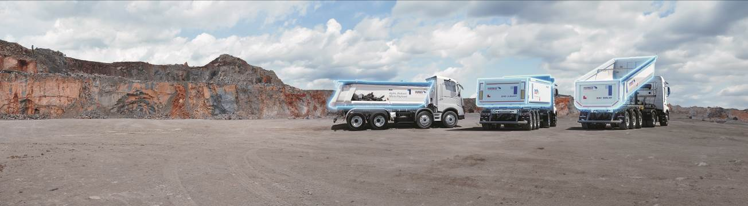

**About Schmitz Cargobull**

Schmitz Cargobull is the leading manufacturer of semi-trailers for temperature-controlled freight, general cargo and bulk goods in Europe, and a pioneer in digital solutions for trailer services and improved connectivity. The company also manufactures transport cooling units for refrigerated box body semi-trailers for temperature-controlled freight transport. With a comprehensive range of services from financing, spare parts supply, service contracts and telematics solutions to used vehicle trading, Schmitz Cargobull supports its customers in optimising their total cost of ownership (TCO) and digital transformation. Schmitz Cargobull was founded in 1892 in Münsterland, Germany. The family-run company produces around 60,000 vehicles per year with over 6,000 employees, and generated a turnover of around €2.4 billion in the 2023/24 financial year. The international production network currently comprises ten plants in Germany, Lithuania, Spain, England, Turkey, Slovakia and Australia.

**The Schmitz Cargobull press team:**

Anna Stuhlmeier +49 2558 81-1340 I [anna.stuhlmeier@cargobull.com](mailto:anna.stuhlmeier@cargobull.com)

Andrea Beckonert +49 2558 81-1321 I [andrea.beckonert@cargobull.com](mailto:andrea.beckonert@cargobull.com)  
Silke Hesener +49 2558 81-1501 I [silke.hesener@cargobull.com](mailto:silke.hesener@cargobull.com)