Pressemitteilung SCB x FLEETLOOP, TL 2025
FLEETLOOP: Revolution in Trailer Rental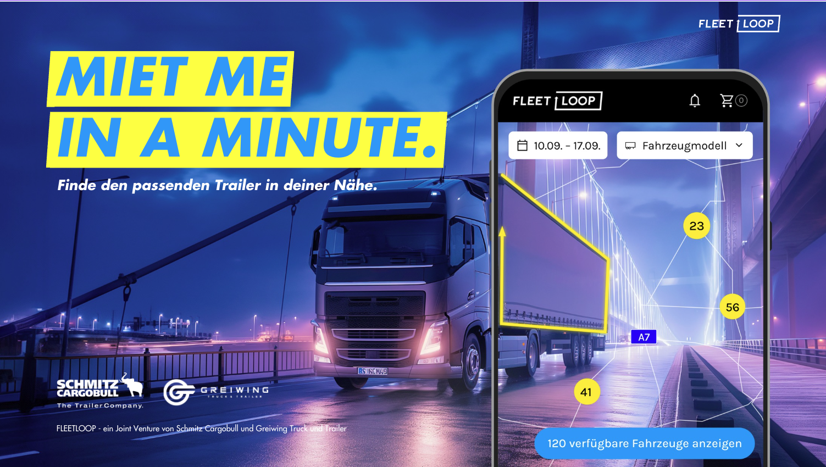24/7 Availability: FLEETLOOP trailers can be picked up contactless at six locations across Germany, anytime.
Greven, June 2025 – The transport industry faces significant challenges, especially for small and medium-sized enterprises. FLEETLOOP, an innovative startup, emerges as a joint venture between commercial vehicle rental specialist Greiwing Truck & Trailer and renowned trailer manufacturer Schmitz Cargobull, revolutionizing trailer rental. The platform offers maximum flexibility, efficiency, and user-friendliness, setting new standards in commercial vehicle leasing.

Innovative Solutions for Current Challenges
FLEETLOOP addresses urgent industry challenges by enabling flexible, hassle-free vehicle procurement. Its fleet includes a wide range of new and lightly used vehicles, such as refrigerated, box, and curtain-side trailers, as well as tipper semi-trailers. These can be rented flexibly and at short notice across six German locations.

Contactless Pickup Around the Clock
The proprietary online booking portal, my.fleetloop.com features an interactive real-time trailer availability map and a fully digital booking process. A key advantage is the contactless, location- and time-independent vehicle handover. Drivers receive a personalized PIN to access trailers anytime, saving valuable time—vehicle condition checks are handled digitally.
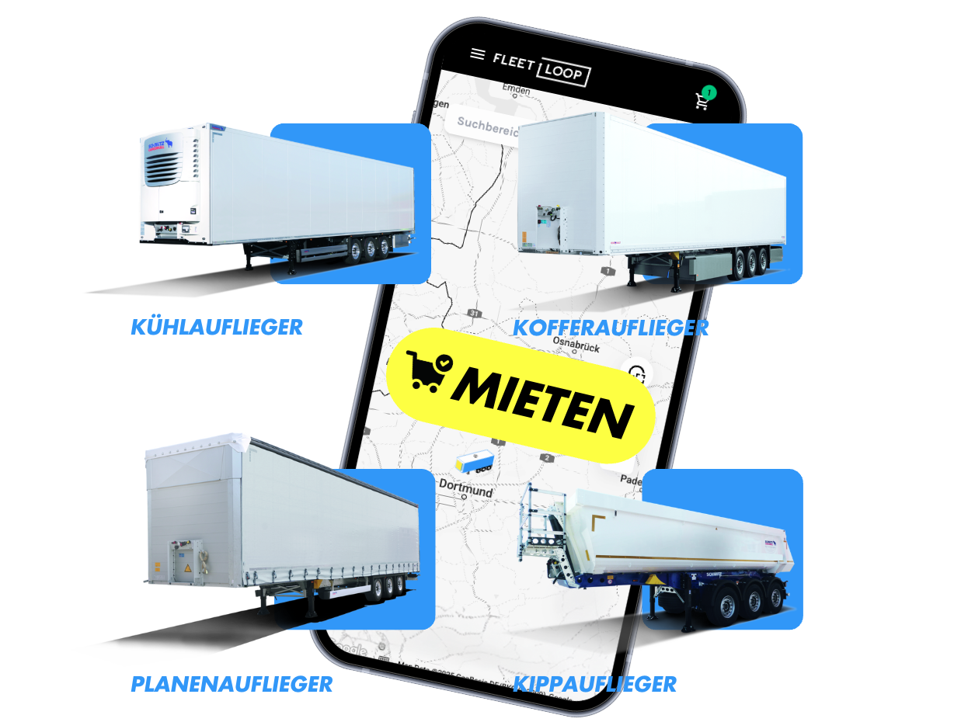

24/7 Rental: FLEETLOOP trailers can be booked anytime via PC or smartphone.

All-Inclusive Service for Customers
During rentals, FLEETLOOP manages the entire fleet, including 24/7 breakdown and customer service, maintenance, damage claims, and repairs. Additional value-added services like TrailerConnect® telematics, reduced deductibles for damages, and TyreGuard complete the offering.

Proven Customer Success
Melanie Niethammer, Senior Manager European Road Transport & Customer Service at STI (Germany) GmbH, highlights FLEETLOOP’s benefits: *"During peak demand, the seamless availability of trailers is a game-changer. Contactless pickup and returns give our logistics team unmatched flexibility."*

Future Plans and Expansion
In 2025, FLEETLOOP aims to open at least five additional depots in Germany and expand internationally. Managing Directors Simon Greiwing and Anselm Steinhaus emphasize FLEETLOOP’s quality promise to lessors and lessees. Talks for European expansion are already underway.

Unique Differentiators
Unlike traditional rental providers, FLEETLOOP stands out with 24/7 availability, fully digital processes, and rapid turnaround from booking to handover.
With FLEETLOOP, trailer rental has never been easier or more flexible. The platform empowers transport companies to adapt swiftly to changing demands, redefining industry standards.

Contact:
FLEETLOOP GmbH
Matthias Cordes
Email: matthias.cordes@fleetloop.com
Phone: +49 151 10574773

