Press Release
2025-177

Schmitz Cargobull AG
Schmitz Cargobull presents all-electric S.KOe COOL semi-trailer at the CNL workshop in Austria

December 2025 - Schmitz Cargobull presented its all-electric S.KOe COOL semi-trailer at the "Council for Sustainable Logistics" (CNL) workshop in Austria. The event took place at Austrian logistics expert Schachinger Logistik and provided a platform for exchanging ideas on innovative solutions for decarbonising freight transport.

As part of the workshop, Schmitz Cargobull presented the advantages of the all-electric trailer for emission-free transport. It discussed the current challenges and opportunities with regard to VECTO targets and the achievement of CO₂ targets with industry experts in the subsequent panel discussions.

The CNL is pursuing the goal of supporting climate neutrality in Austria by 2040. The initiative relies on the use of zero-emission vehicles such as e-trucks and e-trailers as well as a holistic system that includes charging infrastructure, efficient power grids, funding programmes and best-practice solutions.

Fully electric S.KOe COOL semi-trailer body for zero-emission transport
Schmitz Cargobull offers a practical solution for the emission-free transport of temperature-controlled freight with the all-electric S.KOe COOL refrigerated box semi-trailer. The equipment includes an electric refrigeration machine with integrated power electronics, a high-voltage battery system and an optional electric generator axle. This recuperates energy during braking and at certain speeds, extends the operating time of the refrigeration machine, and reduces recharging times via the power grid. The additional battery weight is almost completely compensated for by the elimination of the generator, helping to maintain payload capacity and space for up to 36 pallets. The all-electric S.KOe COOL refrigerated trailer with generator axle has also been type-approved, which ensures safe and environmentally friendly operation without the need for subsequent authorisations.

2025-177

With the S.KOe COOL and other innovations such as hybrid refrigeration units with an ePTO interface, Schmitz Cargobull is making an important contribution to the decarbonisation of road freight transport and supporting the industry in achieving its climate targets.

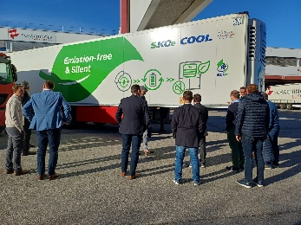 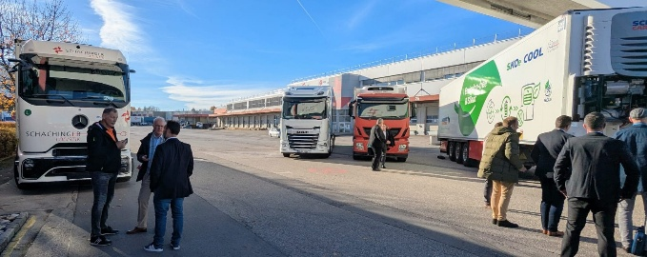 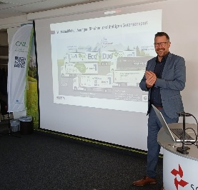
Photo Credits: C. Mayr, Schachinger Logistik

Caption: Presentation of the Schmitz Cargobull S.KOe COOL electric semi-trailer at Schachinger Transport by Carsten Krieger, Product Manager Cool Freight, Schmitz Cargobull

About Schmitz Cargobull
Schmitz Cargobull is the leading manufacturer of semi-trailers for temperature-controlled freight, general cargo and bulk goods in Europe, and a pioneer in digital solutions for trailer services and improved connectivity. The company also manufactures transport cooling units for refrigerated box body semi-trailers for temperature-controlled freight transport. With a comprehensive range of services from financing, spare parts supply, service contracts and telematics solutions to used vehicle trading, Schmitz Cargobull supports its customers in optimising their total cost of ownership (TCO) and digital transformation.
Schmitz Cargobull was founded in 1892 in Münsterland, Germany. The family-run company produces around 50,000 vehicles per year with over 6,000 employees and generated a turnover of around €2.16 billion in the financial year 2024/25. Its international production network is made up of factories in Germany, Lithuania, Spain, Turkey and the UK.

The Schmitz Cargobull press team:
Anna Stuhlmeier +49 2558 81-1340 I anna.stuhlmeier@cargobull.com
Andrea Beckonert +49 2558 81-1321 I andrea.beckonert@cargobull.com
Silke Hesener +49 2558 81-1501 I silke.hesener@cargobull.com

